Victor Dvurechenskikh
Vladimir Baranov

On the “response-diffusion” model in US economic safety problem

Brief introduction
This problem was known earlier. It comes down to the problem on the topic On the ‘Response-Diffusion’ Model in the Analysis of Threats to the US Economic Safety. This topic has official confirmation and will be presented at the conference. The result will be presented after competitive selection on the Policy Modeling topic from the 30th of June until the 2nd of July 2004.
The general ideology was the following:
1.1.1 | Research and development of methodology of assessment of national resources (riches) of the Russian Federation | 1-2 quarter | Methodology | Research Report | 1. S.V.Stepashin Chairman of the General Controller  2. NII SP
This report corresponds to the above mentioned approach.
Any information is welcome. A critical analysis of results is encouraged. We will also be glad to hear critical analysis.

Problem
Setting the scientific task comes down to the following (fig.1). Let us analyze a typical situation for current expenditures (in billion $ per year).
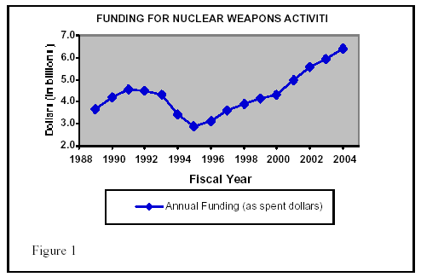
Fig.1. The real tendency is for the expenditures to increase.

Thus, we witness a monotonous growth within 1996. The problem is to assess the increase rate.
The essence of the matter is that, according to Scarf, the following happens.
What happens to Scarf? This paradox has already been described as a process of finding equilibrium by competitors striving for the state budget resources. Based on (1):
(1) 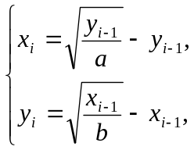
where i = 1, …, n — “system time”, as is customary to call an integer-valued index numbering discrete moments of time.
A feature of a and b parameters are obvious supplementary conditions. If supply of some boon x can not be assigned ad arbitrium, i.e. if it is determined by those objective external circumstances that depend on the type of a contestant and required final conditions (mitigation of threat coming from a contestant or its complete elimination, compulsion of a contestant of political concessions or his full capitulation with the following occupation of some part of his territory etc.), than the price a can considerably vary: as a matter of fact, the only real constraint for it is a condition 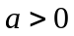. The same can be also maintained for the relation of the supply of a boon y and its price, for which value a priori there is no any constraints except a condition 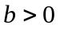 natural for any price. A system, in principle, is able to move up to the goal (Kurno equilibrium) along an aperiodical (Fig. 1a), cyclic (Fig. 1b), or chaotic (Fig. 1c) trajectory.

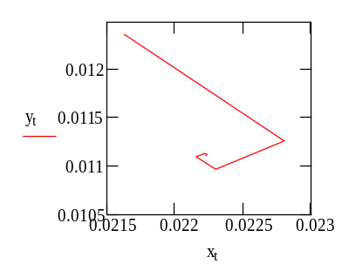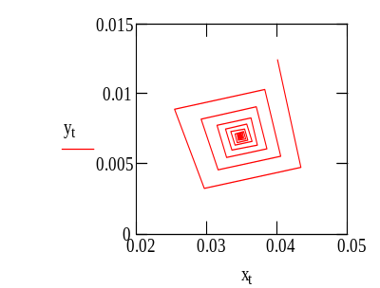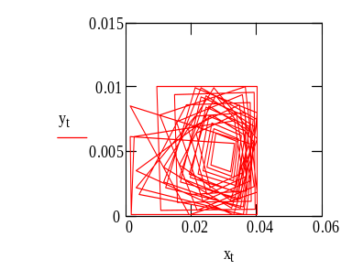

Fig. 1 a, b, c. Typical types of trajectory of the budget equilibrium dynamics.

Our purpose here is to ascertain conditions for initiation of each of the above types of movement, as well as their interpretation in respect to the budget dynamics, its predictability and potential implications for the economics and politics. A particularly interesting issue is loss of the movement stability, i. e., a transition from the aperiodic trajectory to the cyclic one (bifurcation of the cycle origination). Assume that it can occur in some fixed point. Differentiating response functions we obtain:
(2) 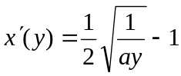 и
(3) 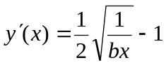.
Then, substituting “Kurno point” coordinates from (8) and (9) to (2) and (3), we obtain, accordingly:
(3) 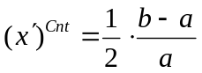 and
(4) 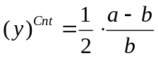.
The loss of stability in the fixed point occurs, when
(5) 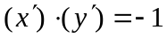.
Substituting derivative values from (7) and (8) to the expression (6) we obtain the condition of stability in the following form:
(6) 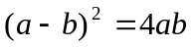.
It is interesting to compare it with the evaluation of the budget trajectory stability obtained from totally different assumptions of the stability model:
(7) 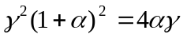,
where α and γ, respectively, are an accelerator and a multiplicator, and an equals sign in (7) — corresponding to a nonfluctuating and non-oscillating trajectory — can be substituted by the greater-than or less-than sign at other types of trajectory. The equation (18) has solution for a/b or b/a equal to 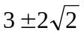. Coming back to our primitive conjectures, we recall that it is a question of the ratio of prices of that very two necessary boons (“security” and “consumption”) proposed to the Federal budget by suppliers, which compete in the fight for its finance resource. The numerical result obtained above means the following: if the price ration is in the interval 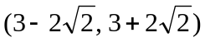, the stable type of the budget equilibrium movement is the case; but if this ratio goes beyond this interval, then the uniqueness in the budget dynamics is lost at once: a scenario arises known in theory as the “duplication of a period” that can result in appearance of the chaotic regime. In other words, a cycle or a “strange attractor” arises instead of the equilibrium point. The cyclic budget equilibrium dynamics, in principle, is predictable, however, for the model in question here, conditions of origination of the chaotic regime, for which expected values of the budget equilibrium trajectory cannot be predicted in principle, can also be specified.
The response functions (Fig. 1) can be determined by the values of variables at the zero and maximum points. So, the response function (4) reduces to zero for 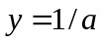 and to the maximum for 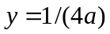. Accordingly, 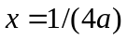 corresponds to the maximum. A response of other duopolist for this maximum can be obtained by substitution of its response expression to the response function (6) that gives 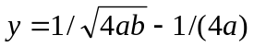, where this value should not “miss to zero”(6), otherwise the model would “blow up”.
Conditions of no “blow-up” are as follows:
(7) 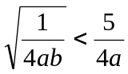, or
(7') 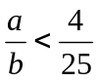.
The same considerations can also be symmetrically carried out for the other response function, hence we obtain
(7'') 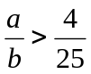.
I.e., in the model, their own ratio of the marginal cost of the two budget tasks solved by the budget corresponds to the both phenomena — the cycle origination and the transition to the chaotic regime. Blow-up of the model analyzed above occurs beyond the interval, i. e., for the price ratio 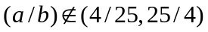. Accordingly, cycles in the budget equilibrium dynamics trajectory meet the condition 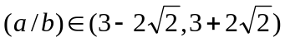.
The facts are as follows: the volatility of the budget equilibrium over the last ten years has notably grown – see an illustration in Fig. 2.
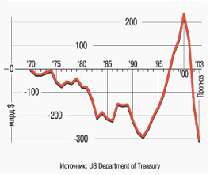
Fig. 2. Deficit of the US Federal Budget
(as per the Treasury data for the period 1970 to 2002 and with the forecast for 2003)

At the same time, percent of the US Federal Budget defence expenditures have declined steadily for the last forty years – see the illustration referred to the US GAO source. They have reduced from near 50% in 1962 to 25% in 1982 and to 17% in 2004. The share of military spending in the US Federal Budget for 2004 has been planned also at approximately the same level.
Perhaps, the criterial index a/b following the change of the x/y relative share in the budget has reached its critical value determined by (2'), (2''). In fact, in the framework of this report, we have only posed a problem to show numerability of the deduction of the budget dynamics. However, we can illustrate and discuss the formulated hypothesis only with relation to its plausibility, but we are not able to present a result of a/b calculation in favour of this hypothesis. Problems related to the budget expenditure data acquisition, part of which is inaccessible in principle due to military secrecy considerations, make the task of calculated demonstrations more difficult.
Let us try to evade the problem of data absence. Not having the possibility to calculate the actual value of the a/b index we, nevertheless, have at our disposal another ratio – a share of the boon proportion x/y that is cited in the Federal Treasury reports.
For the analyzed duopoly task, the problem of stability can be formulated in some other terms.
The sense is that using a purposely introduced index, one can make a qualitative (at the level of “stable/unstable”) conclusion of the dynamical equilibrium character on the base of analysis of the relative proportion x/y of financing boons x and y in the budget, as well as elasticity of such boons substitution. We will show relation of this index with the considered duopoly model below.
In accordance with the cited source, the index is calculated as follows. Let the elasticity value of the substitution of the first boon by the second one, and also a proportion of the first boon in the budget expenditures are given. Then the stability index s, according to Scarf, has the form of
(8) 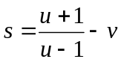,
where: u, v — so-called Scarf coefficients that are calculated as follows:
(8') 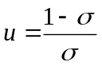,
(8'') 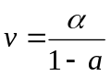.
Budget equilibrium instability answers the negative index индекса s values, i. e. the chaotic character of the trajectory dynamics that is the result of the conditions determined by (7'), (7'').
Let us give the value 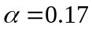, exactly such as it is specified for 2002 in Fig.3, i.e. let us follow the official US information for the military spending proportion planned in the US Federal Budget США for 2003. Then it is necessary to specify the value of the boon substitution elasticity. Two substitution strategies, high and low, — roughly speaking, are considered to be possible. Above, we already discussed an example of the GPS navigation field, rather special, but giving a notion of some tendency in the substitution. And now, giving various values for the level , we shall obtain conditions of the 2004 US budget stability according to Scarf. The calculation results are shown in the form of a response function (Fig. 3).
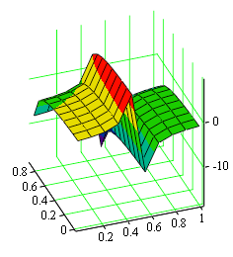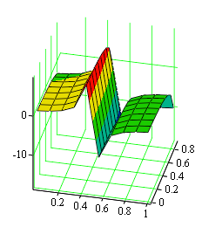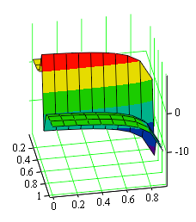
Fig. 3. The response function of the index s to 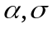values.

It is easy to note from the analysis of the response surface to Scarf (Fig. 4) that stability is the exclusive feature: stable budgets, according to Scarf, turn out to be in clear minority. On the diagram in Fig. 4, “warmly” coloured s values answer stable and combinations, accordingly, unstable budgets are represented on this diagram by “cold” colours. We cannot show an expert estimate of the value for the current US economy status; perhaps, this value estimate is not known at all. But, nevertheless, we can judge of the elasticity value more realistically, than of the price proportion a/b in the duopoly model that is quite abstract criterial index. The point is that even a fleeting glance at the epure character in Fig. 4 is sufficient to find out the presence of the response surface singularity along the line 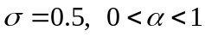, which a terminator between a yellow and green diagram area on the surface s corresponds to. This singularity allows weakening the assumption character reducing primitive conjectures, in fact, to a dichotomy like a “high/low” elasticity value. Assume this value to be relatively high, i.e., 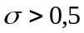. Then the Scarf index for the US 2004 budget at will amount to s = –5.205 already for 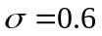, and with the further growth of 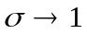, it will be only decrease remaining in the area of negative values. Generally, as follows from the diagram in Fig. 4, for the elasticity values 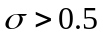 at any values 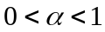, the index value 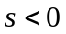 that involve a conclusion of instability of the corresponding budget structures. At the same time, as follows from that very diagram, for the combination 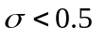 and 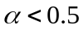 all budgets are stable. Thus, there is sufficient reason to suppose the US Federal Budget for 2004 to be unstable.
In addition, we come to one more conclusion: the military budget “burden”,
unless it exceeds a proportion 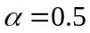, in itself is not a source of its performance instability, but for all that increase of elasticity of x and y boons substitution in the economics over some criterial value 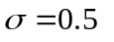 can lead to the instability of the budget financing these boons.
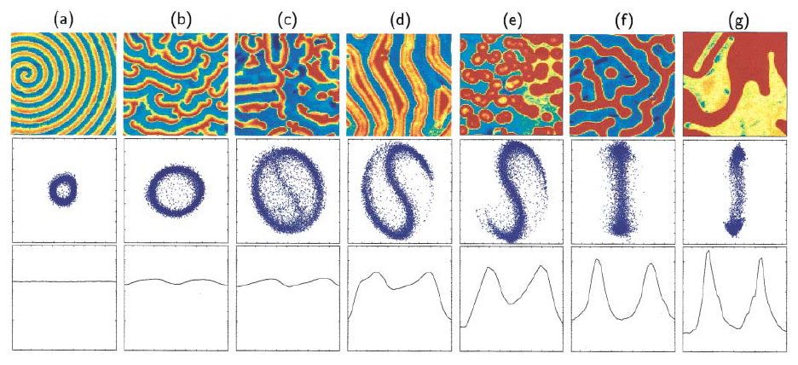
Fig.3. Image in approach (9×9 mm²).
A tendency of the ratio 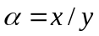 is accompanied (it is important to note!) by the common – technologically conditioned – tendency to the increase of x and y boon elasticity financed from the state budget. In particular, high elasticity boons (so-called substitutes) among that there are GPS, Internet, mobile communication, cable television, in general, any network systems equally highly valued and called for both in the consumption field and for the national security assurance needs.
In conclusion of the discussion we will show the relation between the Scarf index and the duopoly model considered above. In principle, the following considerations can be generalized for an arbitrary number of boons financed from budget, but we will give an illustration for the same two boons that were considered above – “security” and “consumption”.
Imagine a mental experiment for two different cases. In the first case we increase a price a of the boon x fixing at the same constant level the volume of the y boon supply to the budget. It is clear that growth of a will cause decrease of x. In the second case, we will raise a by the same quantity, but now keep at the same constant level not the volume of y supply, as in the first case, but the price of this boon b. As in the first case, based on the limited nature of the budget principle of suppliers’ profit maximization, one should assume that the lower volume of x in the format (9×9 mm²) will be purchased at the changed price.
Thus, the research task of this type in fact questions the trust to the method of mathematical statistics. But statistics is the purpose and means of budget analysis. Decisions of the quality of budget performance are based on the results of statistical information processing of the budget process, and forecast of behavior of the most important indicators of the state budget for the next year is based on the accumulated history. In order to do that, the results of statistical processing are extrapolated using standard tools for the required period of time in future. Why do we start questioning the trust to the method of mathematical statistics?

Analysis of the Statistical Method
The issue of resolution of statistical method of control appeared in the context of the topic of this report in general and is due to unsatisfactory quality of forecasting economic reality which accompanies the practice of forecasting. The modern economic theory is based on the standard model of Arrow-Debreu, which determines the non-uniqueness of the number of equilibriums. But even if the given number of equilibriums is finite, in the neighbourhood of the stable equilibrium behavior of such dynamical system, as the state budget weakly depends on its prehistory. This lessens the value of both forecasting by the prehistory and a widespread practice of replication of the earlier implemented budget solutions at the next ph-phase of the budget policies planning. This means the following: the new budget planning by the template of the old one is convenient, but not functional, as it guarantees nothing. This issue, by virtue of routine and prevalence of the implicitly assumed hypothesis of statistical stability of the statistical expectation by the ensemble of realizations, needs the detailed consideration.
Trying to reason by contraries, from the point of appropriateness of the “template” approach to the planning of the next draft budget as some means of control over the budget feasibility, it is necessary to have evidence of а) the existence, б) the unicity, and в) the stability of such solution. In that case, considering the budget as a special case of some integral macroeconomic model of maximization of functions of the various consumers set with individual utility functions, it would be coherent to require that the nontrivial and unique solution of the budget planning task is reached as satisfying budget constraints and stable one.
But if the conditions of the existence and unicity for the specified budget constraints can be obtained in the wide function class, the problem of stabilization causes the principal challenges. In particular, in spite of carefully developed techniques of utility function recovery from the statistical data, nobody has been able to demonstrate these functions stability on the form independent of the utility function specification yet. The examples are the statements of the existence itself and Pareto-optimality of the competitive equilibrium state. At the same time, the Sonnenschein’s, Debreu’s and Mantel’s “negative” result (“SDM approach”) states that the up-to-date economical theory, in principle, cannot answer this fundamentally important question of the stability without studying the utility function (or – more generally – the drawing function).
The “Arrow’s paradox” and the Boldrin-Montrucchio theorem have the similar nature in respect of the Sonnenschein-Mantel-Debreu result. But even in this quite low-probability assumption, that we would manage to find a universal form for the utility function of all budget consumers, at least, two difficulties arise that have not been overcome yet and are likely insuperable, in principle.
First, natural principles do not allow to uniquely establish the budget process dynamics, the number of possible equilibriums appears to be too large. In other words, incompleteness of the economical equilibrium principles leads to the immense multiplicity of feasible solutions.
The second difficulty is the redundancy of these plausible principles number. So, for example, absolutely different conclusions can be obtained from both Waldrasian and Keynesian models, and, at that, it is totally unclear, which of the patterns should be used in the particular situation. Theoretically, it means that equally plausible models of essence explication of the same, in fact, economical process (in this case – budgetary) lead to the differing, in principle, results. For practical purposes, multiplicity of equilibriums means that in the forward planning one has to reckon that a budget path can always be subjected to deviations from the directive values, - not at all by subjective reasons that are implied at all times, but because of the non-uniqueness of the dynamic system realization. This is such peculiarity that calls forth the budget performance result – expected and actual –coincidence failure. This result, undoubtedly important also in the context of the budget performance control, is ever the key one in the problem of the budget feasibility control. The meaning and significance of the conclusion of the budget realization non-uniqueness as a dynamical system is that it gives a form of the budget feasibility control functional.
First, we have to assume with necessity the budget path to be free, and as regards the original question whether accumulation of the budget performance experience gives necessary and sufficient grounds for conclusions of the next planned budget feasibility, we have to give a negative answer. And, therefore, the feasibility control requires not statistical, but other in kind methods.
Second, assuming the budget path to be the free realization, we also ought to expect the result of the budget feasibility control not in the quantitative (as a measure of deviation of the actual path from the calculated one), but in the qualitative form.
In other words, a problem whether the considered version of the budget is feasible, in principle can be solved exclusively in the qualitative form implying only a binary answer (Yes/No). And vice versa, a solution of the budget implementation is fixed just numerically, in the form of integral functional of the budget receipt and expenditure values within a year. There is no any contradiction in that: a budget deficit fixes the dynamical system status at the final stage, while the feasibility is categorically related to the overall budget performance period. In fact, this work is aimed at the removal of this contradiction.
The objective prerequisites of the budget feasibility control problem have arisen not only and even not so much from the contiguous problem of the budget performance control, but quite “from outside”, from the necessity to compare a outcome of the budget process a priori predicted in the course of planning with the budget performance result recorded a posteriori. Another way, the performance control should also be, in the theory, a tool for confirmation of the conclusions that were made at the phase of the budget feasibility control.
The rightful question: is the actual methodology able, in principle, to be a criterion of the new methodology result correctness? This is that very problem of resolution indicated above. As was already outlined, anticipation of the economical reality by means of the economical theory cannot provide a satisfying result.
But, assume, a conclusion of the budget process feasibility/non-feasibility has been issued by use of some forecasting means.
Then, a question, to what extent the a posteriori confirmation/denial of the a priory forecast of some event in the i-th point of the budget performance discrete process, where 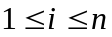, and n – a number of days in the year, can be considered reliable, comes to the evaluation of the mathematical statistics method ability to reveal accumulated changes. That was the way how a research question of the degree of belief in the mathematical statistics method was formulated above.

Resolution Analysis
In order to obtain an answer to the question formulated above of the belief in the mathematical statistics method in the budget dynamics analysis, let us correlate an estimation of dispersion of the two budget process neighbour values difference (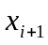 and ), 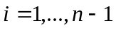 with an estimation of dispersion of the same values (accumulated changes) difference modulus for some significance level of the these estimations quality criterion. Assume the budget dynamics 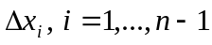 to be discrete, and changes to happen not more frequent than once a i-th day, at that, let us consider the length of the n interval to be a year.
Let us examine the statistics 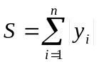, where 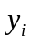 – the first differences 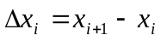 of the process 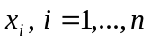. Without loss of generality of conclusions we can assume, that ,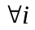 – independent similarly distributed aleatory variables. For definiteness, we will assume them to be Gaussian that is the problem situation mitigation. Then, arriving at conclusions for S on the version of assumptions that occur in the practice, one can consider them a fortiori satisfiable.
Thus, let 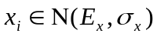. Then a vector 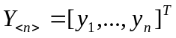, which elements are also Gaussian, is completely specified by a vector of statistical expectations 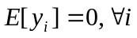 and a correlation matrix
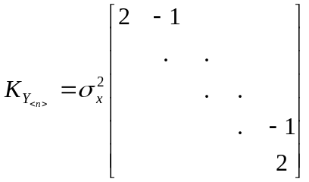 of the banded (three-diagonal) type.
The absolute values of the first differences have 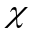-distribution with one degree of freedom, on the base of its features we have
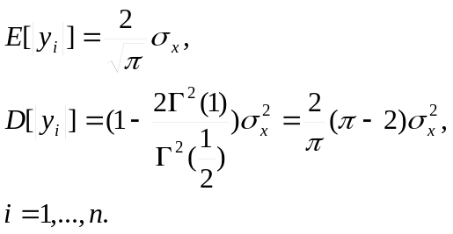
It follows from these relations that the statistics 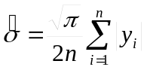 is an unbiased estimation of the mean square deviation (m.s.d.) of the aleatory variable x. Let values 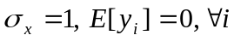, and a correlation matrix of the vector 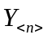 corresponds to the above assumptions, then the n-dimensional distribution density of the normalized vector will have a form (we omit below the implicit dimensionality n of Y vector)
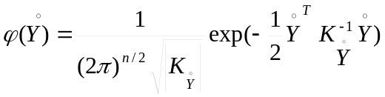.
Based on these assumptions, let us consider the asymptotic behavior of the estimation  that will, on the base of the strengthened Lyapunov theorem, follow the Gaussian probability distribution with such numerical characteristics 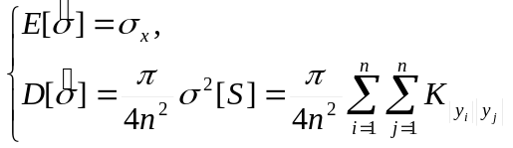.
It follows from the last equation that in order to determine the variance of estimation , it is necessary to determine a correlation matrix of 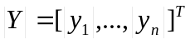 vector. It is obvious already from the form of the matrix 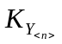 that the first differences and 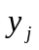, which indices i and j differ more than by one, are not correlated. Taking into account this fact when n=2 we have a special case of the expression for the distribution density 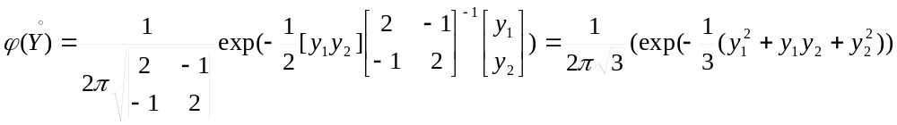.
In the general case, transition from the distribution density of the vector to the 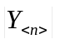 density can be made by n-times summation of the vector density values in 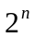 vertexes of n-dimensional simplex with the coordinates 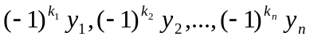, where, for our case, the index 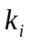 takes values from the set {1,2}.
A formal record of the above transition has the following form 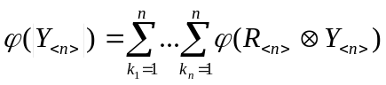,
where 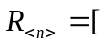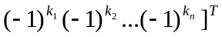;
 – a symbol of the direct product (Kronecker product) of two vectors, which meaning for two vectors of similar dimensionality is illustrated by the expression
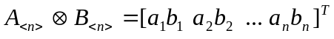.
Using this transition relation for n=2, we have the density of distribution of two absolute values of consecutive first order differences in the form of:
.
The correlation between absolute values of the consecutive differences 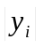 and 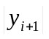 is determined by the expression
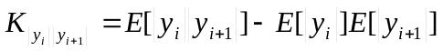,
where 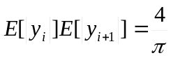, and 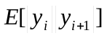 can be determined from the quite obvious relation 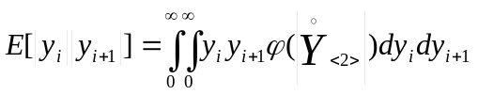.
In order to calculate the double integral in its right part, let us pass on to the polar coordinates and use a substitution 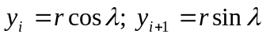, where 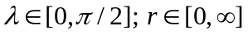. This trick allows using standard integrals.
As a result we have 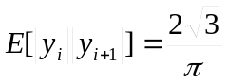. Accordingly, taking into account that , we have the correlation values 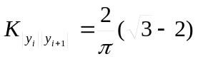 and the values of first difference modulus correlation coefficients in the form of
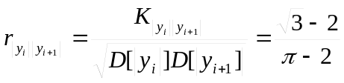.
The correlation matrix of vector will have the form
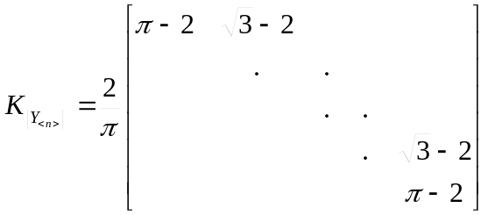.
In accordance with the distribution density function characteristics theorems, we obtain an aleatory variable sum variance as a sum of all elements of the correlation matrix, hence the desired m.s.d. of the S statistics will take a form
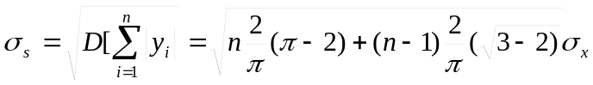.
Taking into account linearity of the S statistics, we have, accordingly, the following final variance equation from the last expression: .
Thus, the variance of the standard deviation characteristics S is representable as a function connecting the amount of sampling n with some constant
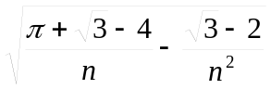.
In order to gain an idea to what extent such accuracy of variance estimation is acceptable, let us compare it with the so-called lower Kramer-Rao limit determined for the numerical characteristics of the given distribution. Remaining in the frame of the gaussianity hypothesis, let us write a canonical expression of the lower Kramer-Rao limit for the estimation of parameter of the Gaussian distribution of the value x in the following form:
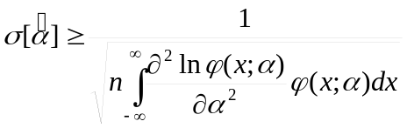.
Assuming that 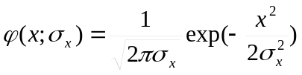, we have 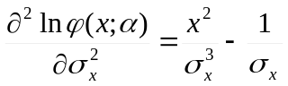. Substituting expressions for the density function and second partial parameter derivative of the density function under the integral, after obvious transformations, we come to the theoretical estimation 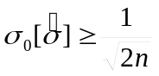 of accuracy of dispersion estimation that is to be compared with the obtained expression
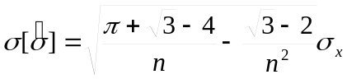.
As follows from the curves in ‘variance – amount of sampling’ co-ordinates, when , the curve 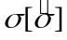 is asymptotically approach “from above” the curve 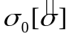 – the lower Kramer-Rao limit “from above”, and, for the sampling amount n=100, allows to obtain appropriate estimations of S statistics and, therefore, to come to the reasonable solutions on their base. However, in the area of practically interesting values 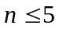 that corresponds the data sampling amount within the business week, discrepancy of the estimation variance and its theoretical limit is rapidly increasing and becomes unacceptably large.
So, if, in order to estimate 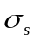 by standard means, one constructs a confidence interval 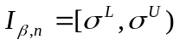, where 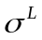 and 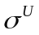, correspondingly, are an upper and lower limit of 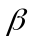-percent confidence interval, then we have 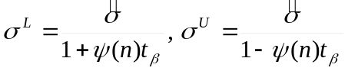, where 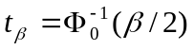 – the standard Gaussian distribution.
The confidence interval of the estimation for the average m.s.d. by a data sampling 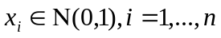 at n=100 and assuming 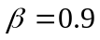 will be 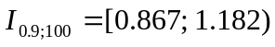, while, for the same significance level, but at the decreased amount n of sampling from 100 to 5 it will turn into 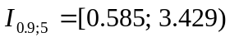. This means that the corresponding confidence interval width increases from about 30% of the controlled value nominal at n=100 up to almost 300% at n=5. In other words, the mathematical statistics method cannot, in principle, catch the accumulated changes at the practically interesting low values of the “running window” width with the accuracy acceptable for the decision making. Thereby, monitoring understood as a control of current changes is actually excluded. A the same time, there is no ground for the budget process control by deviations of current values of the process from calculated values due to non-uniqueness of the budget realization as a dynamical system.

Final Results
The deduction, as regards the question set above, represent such set of conclusions, which is, per se, a statement of impossibility.
Conclusions of the sub-section are related to the problem of economical dynamics and based on the well-known aspects of the theory. There essence was that there is no a satisfactory solution of the integrated problem of the existence, unicity, and stability of the dynamic balance equation solutions in the present-day economical science. This group of conclusions can be determined as a result of comprehension in the analysis of economic dynamics data – by the statistical METHOD.
The main practical implication of the set of statements of the present-day economical theory concerning the budget practice is that the imitation (what-if) modeling of the budget process is counter-productive. The meaning of the above last conclusion is that any attempt to foresee the future of the budgetary process, on the base of whatever developed models, is doomed to failure due to the nature of the predictable process that is an outcome of the so-called dissipative system ; social systems including economical systems (state finance is part of them) are often described by the model of the dissipative system.
The second group of conclusions organically supplements a pessimistic result as regards impossibility of transference of obtained conclusions to the future by induction. Even if this forecast appeared ideal, statistical means, all the same, would not allow to come to the reliable conclusion whether the issued forecast was correct or erroneous. The limitation is the variance of the process trend estimation that appears to be unacceptably high for short samplings. It should be noted that the conclusion was obtained here for the excessively “mild”, practically improbable assumptions, to expect such compliance with such assumptions in practice is too optimistic. It only strengthen the pessimistic result obtained. The meaning is the following: such processes as, for instance, the default in 1998 that led, among other things, to the collapse of the state budget run quite transiently. For such processes, a business week (maximum 5 data points) can be deemed the utmost acceptable period of expectation by political leaders of conclusions on the current budgetary process state. But for such sampling amounts, small for the mathematical statistics, an analyzed event practically “is lost in noises” that is shown in the form of the theoretical result.
Interrelation of negative results – as regards economical dynamics, from one hand, and observational practice, from the other hand, – has the deep nature. In fact, we are dealing with some variant of system constraint at the level of the inhibition principle, some course of action in practice independent of the state finance control. Such actions as the imitation modeling of the budgetary process and operational control over this process by “observed” indices, i.e. indices accessible for direct observation (NB: not by the dynamic budget model parameters) in the monitoring regime appear to be actually unfeasible due to described system constrains. Simulation as a method is forbidden, as for the economical dynamics there is no, in principle, unequivocal relation between the benchmark conditions and implementation of the dynamic budgetary process. Monitoring is impossible, because processes of developed instability run at the same relevant periods that are corresponded by the interval of discretization of the budgetary process that makes the sampling method unsound. In addition, it is impossible by any means to eliminate this inhibition only by mere technological improvements. Upgraded computers, data exchange networks and related system and application software do not at all compensate the above methodological shortcomings.
As a summary, it should be highlighted that this negative result characterizes, in fact, only the resolution of the outdated “head-on” approach applicable now. In other words, it seems impossible to come to any conclusions of the budget feasibility control trustworthiness by the results of its performance control only due to the applicable methodology resolution constrained in principle. However, this only witnesses of a problem that by now has not had a satisfactory solution yet. And in this sense the above result is a ground for discussion of alternative approaches to the budget process analysis that are considered in the following sections of this work.

Acknowledgements
The authors thank Prof. M. Tsypkin for the assistance and E. Tyuremnova for the translation.

Fiscal Year 2004 Budget Request. For Nuclear Weapons Activities an Analysis. Dr. Robert Civiak. Tri-Valley CAREs 2582 Old First Street, Livermore, CA 94551 (925) 443-7148 http://www.trivalleycares.org
? Scarf, H. Some Examples of Global Instability of the Competitive Equilibrium // International Economic Review, 1960, 1, 157–171.
Information Quality and Budget Tracking for Large-Scale Projects — by Viktor Dvurechenskikh, Vladimir Baranov and George Huntington. // Proceedings of the Sixth International Conference on Information Quality. – MIT: Cambridge, Massachusetts, 2001. P. 445–447.
Feigenbaum M.J. The Universal Properties of Nonlinear Transformations // Journal of Statistical Physics, 1978, 21, p. 669.
P. Berge, Y. Pomeau, C. Vidal. The Order in Chaos. — Moscow: Mir, 1991, page 119.
Budget of the United States Government, Fiscal Year 2003, White House, Office of Management and Budget (http://www.whitehouse.gov/omb/budget/fy2003/)
Arrow K.J. and G. Debreu (1954) Existence of Equilibrium for a Competitive Economy, Econometrica, 25, 265-290.
Sonnenschein H. (1972) Market Excess Demand Functions, Econometrica, 40, 549-563.
Sonnenschein H. (1973) Do Walras' identity and continuity characterize the class of community excess demand functions? Journal of Economic Theory, 6, 345-354.
Debreu G. (1974) Excess Demand Functions. Journal of Mathematical Economics, 1, 15-23.
Mantel R. (1974) On the Characterization of Aggregate Excess Demand, Journal of Economic Theory, 7, 348-353.
Arrow K.J. (1951) Social Choice and Individual Values. – New York: Wiley, 1963, 2nd ed.
Boldrin M. and L.Montrucchio (1986) On the indeterminacy of Capital Accumulation Paths, Journal of Economic Theory, 40, 26-39.
In the current context, applying terms “realization” and “path” we do not attempt to define rigorously these and other related concepts until clarification of principle aspects. – Author’s note.
Gradshtein I.S., Ryzhik I.M. Tables of integrals, sums, series and products. – Moscow: Nauka, 1971, page 152, Integrals no 40 and no 45.
On this type of dynamic systems – please refer below. – Author’s note.

