Paper for International Conference on Policy Modeling
Paris, June 30-July 2, 2004

Dutch AG-MEMOD model;

baseline projections and crop policy simulation

14 January 2004

Myrna van Leeuwen and Andrzej Tabeau
Agricultural Economics Research Institute
P.O. Box 29703
2502 LS The Hague, The Netherlands

Dutch AG-MEMOD model; baseline projections and crop policy simulation

Abstract
This paper describes the specification of the Dutch AG-MEMOD model and makes scenario projections for the agricultural markets in the Netherlands over the years 2002-2012. The study must give an idea about the behaviour of the model on changes in policy or macroeconomic variables, and its usefulness for policy makers. Examining the influence of the crop market reform under the Luxembourg CAP agreement of June 2003 tests this issue. It can be concluded that the repercussions of the policy reform on Dutch agricultural markets seems to work according to the expected relations that have been implemented in the Dutch AG-MEMOD model.

1. Introduction

AG-MEMOD is an econometric, multi-equation, recursive dynamic, partial equilibrium model for fifteen EU member states as well as for nine new EU accessing states in future. It described the supply and demand development and the price formation of twenty-seven agricultural commodities. All country models will be combined with each other to an integrated model for the whole EU. Each member of the AG-MEMOD Partnership is responsible for his or her own national level commodity models. Economic theory is the first guide in specifying the models to maintain the analytical consistency of the model across the national sub-models. Theory and expert judgment is also used in the verification and, if necessary, adjustment of econometrically estimated equations, particularly when used to generate projections. Contacts with users include those with the European Commission, public administrations throughout the EU, and businesses from farmers to retailers. AG-MEMOD incorporates commodity level policy instruments under the CAP and WTO commitments in a transparent and economically meaningful manner. The recursive dynamic characteristic allows for projections through time (over a ten year horizon) of the impact of policy and market developments at the individual commodity market level. Through the combination of these partial equilibrium models of different commodity markets, national and EU level projections of the impact of policies at an aggregate EU commodity market level are obtained.
This paper starts to describe the specification of the Dutch AG-MEMOD version in section 2. Hereafter, attention will be paid to two scenario projections for the agricultural markets in the Netherlands on the basis of this model for the period 2002-2012. The main assumptions used to generate the baseline scenario have to do with macroeconomic and policy variables under the CAP. Section 3 gives an overview of these assumptions, and addresses its most important outcomes. A main goal of this paper is to get an idea about the behaviour of the Dutch country model on changes in policy or macroeconomic variables, and whether the model could be helpful for policy makers. To test these issues, we have examined the influence of the crop market reform under the Luxembourg CAP Agreement of June 26th 2003 on the agricultural sector in the Netherlands. The new policy assumptions used to generate the crop policy scenario will be described in section 4. Then, the model results for Dutch agriculture due to this policy reform are compared with the outcomes under the baseline scenario. The paper ends up with some conclusions regarding the use of the Dutch AG-MEMOD model for policy analysis and decision-making in the public and private sector.

2. Dutch model

2.1 General description

This paper will not focus on projections from the combined EU model because that work is still under construction, but it contains results from the Dutch stand-alone version. This country model can produce calculations for supply and demand account elements on the markets for grains (soft and durum wheat, barley and maize), oilseeds (rapeseed, soybeans and sunflower seed), root crops (sugar beet, sugar and potatoes), livestock (cattle and beef, pigs and pork, poultry, and sheep and sheep meat), milk and dairy products (cheese, butter, whole and skim milk powder) in the Netherlands. All markets are linked with one another via substitution and technological relations in production or consumption. F.i., grains are used as feed inputs for livestock, the dairy sector is supplying calves for beef production, and pig meat demand can be substituted by poultry, beef or sheep meat.
At the individual country level, commodity prices are linked to key prices, which are further used to clear the markets in the combined EU model. F.i., the key prices for cereals are endogenously determined in the French model at first, and then considered as given key prices for the Dutch model. Together with cereal self-sufficiency rates for respectively the domestic country (the Netherlands) and the country that is delivering the key price (France), the French key prices for cereals will generate the Dutch domestic cereal prices. Together with other variables, the domestic prices generate projections for supply and demand that have further feedback effects on domestic prices via domestic self-sufficiency ratios. For each country, commodity and year, net export supply will be calculated as the difference between domestic supply (production and beginning stocks) and domestic demand (domestic consumption, waste and ending stocks). The sum of net export supplies across all EU member states gives the EU net export supply. The EU commodity markets will close by interacting net EU export supply with the net EU export demand (determined through WTO commitment, relative EU and world market prices). F.i., if the EU net cereals export supply exceeds the net EU cereals export demand in 2005, then the French cereal price is lowered. Lower French prices will lead, via the price linkage equation, to lower prices in the other member states and in the EU. On its turn, supply and demand for cereals in the member states and in the entire EU will change until equilibrium on the EU cereal market is attained. In summary, AG-MEMOD is solved through an iterative process, which brings all EU commodity markets in all years in equilibrium in terms of a same supply and demand for exports.
For all commodities, a set of behavioural equations have been specified and estimated in terms of prices, and demand and supply variables. Equilibrium on national commodity markets is attained under the condition that production plus beginning stocks plus imports is equal to domestic use plus ending stocks plus exports. As there is no guarantee that variables computed with the econometric model will automatically satisfy the supply and demand equilibrium condition, a closure variable is chosen to ensure that identity. Thus, for each commodity market there exists one endogenous variable, generally the export or import variable, which is determined through a supply and demand identity and which is closing the model. Estimations have been based on annual data for the period 1973-2001, which was obtained from New-Cronos, FAO, USDA and Dutch statistical offices. At last, the entire econometric model has been implemented and solved in Excel as well as in GAMS.

2.2 Crop model description

This paper emphasizes the potential impacts of the Luxembourg CAP reform agreement for crops on 26th June 2003. A comprehensive description of the entire model can be found in Van Leeuwen and Tabeau (2002), but here we will particularly focus on the specification of the crop models for respectively grains, oilseeds, sugar beets and potatoes.
The area allocation is modelled as a two-stage decision mainly driven by comparison of expected real gross returns. The real gross return variable is a function of the moving average of past market prices, compensation payments, and a trend productivity growth (trend yield). First, producers decide how much area to plant to cereals, oilseeds, sugar beets, potatoes and grassland. Second, total cereal area is allocated to its specific cultures wheat (soft and durum), barley and corn, while total oilseed area is allocated to its specific cultures rapeseed, sunflower seed and soybeans. The total area harvested equations for grains, oilseeds and root crops can be written as

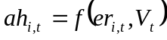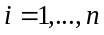

where 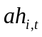 is the area harvested in year for culture group i, 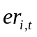the real expected return in year t of culture group i, and V_{t} is a vector of explanatory variables which could have an impact on the considered area harvested. Such variables are the compulsory set-aside rate, the sugar beet and starch potato quota, or the area harvested in year t for another culture group. Total cereal area is assumed to be relatively inelastic with respect to compensatory payments, which are included in the gross market return variable. As earlier mentioned, this gross return is also explained by the expected market returns, which are a three-year weighted average of lagged market prices. Compensation payments are assumed to have a smaller effect on total grains area than the expected market return. The set-aside rate has a negative effect on the area harvested. The equations used to determine the share of specific cultures in total cereal and oilseeds area are written as:

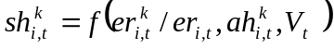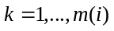

where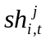 is the share of culture k belonging to culture group i, and 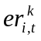is the real expected return in year t of culture k belonging to culture group i, and vector V_{t} of explanatory variables is including the compulsory set aside. The yield equation for each of the crops depends on trend yields, a 5-year moving average of crop prices and the crop area harvested.

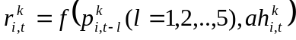

where 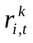and 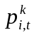 are respectively the yield per hectare and the real market price of culture k belonging to culture group i.
The demand side of the model refers to respectively feed use, food use per capita and crush demand (for the meal, oil and sugar produced, when oilseeds and sugar beets are crushed). The feed demand depends on feed prices and animal production costs, which is a function of the unit production costs and the production quantity.

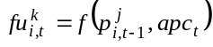

where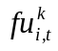 is the feed demand for culture k belonging to culture group i, and apc_{t} stands for animal production costs. Food demand is generally modelled as the per capita demand depending on the own real price, cross prices, and the real GDP.

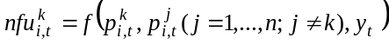

where 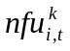 is the food demand for culture k belonging to culture group , and y_{t} is the GDP per capita. Crush or industrial use is written as

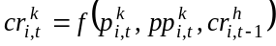

where 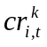 is the crush demand for oilseeds and sugar beets, as well as for the industrial use for potatoes, 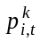 is the real price of oilseeds, sugar beets and potatoes, and 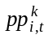 is the real price of commodities produced from oilseeds and sugar beets, namely seed meal and oil from oilseeds and sugar from sugar beets.
Stock level, exports and imports have been specified with the following general functional forms

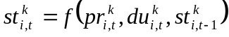
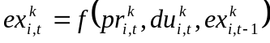
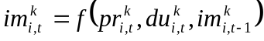

where 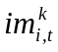, 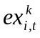 and 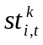 are respectively the ending stocks, exports and imports for culture k belonging to culture group i in year t, 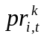 refers to the production, and 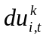 to the total domestic use of culture k belonging to culture group i. As earlier mentioned, whether export or import is chosen as the closing variable to balance supply and demand for each commodity. Thus, only one of both variables will be specified according to the outlined specification, while the other one is calculated from the supply-use identity.
Obviously, our model doesn’t represent a closed economy since other member states and the rest of the world will have important impacts on the Dutch economy modelled. To account for such impacts the model covers price linkage equations to capture the relations between member’s states on the one hand, and between the European Union and the rest of the world on the other hand. For each commodity a member state is considered to be the key market in the EU. The key price is the price to which all national level and EU level prices are ultimately linked. In the case that the Dutch market is not considered as the key market in the EU, the price linkage equation is written as

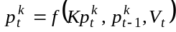

where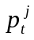 is the Dutch price of culture j in year t, 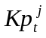is the key price of culture j in year t and V a vector of variables which could have an impact on the Dutch price (like the Dutch self-sufficiency rate and the self-sufficiency rate in the key market). When the Dutch price is considered as the key price, the price linkage equations is written as

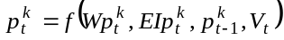

where 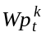 is the corresponding world price of culture k in year t, 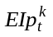 the corresponding European intervention price of culture k in year t and V_{t} is a vector of other explanatory variables, which could have an impact on the Dutch price (like trade ratio quota and subvention export limit).

3. Baseline scenario

3.1 Dutch agricultural sector

After France (21.6%), Italy (16.1%), Germany (15.1%), Spain (12.3%) and the United Kingdom (8.7%) the Netherlands takes the sixth position (with 7.9%) in terms of contribution to EU’s production value. Figures 3.1 and 3.2 address the relative importance of the activities for respectively production value and value added.

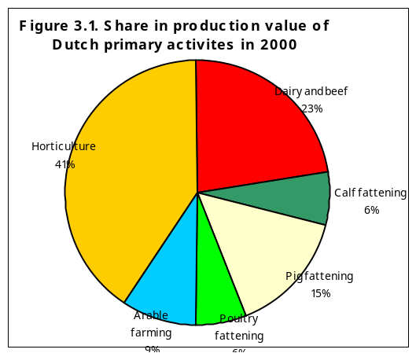
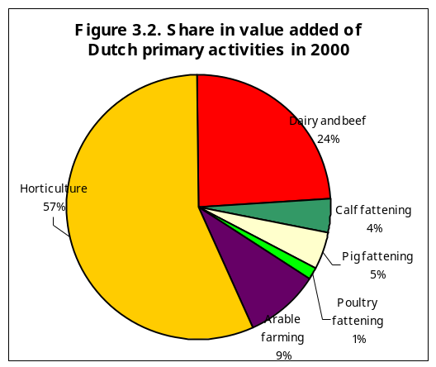

3.2 Assumptions

With a share of 40%, horticulture (vegetables and fruit, plants and flowers, flower bulbs, tree nursery) generates most to the Dutch primary production value. Subsequently, both the dairy and beef farming sector and the intensive cattle farming sectors contribute about one quarter, while the share of arable farming is with 9% rather small. In dairy and beef farming the share of dairy products adds up to almost three quarter, while beef products amounts to the rest. In terms of value added, horticulture generates more than half of the Dutch value in primary industry; a quarter is earned by dairy and beef farming, and around 10% by both intensive cattle and arable farming. Figure 3.3 addresses the importance of arable and horticultural products related to hectare land use. Land use for grains (23%), potatoes (22%), sugar beets (13%) and green fodders (23%) is relatively high in the Netherlands compared with the average EU15, while land use for rapeseeds, olives, cotton and tobacco could be neglected.
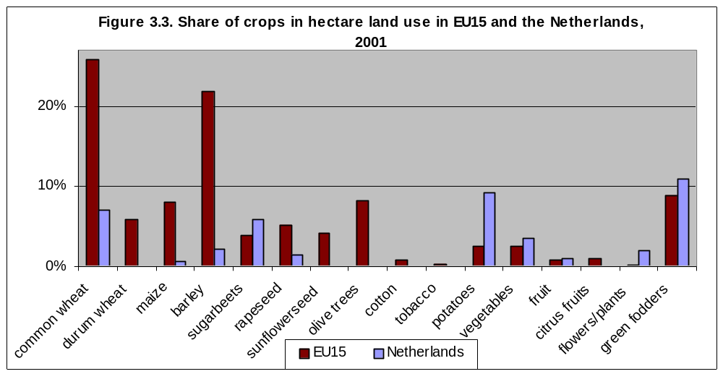

The AG-MEMOD partnership has appointed some ruling conditions for incorporating commodities to the model: CAP should either influence them, or they should be of major importance on the EU level. Horticultural products like vegetables, fruit, plants and flowers, flower bulbs and tree nursery have not been included, because they do not satisfy the conditions. Al in all, the AG-MEMOD commodity list covers 60% and 80% of respectively Dutch and EU agricultural production. The addition of grazing land to AG-MEMOD has been considered as optional to the partners so far. Due to its important role in terms of claiming land and feeding cattle and sheep, we have incorporated grassland in the Dutch model. Herewith, AG-MEMOD covers 85% of total Dutch agricultural land use.

3.2 Assumptions

The baseline simulation is a view of the world where policies remain unchanged. It is generated in order to evaluate the policy change scenario of section 4, and it provides results of the model under assumption of current policy, normal weather and external macroeconomic projections. In order to be helpful for policy debates, the Dutch model includes a set of policy instruments associated with CAP and the GATT-WTO, which can reflect the economic differences with other member states from policy effects. For our baseline projections, we have assumed that all national and international agreements remain in place over the projection period, and that the Agenda 2000 settings will reflect the agricultural policy assumptions. Annex 1 summarizes the policy instruments used in the Dutch model, and presents the whole set of policy assumptions beyond the projections. A second and third set of assumptions in this annex concerns respectively the macroeconomic variables, the key prices and the world prices. Again, the last are the prices to which each national level prices and the EU level prices are ultimately linked. In the grains model the key prices are the associated French prices, while the German prices are determining most of the commodities within the livestock models. The Rotterdam price, which is assumed to reflect the world market price, is linked to the oilseeds model. The FAPRI-model, which is based on the same equation specifications and assumptions as AG-MEMOD, is delivering the forecasts for the world prices (FAPRI-Ireland Outlook, 2003).

3.3 Projections

This section summarizes the Dutch baseline projections for grains, oilseeds, livestock and dairy markets over the period 2002-2012. All crops will show higher yields over the projection period due to rising trend yields (table 3.1). Yield incline for potatoes is relatively low as a result of the sharp rise in the potato area harvested. This is explained through the rationale that the productivity of each additional hectare harvested will be lower. The Dutch total root crop area harvested is projected to rise with 4.8%. Due to higher yields per hectare and the restricted sugar quota, the sugar beet area will decline with 7%, while the potato area is expected to incline with 12% up to 2012. Further, the model shows declines for cereals and oilseeds area harvested due to declining market prices. Concerning grains and oilseeds, soft wheat and maize area harvested would establish relatively small reductions with respectively –0.6% and -1.1% in 2012. This can be explained from their relatively high yields compared to barley and rapeseed yields. Production of durum wheat, soybeans and sunflower seed does not exist in the Netherlands.

Table 3.1 Harvested area, yields, food use, feed use and crush demand of Dutch crops
 | 2002 | 2012 | % | 2002 | 2012 |  | % | 2002 | 2012 | % | 2002 | 2012 | %
 | Area harvested  (1,000 ha) |  |  | Yields  (ton/ha) |  |  |  | Food demand  (1,000 ton) |  |  | Feed/crush demand (1,000 ton)
Soft wheat | 141.5 | 140.6 | -0.6 | 8.5 | 9.9 | 16.8 |  | 3219 | 3613 | 12.2 | 1209 | 1328 | 9.9
Durum wheat | -- | -- | -- | -- | -- | -- |  | 55 | 87 | 56.9 | 3 | 3 | 0.0
Barley | 49.0 | 45.1 | -8.0 | 6.2 | 6.9 | 10.6 |  | 1176 | 1205 | 2.5 | 663 | 543 | -18.0
Maize | 16.8 | 16.6 | -1.1 | 7.4 | 9.0 | 22.4 |  | 1381 | 1446 | 4.7 | 976 | 1156 | 18.4
Rapeseed | 0.9 | 0.7 | -19.2 | 3.4 | 3.7 | 7.0 |  | 141 | 115 | -18.3 | 136 | 110 | -19.0
Sunflower seed | -- | -- | -- | -- | -- | -- |  | 608 | 693 | 14.1 | 601 | 686 | 14.2
Soybean | -- | -- | -- | -- | -- | -- |  | 4352 | 4595 | 5.6 | 4077 | 4320 | 6.0
Potatoes | 176.7 | 198.2 | 12.1 | 45.0 | 46.0 | 2.2 |  | 4300 | 4176 | -2.9 | 769 | 758 | -1.4
Sugar beets | 108.0 | 100.1 | -7.3 | 62.3 | 67.5 | 8.3 |  | 6736 | 6766 | 0.4 | 6629 | 6659 | 0.5

Within the group of grains, the projected change in domestic use is varying from 2.5% for barley, to 12.2% and 56.9% for respectively soft and durum wheat in 2012. Feed use of grains will be stimulated through the sharp incline of the Dutch poultry production. Within the group of oilseeds, soybean and sunflower seed domestic use and crush demand are expected to rise over the projection period (6% to 14%) due to the long-term trend, while rapeseed domestic use and crush demand might decline with 18%. Demand for sugar beets will remain stable, while the processing of potatoes is expected to decline in particular due to higher market prices for potatoes.

Table 3.2 Market prices of Dutch crops (euro/100 kg)
 | Soft wheat | Barley | Maize | Rapeseed | Potatoes | Sugar beets
2002 | 102 | 105 | 117 | 209 | 107 | 50
2012 | 96 | 102 | 108 | 192 | 125 | 49
Change | -6.0% | -3.4% | -7.9% | -8.3% | 17.4% | -0.4%

Table 3.2 presents the evolution of Dutch market prices over the projection period. Developments of soft wheat, barley and maize prices are determined by the French key prices (respectively –6%, –3.4% and –7.9%), while development of the rapeseed price is following the world price. The sugar beet price will remain stable, while the potato price is expected to increase with around 17% over the years 2002-2012. The Dutch potato market is characterized by a production cycle: a price incline in year t-1 is often being followed with a production incline in year t, which on its turn will result in lower prices in year t. Therefore, potato price may fluctuate from year to year.
Concerning the livestock and dairy sectors, the main findings are summarised in the following tables. The livestock supply market will be characterised by drops in cattle and pig numbers (table 3.3). Lower milk prices in future would result in a reduction of the cow herd. Due to environmental requirements, the Dutch government decided to buy-up one million so-called pig rights from producers in the period 2001-2003. From 2003 pig number will be limited to 11,7 million, which will mean a more than 5% reduction over the period 2002-2012. Despite a 10% lower cow slaughtering, total cattle slaughtering will rise with 4% due to the slaughtering of relatively more other cattle (42%) and calves (8%). Compared with other countries, the production of calves is establishing a huge part of total cattle slaughtering in the Netherlands. It must be remarked that the strong incline in beef and veal production is a consequence of the FMD crisis in 2001. Despite the recovery process that has started since the last months of 2001, total cattle slaughtering number was still on a relatively low level in 2002. The long-term development of the Dutch beef and veal production, however, is a declining one. This is reflected in an even 11% lower slaughtering level in 2012 compared to 2000. Sheep slaughtering would increase due to higher inventories, while pigs slaughtering would decrease due to lower inventories.

Table 3.3 Ending stocks and slaughtering of Dutch livestock (1,000 head)
 | 2002 | 2012 | Change | 2002 | 2012 | Change
 | Ending inventories |  |  | Total slaughter
Total cattle | 4281 | 3850 | -10.1% | 1901 | 1981 | 4.2%
Cows | 1559 | 1249 | -19.8% | 649 | 585 | -9.9%
Pigs ¹⁾ | 12371 | 11705 | -5.4% | 16831 | 15255 | -9.4%
Sheep | 1291 | 2007 | 55.5% | 656 | 1157 | 76.5%
¹⁾ Since 2003, Dutch pig number has been limited to a quota of 11,7 million.

Production of respectively beef and veal, poultry and sheep meat are expected to increase over the considered period, while production of pig meat would fall. The sharp rise in beef and veal production is the result of the already mentioned recovery process of the animal crisis in 2001. Sheep slaughtering production is showing a sharp incline over the period 2002-2012 with almost 76%. This is not only due a long-term trend, but the sector will also profit from a better return-cost ratio. Dutch meat market prices will not only be influenced by declining intervention prices, but also through higher self-sufficiency rates. A higher production-consumption ratio will result in lower national prices. The pig meat price would remain stable due to the applied national quota on pig number in the Netherlands (table 3.4).

Table 3.4 Production (1,000 ton) and prices (euro/100 kg) of Dutch meat
 | 2002 | 2012 | Change | 2002 | 2012 | Change
 | Production |  |  | Market price
Beef and veal | 416 | 480 | 15.2% | 287 | 267 | -6.9%
Pig meat | 1475 | 1395 | -5.4% | 144 | 143 | -0.9%
Broiler | 687 | 683 | -0.5% | 59 | 53 | -10.5%
Other poultry meat | 82 | 120 | 46.2% | 59 | 53 | -10.5%
Sheep meat | 17 | 30 | 75.4% | 501 | 448 | -10.6%

The production of butter, skim and whole milk powder would decrease, while the production of cow’s milk would remain constant over the projection period (table 3.5). Profitability of the Dutch cheese production can gain from lower intervention prices of butter and milk powder. The market prices for all dairy products are expected to decline, which is particularly due to declining key prices.
Table 3.5 Production (1,000 ton) and prices (euro/100 kg) of Dutch dairy products
 | 2002 | 2012 | Change | 2002 | 2012 | Change
 | Production |  |  | Market price
Cow's milk | 11236 | 10795 | -3.9% | 32 | 29 | -8.0%
Cheese | 701 | 770 | 9.8% | 339 | 325 | -4.0%
Butter | 118 | 76 | -35.4% | 307 | 248 | -19.3%
Skim milk powder | 40 | 12 | -69.1% | 211 | 193 | -8.6%
Whole milk powder | 90 | 55 | -39.0% | 256 | 223 | -13.1%

Finally, consumption per capita will increase for most commodities considered in the livestock and dairy sectors as a result of lower market prices (table 3.6).

Table 3.6 Per capita consumption of Dutch meat and dairy products (kg)
 | 2002 | 2012 | Change
Beef and veal | 19.4 | 20.4 | 4.9%
Pig meat | 44.1 | 45.5 | 3.0%
Broiler | 17.3 | 19.7 | 13.6%
Other poultry meat | 5.4 | 6.6 | 22.7%
Sheep meat | 1.6 | 2.3 | 42.1%
Cow's milk | 123.6 | 119.7 |  | -3.2%
Cheese | 14.3 | 17.3 |  | 21.0%
Butter | 3.4 | 3.5 |  | 4.1%
Skim milk powder | 9.7 | 6.3 |  | -35.5%
Whole milk powder | 1.1 | 1.2 |  | 9.0%

4. Crop policy scenario

4.1 Development of Dutch crop production

Dutch soft wheat production showed a stable pattern around 120 thousand hectare in the period 1973-2000, while barley production area declined somewhat. Since the MacSharry reforms, maize area has become more attractive and has partly substituted barley (figure 4.1). Under Agenda 2000, the different compensatory payments for grains and oil seeds have been substituted by one – not crop linked – payment. This might reduce the hectare support for oilseed, while EU grain production will benefit from the higher supports. This could be of disadvantage for the major oil seed producers like Germany (rapeseed) and France (sunflower seed), while a direct impact for the Netherlands will be limited. The Dutch oilseed sector is not depending on domestic agriculture: soybeans and sunflower production is zero, while rapeseed production was with 5 mio ton rather small in the nineties (figure 4.2). Actually, the baseline projections in section 3 have supported these kinds of expectations.

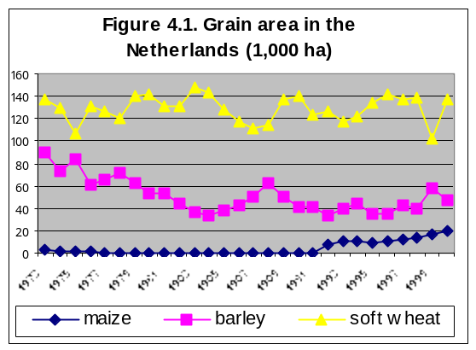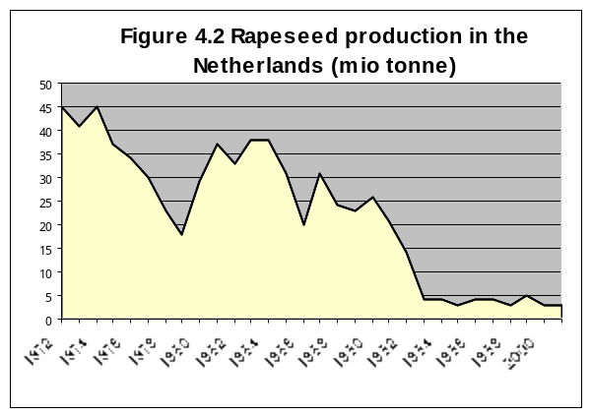

Due to rising yields per area and the quota system of the EU sugar policy regime, Dutch harvested sugar beets area has been declined since the eighties (figure 4.3). The sector is characterized by high guarantee prices that lie far above the world market prices, which makes the sugar beet production a quite attractive crop for Dutch arable farming in terms of income generation. The sugar sector is not only protected in the EU, but also in other WTO countries like the US. Opposition against protection of the sugar sector is growing within the EU from the sugar processing food industry. In their opinion, quota restrictions and the small market growth are limiting their future potentials.
Dutch potatoes land use can be divided into seed potato use (39 hectare in 2000), consumption potato use (84 hectare in 2000) and starch potato use (61 hectare in 2000). The three types have different price levels and different price developments. The starch potato price is lowest and is showing a stable pattern, the consumption potato price is about twice the price for starch potatoes and is showing a quite unstable pattern, while the seed potato price is three or four times the starch potato price and is following an unstable path too. More than 80% of the unprocessed potato export goes to other EU states like Belgium and Germany. Although the Dutch potato sector has lost some of its share in the EU market, the Netherlands is still dominating the world market of seed-potatoes (due to the availability of many races, good organized trade and processing system etc.). The number of processed potatoes has increased further in last years, of which about the half is exported. On the other hand, there are important potato import flows too. Due to land use competition and the already high returns per hectare, the sector has only modest possibilities to expand since the starch potato quota has been introduction in 1995 (figure 4.4).

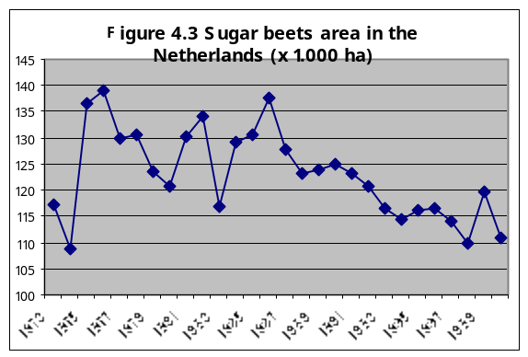
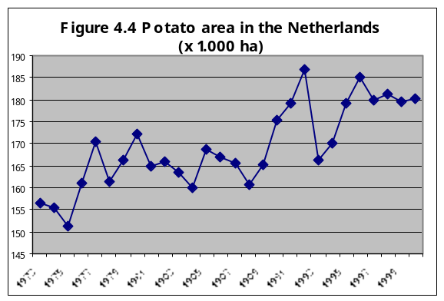

4.2 Assumptions

The behaviour of the Dutch AG-MEMOD model is examined through implementing the elements of the crop reform under the Luxembourg Agreement of 26th June 2003. We have introduced a 75% decoupling of the arable aid payment from 2007. The intervention price for cereals will remain unchanged. Annex 2 captures the new values for both policy and key prices used to generate the crop policy scenario in this section. The cereal key prices have been endogenously generated in the French model (Chantreuil, 2003), and exogenously used in the Dutch model on its turn. All other CAP policy variables and key prices remain the same as under the baseline situation.

4.3 Projections

This section provides the main findings for the Dutch agricultural sector under the crop policy scenario, which are compared with its baseline levels. As the decoupling of direct payments from production will lead to lower returns, this would have negative impacts on respectively cereal and rapeseed area harvested and on its production amounts (figure 4.5). On the other hand, the relative profitability of alternative crops like potatoes and sugar beets will improve. Due to the sugar quota policy, the sugar beet area harvested has less capacity to extent than the potato area harvested (figure 4.6).

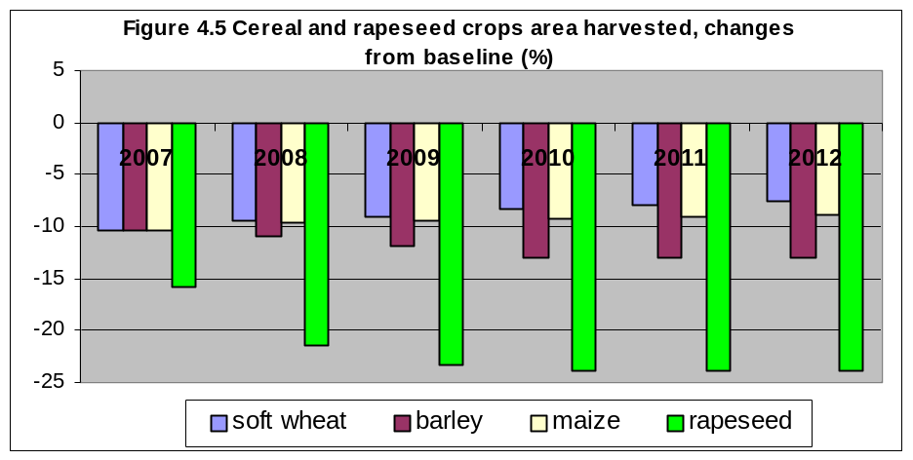

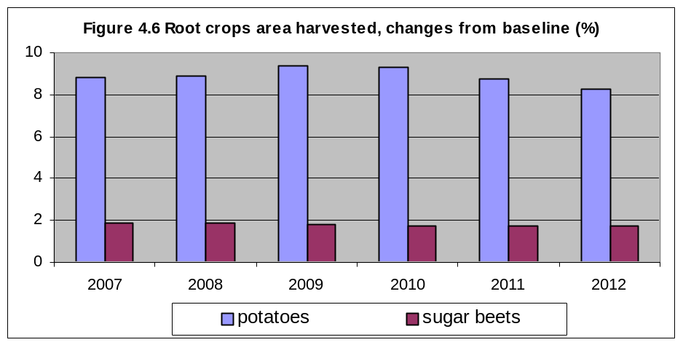

Over the simulation period, cereal yields are improving due to the negative impact for the area harvested. This means that as the area devoted to grains declines, the productivity of the hectares will be higher. On its turn, the additional area harvested to potatoes will reduce the productivity or yield per hectare (table 4.1).

Table 4.1 Yields of Dutch crops, changes in crop scenario from baseline (%)
 | 2007 | 2008 | 2009 | 2010 | 2011 | 2012
Soft wheat | 0.5 | 0.4 | 0.4 | 0.3 | 0.3 | 0.3
Barley | 0.9 | 0.9 | 0.9 | 1.0 | 1.0 | 1.0
Maize | 4.7 | 4.3 | 4.0 | 3.9 | 3.7 | 3.8
Rapeseed | 0.5 | 0.5 | 0.3 | 0.3 | 0.3 | 0.3
Potatoes | -2.7 | -3.0 | -3.3 | -3.3 | -3.2 | -3.1
Sugar beets | 0.2 | 0.1 | -0.1 | -0.1 | -0.1 | -0.1

Domestic use of cereals would remain stable due to the very marginal price changes of these commodities under the crop policy scenario compared to the baseline results (figures 4.7 and 4.8). Dutch prices for soft wheat, barley and maize are for the main part following the French key price developments, which are expected to remain quite stable under the alternative policy scenario (FAPRI-Ireland, 2003). The impact of other explanatory variables on the cereal prices, like the declining Dutch self-sufficiency rates, is less important. Therefore, the changes in the cereal crop sector have just limited impacts on other sectors. Only the demand for potatoes is flighty due to fluctuating prices, while the on average 1.5% higher demand for sugar beets is the result of a lower market price.

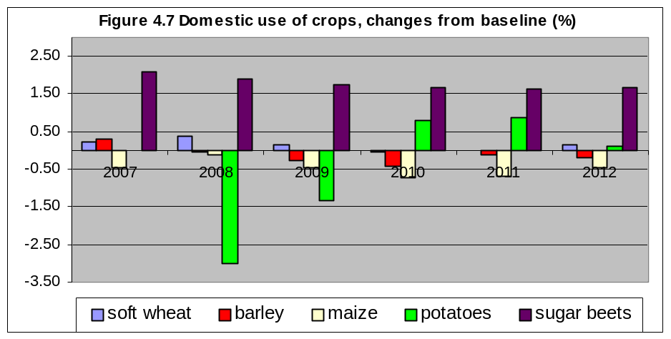

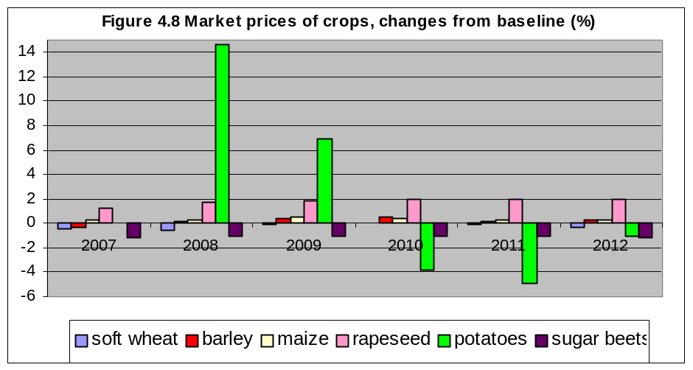

On the longer term, the slaughtering and ending inventories of the sheep sector will establish lower number in the crop scenario compared to the baseline. Relative profitability will get worse due to smaller returns. The development of sheep meat production will be in line with the development of number on sheep slaughtering under the crop policy scenario (figure 4.9). Concerning the other livestock sectors, the effects of the crop policy reform are expected to be not significant.

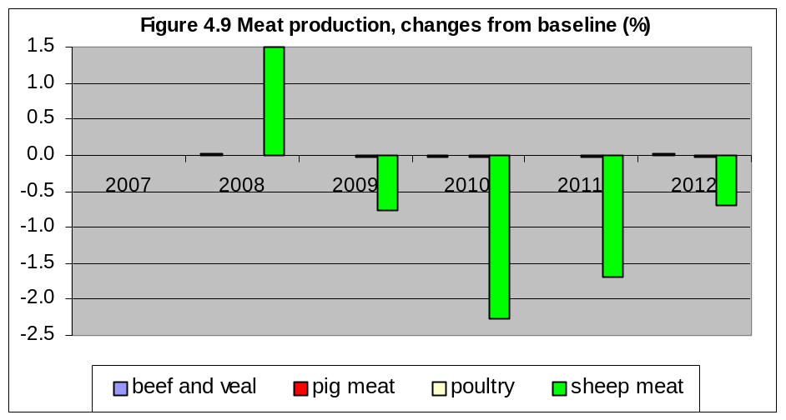

Further, table 4.2 shows that production levels of dairy products are hardly influenced by the crop policy changes. Compared to other EU countries, Dutch cattle is consuming green fodders and grass instead of grains, which could explain the very small influence of changes in grain prices on cattle stocks. As the dairy cow stock will neither be influenced, the production of dairy commodities like cheese, butter and powder will remain quite similar to their levels in the reference scenario too.

Table 4.2 Production of Dutch dairy commodities, changes from baseline (%)
 | 2007 | 2008 | 2009 | 2010 | 2011 | 2012
Cow's milk | 0.0000 | 0.0016 | -0.0009 | -0.0021 | -0.0016 | -0.0011
Cheese | 0.0000 | 0.0034 | -0.0018 | -0.0043 | -0.0033 | -0.0023
Butter | 0.0000 | 0.0003 | -0.0001 | -0.0003 | -0.0003 | -0.0002
Skim milk powder | 0.0000 | 0.0000 | 0.0000 | 0.0000 | 0.0000 | 0.0000
Whole milk powder | 0.0000 | 0.0001 | -0.0001 | -0.0001 | -0.0001 | -0.0001

Except for sheep meat, market prices for meat and dairy commodities are very limited due to very limited production changes. Smaller production levels lead to lower self-sufficiency rates for sheep meat in the alternative scenario, which will incline its market price somewhat (figure 4.10).

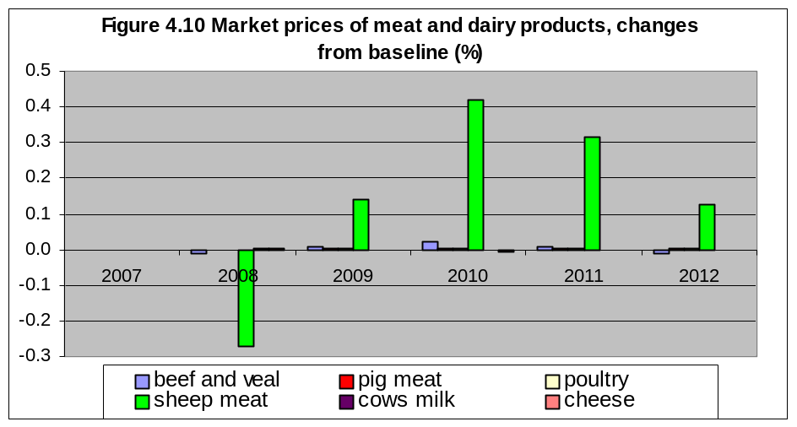

5. Concluding remarks

Our projections were based on the stand-alone Dutch model version of the combined EU AG-MEMOD model. The latest is based on the same set of assumptions and rationales, but is still under construction at the moment of writing. A first goal of this paper was to present some baseline scenario projections for agricultural markets in the Netherlands with the national model. For the baseline scenario, we have assumed that all national and international agreements remian in place over the projection period, and that the Agenda 2000 settings will reflect the agricultural policy assumptions. The most interesting expectations over de period 2002-2012 can be summarized as follows:

- decline in cereals and oilseeds area harvested due to lower market prices;
- force rise in potato area harvested;
- Dutch potato market is a cyclic market: a price incline in year t-1 is often followed with a production incline in year t, which on its turn will result in lower prices in year t;
- sugar beet area harvested is expected to decline with 7% due to higher yields per hectare and the binding sugar beet quota;
- for environmental reasons, the Dutch government is buying-up one million pigs from producers in 2001-03; pig meat production can only improve through growing slaughtering weights;
- poultry production is profiting from lower grain feed prices;
- increase in beef and veal production is particularly a recovery effect from the FMD crisis in 2001; the 2012 beef and veal production is still below the 2000 level;
- cattle and pig stock numbers are falling;
- sheep meat production is relatively small in the Netherlands, but shows a sharp incline due to trend development and a better return-cost ratio.

A second goal of this paper was to get an idea about the behaviour of the Dutch country model on changes in policy variables. We have examined the influence of the crop reform part under the Luxembourg CAP agreement of June 2003 on the agricultural sectors in the Netherlands, and have compared the outcomes with its baseline levels. We found the following results:

- decline of total cereal area harvested due to lower returns;
- cereal production will fall at a smaller rate due to improving yields;
- cereal yields will improve due to a better productivity of the (lesser hectares) land under use;
- relative profitability of potato area harvested may improve compared with that for cereal crops area harvested;
- sugar beet area harvested would incline, but within the bounds of the sugar quota;
- profitability of sheep meat production would deteriorate because the getting worse of the return-cost ratio;
- no production impacts for respectively beef and veal, pig meat and poultry.

We would conclude that the repercussions of the crop reform on the agricultural markets seems to work according to the expected relations as have been implemented in the Dutch AG-MEMOD model. With that respect, the current Dutch version could already be helpful for policy makers.

References

Chantreuil, F. and F. Levert (2003). French agricultural markets under alternative crops common agricultural policy scenario. INRA, November 2003 (draft)

FAPRI-Ireland (2003). Medium Term Analysis for the Agri-Food Sector; Outlook 2003. Dublin.

Leeuwen, M. van, and A.A. Tabeau (2002). AG-MEMOD estimation procedures and results; template for the Netherlands (draft)

Annex 1. Assumptions in Dutch AG-MEMOD model for baseline

Table A1.1 Policy assumptions in baseline scenario
 | 2002 | 2003 | 2004 | 2005 | 2006 | 2007 | 2008 | 2009 | 2010

EU Crop Sector (euro/100 kg)
Common wheat intervention price | 101.3 | 101.3 | 101.3 | 101.3 | 101.3 | 101.3 | 101.3 | 101.3 | 101.3
Barley intervention price | 101.3 | 101.3 | 101.3 | 101.3 | 101.3 | 101.3 | 101.3 | 101.3 | 101.3
Maize intervention price | 101.3 | 101.3 | 101.3 | 101.3 | 101.3 | 101.3 | 101.3 | 101.3 | 101.3
Cereal compensation | 63.0 | 63.0 | 63.0 | 63.0 | 63.0 | 63.0 | 63.0 | 63.0 | 63.0
Oilseed compensation | 63.0 | 63.0 | 63.0 | 63.0 | 63.0 | 63.0 | 63.0 | 63.0 | 63.0
White sugar intervention price | 631.90 | 631.90 | 631.90 | 631.90 | 631.90 | 631.90 | 631.90 | 631.90 | 631.90
Sugar beet basic price | 47.67 | 47.67 | 47.67 | 47.67 | 47.67 | 47.67 | 47.67 | 47.67 | 47.67
Cereal set-aside rate | 10.0 | 10.0 | 10.0 | 10.0 | 10.0 | 10.0 | 10.0 | 10.0 | 10.0
Cereal reference yield | 6.60 | 6.60 | 6.60 | 6.60 | 6.60 | 6.60 | 6.60 | 6.60 | 6.60
Oilseed reference yield | 6.60 | 6.60 | 6.60 | 6.60 | 6.60 | 6.60 | 6.60 | 6.60 | 6.60
Sugar quota A | 684.10 | 684.10 | 684.10 | 684.10 | 684.10 | 684.10 | 684.10 | 684.10 | 684.10
Sugar quota B | 180.40 | 180.40 | 180.40 | 180.40 | 180.40 | 180.40 | 180.40 | 180.40 | 180.40
Starch potato quota | 507.40 | 507.40 | 507.40 | 507.40 | 507.40 | 507.40 | 507.40 | 507.40 | 507.40
Sugar levy on A quota | 2.00 | 2.00 | 2.00 | 2.00 | 2.00 | 2.00 | 2.00 | 2.00 | 2.00
Sugar levy on B quota | 37.50 | 37.50 | 37.50 | 37.50 | 37.50 | 37.50 | 37.50 | 37.50 | 37.50
EU Livestock Sector (euro/100) )kg))
Beef intervention price | 278.0 | 156.0 | 156.0 | 156.0 | 156.0 | 156.0 | 156.0 | 156.0 | 156.0
Butter intervention price | 328.2 | 328.2 | 328.2 | 311.8 | 295.4 | 279.0 | 279.0 | 279.0 | 279.0
SMP intervention price | 205.5 | 205.5 | 205.5 | 195.2 | 185.0 | 174.7 | 174.7 | 174.7 | 174.7
Suckler cow premium | 200.0 | 200.0 | 200.0 | 200.0 | 200.0 | 200.0 | 200.0 | 200.0 | 200.0
Male bovine premium | 210.0 | 210.0 | 210.0 | 210.0 | 210.0 | 210.0 | 210.0 | 210.0 | 210.0
Butter consumption subsidy | 39.7 | 39.7 | 39.7 | 31.8 | 23.8 | 15.9 | 15.9 | 15.9 | 15.9
SMP feed subsidy | 75.0 | 75.0 | 75.0 | 60.0 | 45.0 | 30.0 | 30.0 | 30.0 | 30.0
Ewe premium | 19.3 | 20.9 | 20.0 | 20.3 | 20.7 | 20.9 | 21.0 | 21.0 | 20.8
Milk quota (applied) | 10,991 | 10,991 | 10,991 | 11,046 | 11,102 | 11,157 | 11,157 | 11,157 | 11,157
Suckler cow quota | 63 | 63 | 63 | 63 | 63 | 63 | 63 | 63 | 63
Animal density threshold | 1.9 | 1.8 | 1.8 | 1.8 | 1.8 | 1.8 | 1.8 | 1.8 | 1.8

Table A1.2 Macroeconomic assumptions in baseline scenario
 | 2002 | 2003 | 2004 | 2005 | 2006 | 2007 | 2008 | 2009 | 2010
Real GDP | 429 | 434 | 445 | 456 | 467 | 478 | 490 | 502 | 514
Population | 16.08 | 16.14 | 16.20 | 16.30 | 16.39 | 16.46 | 16.53 | 16.59 | 16.65
GDP deflator | 1.32 | 1.35 | 1.37 | 1.40 | 1.43 | 1.46 | 1.49 | 1.52 | 1.55
Exchange rate vs. $ | 2.35 | 2.25 | 2.10 | 2.01 | 1.95 | 1.92 | 1.92 | 1.92 | 1.92
Exchange rate vs. euro | 2.20 | 2.20 | 2.20 | 2.20 | 2.20 | 2.20 | 2.20 | 2.20 | 2.20

Table A1.3 Key and world prices in baseline scenario
 | 2002 | 2003 | 2004 | 2005 | 2006 | 2007 | 2008 | 2009 | 2010
Key prices (euro/100 kg)
German beef price | 242.9 | 234.1 | 243.6 | 241.6 | 233.3 | 231.2 | 230.0 | 231.5 | 233.2
German pig meat price | 125.0 | 128.6 | 131.7 | 128.7 | 124.0 | 123.4 | 123.1 | 123.2 | 122.4
German chicken price | 132.1 | 127.9 | 130.1 | 128.3 | 125.9 | 124.6 | 123.5 | 122.7 | 121.8
Irish lamb meat price | 151.5 | 140.3 | 137.9 | 135.9 | 134.7 | 135.8 | 135.0 | 134.1 | 133.6
French cheese price | 491.4 | 483.9 | 486.9 | 475.3 | 463.2 | 451.7 | 451.5 | 450.8 | 449.9
German butter price | 314.5 | 303.9 | 303.5 | 289.7 | 275.9 | 262.5 | 260.2 | 258.1 | 255.9
French soft wheat price | 106.9 | 111.3 | 110.9 | 108.6 | 106.8 | 105.7 | 104.6 | 103.7 | 102.9
French barley price | 102.8 | 111.3 | 110.9 | 108.8 | 106.3 | 104.9 | 103.5 | 102.5 | 101.5
French maize price | 117.2 | 118.2 | 118.3 | 116.3 | 114.6 | 112.7 | 111.4 | 110.5 | 109.9
Italian durum wheat price | 165.6 | 149.3 | 153.2 | 151.8 | 151.9 | 150.8 | 151.4 | 151.6 | 152.7
World prices (US$/ton)
Rapeseed price | 272.2 | 271.7 | 272.2 | 271.7 | 272.2 | 271.7 | 272.2 | 271.7 | 272.2
Sunflower seed price | 291.7 | 289.3 | 291.7 | 289.3 | 291.7 | 289.3 | 291.7 | 289.3 | 291.7
Soybean price | 232.8 | 231.8 | 232.8 | 231.8 | 232.8 | 231.8 | 232.8 | 231.8 | 232.8
Rape meal price | 125.6 | 125.6 | 125.6 | 125.6 | 125.6 | 125.6 | 125.6 | 125.6 | 125.6
Rape oil price | 613.5 | 610.4 | 613.5 | 610.4 | 613.5 | 610.4 | 613.5 | 610.4 | 613.5
Sun meal price | 111.7 | 111.3 | 111.7 | 111.3 | 111.7 | 111.3 | 111.7 | 111.3 | 111.7
Sun oil price | 662.1 | 658.2 | 662.1 | 658.2 | 662.1 | 658.2 | 662.1 | 658.2 | 662.1
Soy meal price | 181.8 | 181.4 | 181.8 | 181.4 | 181.8 | 181.4 | 181.8 | 181.4 | 181.8
Soy oil price | 599.8 | 595.5 | 599.8 | 595.5 | 599.8 | 595.5 | 599.8 | 595.5 | 599.8
World sugar price | 227.4 | 232.0 | 227.4 | 232.0 | 227.4 | 232.0 | 227.4 | 232.0 | 227.4

Annex 2. Assumptions in Dutch AG-MEMOD model for crop policy scenario

Table A2.1 Policy assumptions and key prices in crop policy scenario
 | 2002 | 2003 | 2004 | 2005 | 2006 | 2007 | 2008 | 2009 | 2010

Compensations (euro/100 kg)
Cereal compensation | 63.0 | 63.0 | 63.0 | 63.0 | 63.0 | 15.8 | 15.8 | 15.8 | 15.8
Oilseed compensation | 63.0 | 63.0 | 63.0 | 63.0 | 63.0 | 15.8 | 15.8 | 15.8 | 15.8

Key prices (euro/100 kg)
Soft wheat | 106.9 | 111.3 | 110.9 | 108.6 | 106.8 | 105.2 | 104.0 | 103.5 | 102.8
Barley | 102.8 | 111.3 | 110.9 | 108.8 | 106.3 | 104.5 | 103.5 | 102.7 | 101.9
Maize | 117.2 | 118.2 | 118.3 | 116.3 | 114.6 | 113.1 | 111.7 | 111.0 | 110.3
Durum wheat | 165.6 | 149.3 | 153.2 | 151.8 | 151.9 | 164.0 | 161.8 | 161.3 | 162.1

AG-MEMOD stands for Agricultural Modelling of the EU Member States. The research is supported by public funds from the Commission, through the Fifth Framework Programme, and from member states.

