**The Impact of Population Ageing on the Labour Market:**

**Evidence from Overlapping Generations Computable General Equilibrium**

**(OLG-CGE) Model of Scotland** (*)

by

Katerina Lisenkova

National Institute of Economic and Social Research

Marcel Mérette

University of Ottawa

Robert Wright

University of Strathclyde

September 2012

*Abstract:* This paper presents a dynamic Overlapping Generations Computable General Equilibrium (OLG-CGE) model of Scotland. The model is used to examine the impact of population ageing on the labour market. More specifically, it is used to evaluate the effects of labour force decline and labour force ageing on key macro-economic variables. The second effect is assumed to operate through age-specific productivity and labour force participation. In the analysis, particular attention is paid to how population ageing impinges on the government expenditure constraint. The basic structure of the model follows in the Auerbach and Kotlikoff tradition. However, the model takes into consideration directly age-specific mortality. This is analogous to “building in” a cohort-component population projection structure to the model, which allows more complex and more realistic demographic scenarios to be considered.

JEL Classification: J11

Keywords: CGE modelling, population ageing, Scotland

(*) Financial support from the Economic and Social Research Council under the grant: “*Developing an OLG-CGE Model for Scotland”*,through the Centre for Population Change, is gratefully acknowledged. Corresponding author: Robert E. Wright, Department of Economics, University of Strathclyde, 130 Rotterow, Glasgow, Scotland, UK, G4 0GE, tel: +44 (0)141-330-5138, email: r.e.wright@strath.ac.uk.

**The Impact of Population Ageing on the Labour Market:**

**Evidence from Overlapping Generations Computable General Equilibrium (OLG-CGE) Model of Scotland**

**1. Introduction**

There is considerable interest in the impact of population ageing on economic growth. Population ageing is the shift in the age distribution away from younger age groups (e.g., <20) to older age groups (e.g., 65+), which is caused mainly by long-term below replacement fertility. There are a variety of mechanisms by which population ageing can impact on economic growth and the macro-economy in general (see Borsch-Supan 2003; Weil, 1997). The predominant view is that an ageing population will support lower economic growth because the 20-64 age group gets “squeezed”, leading to low (or negative) rates of labour force growth. In addition, population ageing causes a shift away from investment to consumption since government expenditure tends to increase to meet the increased demand for pensions and other old age-related benefits (such as health care). The populations of many high-income countries are ageing very rapidly, and there is some doubt that standard of living increases can be sustained.

This paper examines the impact of population ageing on macro-economic performance using a computable general equilibrium (CGE) model. A CGE model is mathematical description of an economy using a system of simultaneous equations. As in other general equilibrium models, it is assumed that all the markets, sectors and industries are modelled together with corresponding inter-linkages (unlike “partial equilibrium” models). CGE models tend to be very complex and thus cannot be solved analytically. They are therefore calibrated to “real world” data and rely on solver algorithms that find numerical solutions satisfying all of the model’s equations. CGE models are very flexible, and can be used to analyse the macro-economic effects of variety of economic shocks and policies (see Burfisher, 2011; Dixon and Jorgenson, 2012; Fossati and Wiegard, 2001; Hosoe, Gasawa and Hashimoto, 2010).

It is therefore not surprising to find that CGE models have been used to evaluate the impact of population ageing (see Bommier and Lee, 2003; Borsch-Supan, Ludwig and Winter, 2006; Fougère and Mérette, 1999; Fougère, Mercenier and Mérette, 2007; Fougère et al., 2004). The type of CGE model that is best suited to demographic research has an overlapping generations (OLG) structure, introduced by Auerbach and Kotlikoff (1987). An OLG-CGE model is based on an infinite time horizon and inter-temporal optimisation. The household sector consists of several generations living alongside each other at any point in time. In each period the oldest generation “dies”, a new youngest generation is “born” and all the generations in-between become a period older. From a demographic point of view, an OLG-CGE model more explicitly allows the interaction of age effects. This is a clear advantage since age is usually a critical variable in the understanding of demographic behaviour.

This paper builds on the recent work of Lisenkova et al. (2010), who used a CGE model of Scotland (AMOS) to evaluate the impact of population decline and labour force decline on output and a series of other key macro-economic variables. The Scottish context is of particular interest since population decline and labour force decline are not unlikely in the future given past demographic trends. This paper extends their analysis through the use of an OLG-CGE model that is more sensitive to ageing effects. More specifically, two main mechanisms are considered. The first is through the government expenditure constraint. The idea being that population ageing will put significant upward pressure on per-capita government expenditure. The second is through labour force ageing. If workers of different ages are not perfect substitutes, then labour force ageing will have an effect on per-worker productivity.

The model is in the Auerbach and Kotlikoff (1987) tradition and introduces age-specific mortality following Borsch-Supan et al. (2006). It incorporates vatiation in life expectancy variation with a perfect annuity market, through which unintentional bequests are implicitly distributed. The theoretical description of this approach was first presented in Yaari (1965). This modification allows precise replication of the population structure from the population projections and dramatically improves the accuracy of demographic shocks.

The remainder of this paper is organised as follows. Section 2 outlines the structure of the model. Section 3 discusses how the model is calibrated and gives the data sources. A series of simulations are carried out in Section 4. Conclusions follow in Section 5.

**2. The Model**

The OLG model that we have built should be able to analyse the Scottish long-term economic and labour market implications of ageing in a context of its tight fiscal relationship with the rest of UK. It is therefore composed of two regions: (1) Scotland and the (2) rest-of-the-UK (RUK). Scotland is a small open economy and is specified with detail in the numerical model. The RUK is not explicitly modelled and present to close the government budget and close the current account of Scotland. In the following we describe some aspects of the production, household and government sectors, the PAYG pensions systems, and the trade and transfers between the two regions. We also describe the demographic process which is superimposed on the OLG model and which provides the exogenous shock or driving force behind the simulations results. A more technical description of this type of model and calibration is given in Mérette and George (2010).

**2.1 The Production Sector**

In each region *j*, a representative firm produces at time *t* a single good using a Cobb-Douglas technology. The firm hires labour and rents physical capital. Both factors are region specific. With  representing output,  physical capital,  effective units of labour, *A* a scaling factor and *α* the share of physical capital in value added, a region specific production function is:

(1) 

Firms are assumed to be perfectly competitive and factor demands follow from profit maximization:

(2) 

(3) 

where  and  are the rental rates of capital and wages, and  is the output price.

Labour is distinguished by four skill levels, high-skilled, medium-skilled and low-skilled workers, plus non-working individuals denoted by the binary index of skills *qual*. Therefore, firms also disaggregate their demand for labour *Lj,t* into a demand for skills based on a constant-elasticity-of-substitution (CES) function:

(4) 

where *wqual* is the wage rate for a specific type of skills, and and are respectively share of skill levels and substitution-elasticity parameters. It follows from optimization that the *composite* wage rate  of the firm’s aggregate labour input is related to market wages *wqual* by the following expression:

(5) 

**2.2 Household Behaviour**

Scotland is represented by 21 representative households in an Allais-Samuelson overlapping generations structure. Individuals enter the labour market at the age of 20, retire (on average) at the age of 65, and die at the latest at age 104. We classify generations into twenty-one age groups {*g*, *g*+1, *g*+2,…, *g*+20} (i.e., 0-4, 5-9, 10-14, 15-19, …100-104 age groups). Younger generations (i.e., 0-4, 5-9, 10-14, 15-19) are fully dependent on their parents and play no active role in the model, but they influence the age dependent components of public expenditure (health and education). An exogenous age and time-variable survival rate determines life expectancy.

A household’s optimization problem consists of choosing a profile of consumption over the life cycle, in order to maximize a CES type inter-temporal utility function of consumption, subject to discounted lifetime income. Inter-temporal preferences of an individual born at time *t* are as follows:

(6) 

with 0 < *θ* < 1. *C* denotes consumption;  is the pure rate of time preference and *θ* is the inverse of the constant inter-temporal elasticity of substitution. The future consumption is discounted by the probability of survival up to the age *g+k* represented by the term , where *srt+k,g+k* is an age and time variable survival rate between periods *t+k* and *t+k+1* and ages *g+k* and *g+k+1*. The household is not altruist, that is, it does not leave bequests to its children in this simple framework. Each period in the model effectively corresponds to 5 years and a unit increment in the index *k* represents both the next period *(t+k)* and, for this individual, a shift to the next age group (*g+k*).

Assuming no borrowing constraints and perfect capital markets, the present value of household wealth is the discounted sum of labour income received at each period of time, , over lifetime, taking into consideration the survival rate :

(7)



where *Ri* is the rate of return on physical assets (defined later on in equation (12) with respect to the rental price of capital), *τK* the effective tax rate on capital, *τL*the effective tax rate on labour, and *Ctr* the contribution to the public pension system. Labour income is defined as:

(8) 

where *LSqual* is the exogenous supply of a specific type of skills estimated based on the *Labour Force Survey* (see next section). We assume that skills dependent labour income is a function of the individual’s age-dependent productivity (earnings) profile (*EPj,qual,g*) itself defined as a quadratic function of age:

(9) , *γ, λ, ψ* ≥ 0

with parametric values estimated based on the *Labour Force Survey* (see next section). Retirees’ pension benefits are assumed to be the same across all generations and qualification groups and stay constant in real terms. Differentiating the household utility function with respect to its lifetime budget constraint yields the following first-order condition for consumption:

(10) 

where  is the consumption price index.

## 2.3 Investment and Asset Returns

The accumulation of Scotland’s capital stock (*Kstock*) is subject to depreciation:

(11) 

where *Inv* represents investment and *δ* the depreciation rate of capital.

Financial markets are fully integrated. This means that financial capital is perfectly mobile across regions and undifferentiated so that interest rate parity holds. Let us denote by *Ri* the rate of return on physical assets; it is defined as the rental rate minus the depreciation rate, plus capital gains:

(12) 

**2.4 Government Sector**

The Scottish Government receives transfers from the UK government (*UKTRF*) and interest income from its assets (*GA*). Consequently its budget constraint is defined as:

(13)

where, *τC* is the effective tax rate on consumption, *GovE* is public expenditures on education, *GovH* is public expenditures on health care and *Gov* is public expenditures on other sectors. The left hand side of the equation shows tax revenues from different sources, the interest income from government assets and the transfers received from the UK government. The right hand side of the equation refers to government expenditures and transfers to households. Note that the representative household of generation *g* at time *t* in *j* represents a specific cohort of size and the size of each cohort must be taken into account when computing total tax revenues and transfers to household in a specific period of time. The size of the cohort itself is exogenously given by the two demographic processes—fertility and mortality. Note as well that the pension program is part of the overall government budget.

Public expenditures on health and education are age-dependent. They are held fixed per person of specific age. More specifically, *ASHEPCg* is age-specific health expenditure per-person and *ASEEPCg* is age-specific education expenditure per-person. Therefore, total public expenditure in these categories depends not only on the size of the population but also on the age structure:

(14) ${GovH}_{j,t}=\sum_{g}{{Pop}_{j,t,g}{ASHEPC}_{g}}$

(15) ${GovE}_{j,t}=\sum_{g}{{Pop}_{j,t,g}{ASEEPC}_{g}}$

Other types of public expenditures, *GEPC,* are assumed to be age invariant. That is they are fixed per person and total expenditure, *TPop,* depends only on the size of the total population.

(16) ${Gov}_{j,t}={TPop}_{j,t} {GEPC}_{j}$



**2.5 Market and Aggregation Conditions**

The model assumes that all markets are perfectly competitive. The equilibrium condition for the goods market is that Scotland’s output, added to return on foreign assets (FA) and transfers from RUK must be equal to total demand originating from consumption, investment and government spending:

(17)

Labour and physical capital are immobile across regions, so a market exists for these two production factors in each region. The demand for labour of a specific skill is equal to the supply of this skill:

(18) 

and the stock of capital accumulated at a point in time in period *t* in region *j* is equal to the demand expressed by firms:

(19) 

The capital market must be in equilibrium, that is, the total stock of private wealth (*Lend*) and government assets (*GA*) accumulated at the end of period *t* must be equal to the value of the total stock of capital and foreign assets at the end of *t*:

(20) 

Note that the current account of region *j* can be derived from this model as the difference between national savings and domestic investment:

(21)

Alternatively, the current account is either given as the trade balance plus the interest revenues from net foreign assets holdings, or as the difference between nominal GNP (GDP including interest revenues on net foreign assets) and domestic absorption.

**2.6 Demographic Process**

As mentioned above, the population is divided into 21 generations or age groups (i.e., 0-4, 5-9, 10-14, 15-19, …100-104). In the model, population projections represent an exogenous shock. In other words, demographic variables such as fertility, mortality (life expectancy) and net-migration are assumed to be exogenous. This is a simplifying assumption given that such variables are likely endogenous and affected by, for example, differences in economic growth.

The size of the population of a generation or an age group *g+k* in period *t* is given by two laws of motion:

(22) ${Pop}_{j,t,g+k}=\left\{\begin{aligned}{Pop}_{j,t-1,g+k}{ fr}_{j,t-1} for k=0 \\ {Pop}_{j,t-1,g+k-1 }{sr}_{j,t-1,g+k-1} for k∈\left[1,20\right]\end{aligned}\right.$

The first law of motion simply implies that the number of children (age group *g+k = g*, i.e. age group 0-4) born at time *t* is equal to the size of the preceding generation multiplied by the “fertility rate”, *fr*, in period *t-1*. If every couple on average has two children, the fertility rate is approximately equal to 1 and the size of the young generation *g* at time *t* is approximately equal to the size of the preceding generation. The second law of motion gives the size of any age group *g+k* beyond the first generation, *g*, as the size of this age group a year ago and an age specific conditional survival rate, *sr.* In this model survival rates vary across time and age. For the final generation (*k*=20), the age group 100-104, the conditional survival rate is zero. This means that for the oldest age group at the end of the period, everyone dies with certainty.

Time variable fertility and time/age variable survival rates are taken directly from the population projection. This allows precise modelling of the population structure within the model. This is a unique feature of this model that makes it ideal for study of the impacts of demographic shocks.

**3. Calibration**

The model is calibrated using 2006 data for Scotland (where available). This year is chosen to avoid the effects of the financial crisis, which had a strong negative impact on the performance of the Scottish economy and government finances. Data on public finances and GDP are taken from *2006-07 Government Expenditure and Revenue Scotland Report* (GERS) (Scottish Government, 2008). We use the estimate that assumes that North Sea revenues are distributed based on geographical share. Effective wage income and consumption tax rates are calculated based on the corresponding government revenues category. The total amount of pensions and other transfers is from the *Department of Work and Pensions, Benefit Expenditure by Country, Region and Parliamentary Constituency*. Age-earnings profiles by qualification, age-specific labour force participation rates and distribution of the labour force by qualifications are calculated from the *Quarterly Labour Force Survey* (QLFS) (Q1:2008, Q1:2009 and Q1:2010).

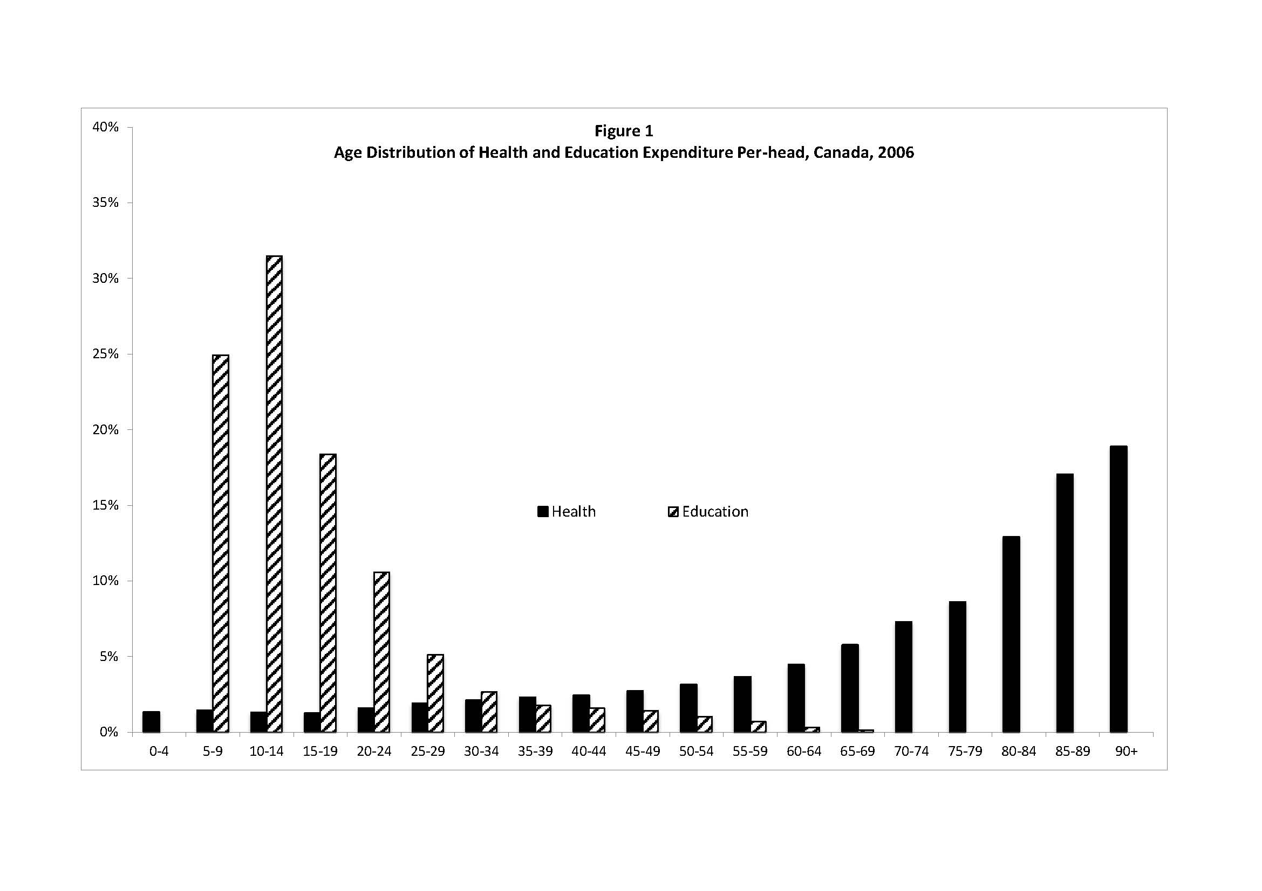

There are no Scotland specific estimates of the age structure of government spending on health and education. The estimates used are from the *Canadian National Transfer Accounts* (see Zhang and Mérette, 2011). Figure 1 shows the age profiles of public spending on health and education in Canada in 2006. The majority of education spending occurs between the ages 5-9 and 20-24. Health spending grows slowly until the age of 55-59 when it starts increasing much faster and accelerates after age 75-79. One would expect the “shape” of the Scottish profile to be similar.

Capital share of the output (*α*) is set to 0.3. The (5-year) intertemporal elasticity of substitution (*1/γ*) is set to 1.5. The (5-year) rate of time preference is solved endogenously in the calibration procedure in order to generate realistic consumption profiles and capital ownership profiles per age group, for which no data are easily available. The rate of time preference and the intertemporal elasticity of substitution together determine the slope of the consumption profiles across age groups in the calibration of the model (when the population is assumed to be stable). This is also the slope of the consumption profile of an individual across his lifetime in the simulated model in the absence of demographic shocks.

**4. Results**

The baseline demographic scenario is the “official” 2010-based principal population projection for Scotland (National Records of Scotland, 2011). This projection is summarised in Figure 2 which shows the growth rates of key age groups. According to this projection, by 2106 total population will increase by 22%, the pension age population (65+) will increase by 127%; the children/youth population (<20) will stay constant and the working age population (20-64) will stagnate during this period with an increase of 1%. It is clear from this projection that significant population ageing is expected.

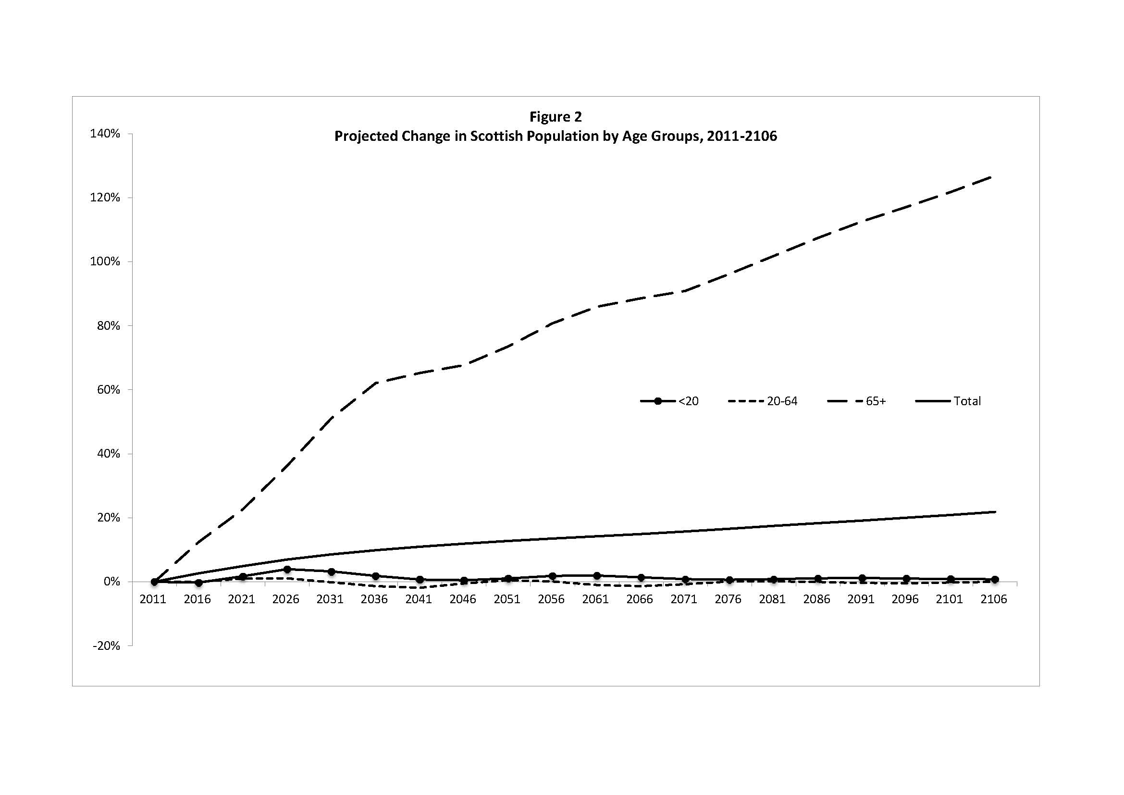

Population ageing in an OLG model results in the accumulation of assets because older generations are relatively asset “rich” compared to younger generations. This leads to an increase in the level of capital stock. At the same time, Scotland will experience little increase in its efficiency-adjusted labour force, which is the population adjusted for age-specific labour force participation rates and age productivity profiles. This accumulation of capital will produce an increase in output. This is shown in Figure 3, which shows the simulated changes in capital (capital stock), labour (productivity-adjusted labour force) and output (GDP). The figure presents clear evidence of the capital accumulation leading to capital deepening. The simulated change in output over the period is 3.8%. This growth is almost totally driven by changes in capital with labour only making a minor contribution.

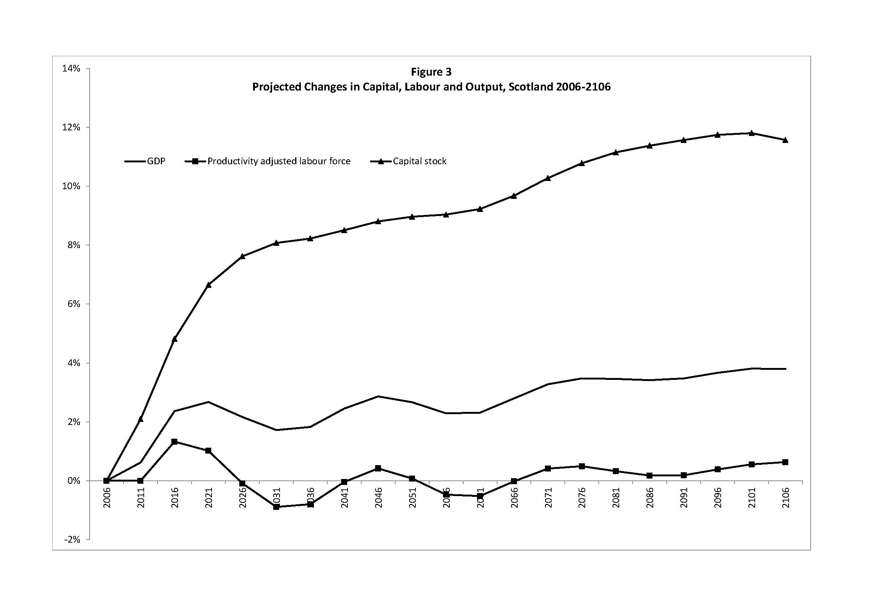

As mentioned above, in the model public expenditures are disaggregated. Two components of expenditures are assumed to be age-dependent—health-related and education-related expenditures. The remaining components of public expenditures are assumed to grow proportionally to total population leaving spending per-capita unchanged over time. Age-dependent public expenditures are assumed to stay the same per-person of specific age. Therefore, as the age structure of the population changes, the total age-dependent public consumption categories also change. With population ageing, the number of individuals eligible for public pensions increases. It is assumed that the pension amount per-person is constant so government expenditures on pensions will increase.

The evolution of various components of public expenditures is shown in Figure 4. The figure shows that age-independent government expenditures increase at the same rate as the total population. Likewise, government expenditures on pensions increase at the same rate as the population aged 65+. Health-related expenditures increase at a rate greater than the increase in the total population because health spending per-person is higher at older ages (see Figure 1). Education-related expenditures increase more slowly than the total population because it is concentrated in the younger ages. A key finding is that the model suggests that government expenditures will grow during the next century at a rate twice as fast as the growth rate of the total population and over eleven times as fast as the growth rate of GDP. It is worth noting that this assumes that spending per-person of a specific age is constant.

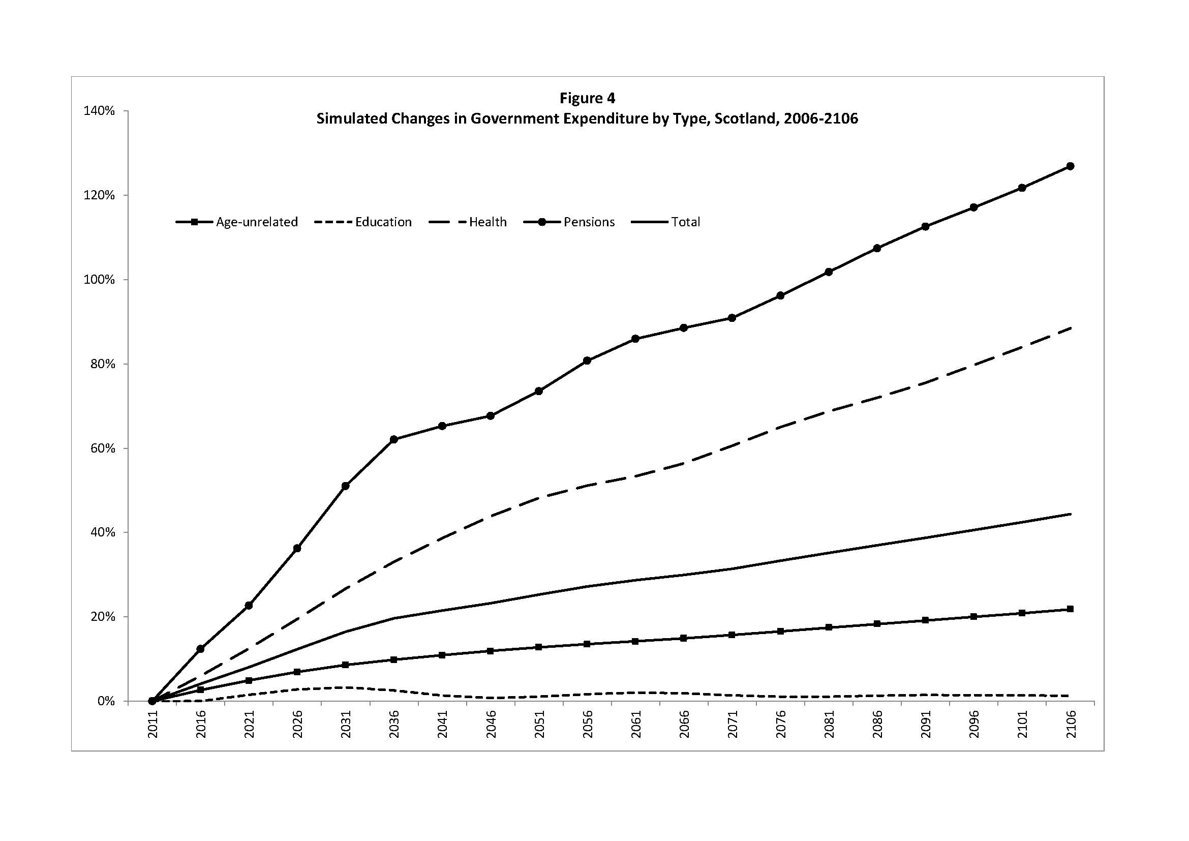

Scotland will not be able to finance this high level of public spending by local taxes. For the baseline scenario we assumed that this deficit is financed by an external transfer. Under the current level of taxes and age-specific public spending per person, the deficit increases from 2.5% of GDP in 2006 to 19% of GDP in 2106. If we assume that the increase in pension payments will be financed by an increase in the pension contribution rate, then the deficit in 2106 reduces to 14% of GDP with the contribution rate increasing from the current effective rate of 6.8% of wage income to 14.7%.

The output effects of population ageing can be decomposed into two components. The first component can be considered to be a “size” or “scale” effect. This consists of the effects generated by changes in population size and changes in the size of key population groups. For example, the size of working age population relative to non-working population (i.e. the support ratio) or the size of population aged 65+ relative to the total population. The second component consists of what can be termed “age-specific effects”. These effects are generated by individual behaviour, productivity and consumption that depend on age. The model has three main age-specific features. The first is age-specific labour force participation rates. The second is age-specific productivity. The third is age-specific government spending on health and education. It is also worth noting that consumption is also age-specific, and it is calibrated to fulfil household optimisation problem and to match aggregate consumption data. These age-specific features of the model (with the exception of consumption) can be “switched on or off” in order to evaluate their relative importance.

Figure 5 reports simulated changes in output with and without age-specific effects. When age-specific effects are not taken into consideration, the change in output is lower, indicating that growth is affected by the inclusion of age-specific labour force participation rates and age-specific productivity profiles. The inclusion of these effects changes the size of productivity-adjusted labour force and the rate of capital accumulation by households.

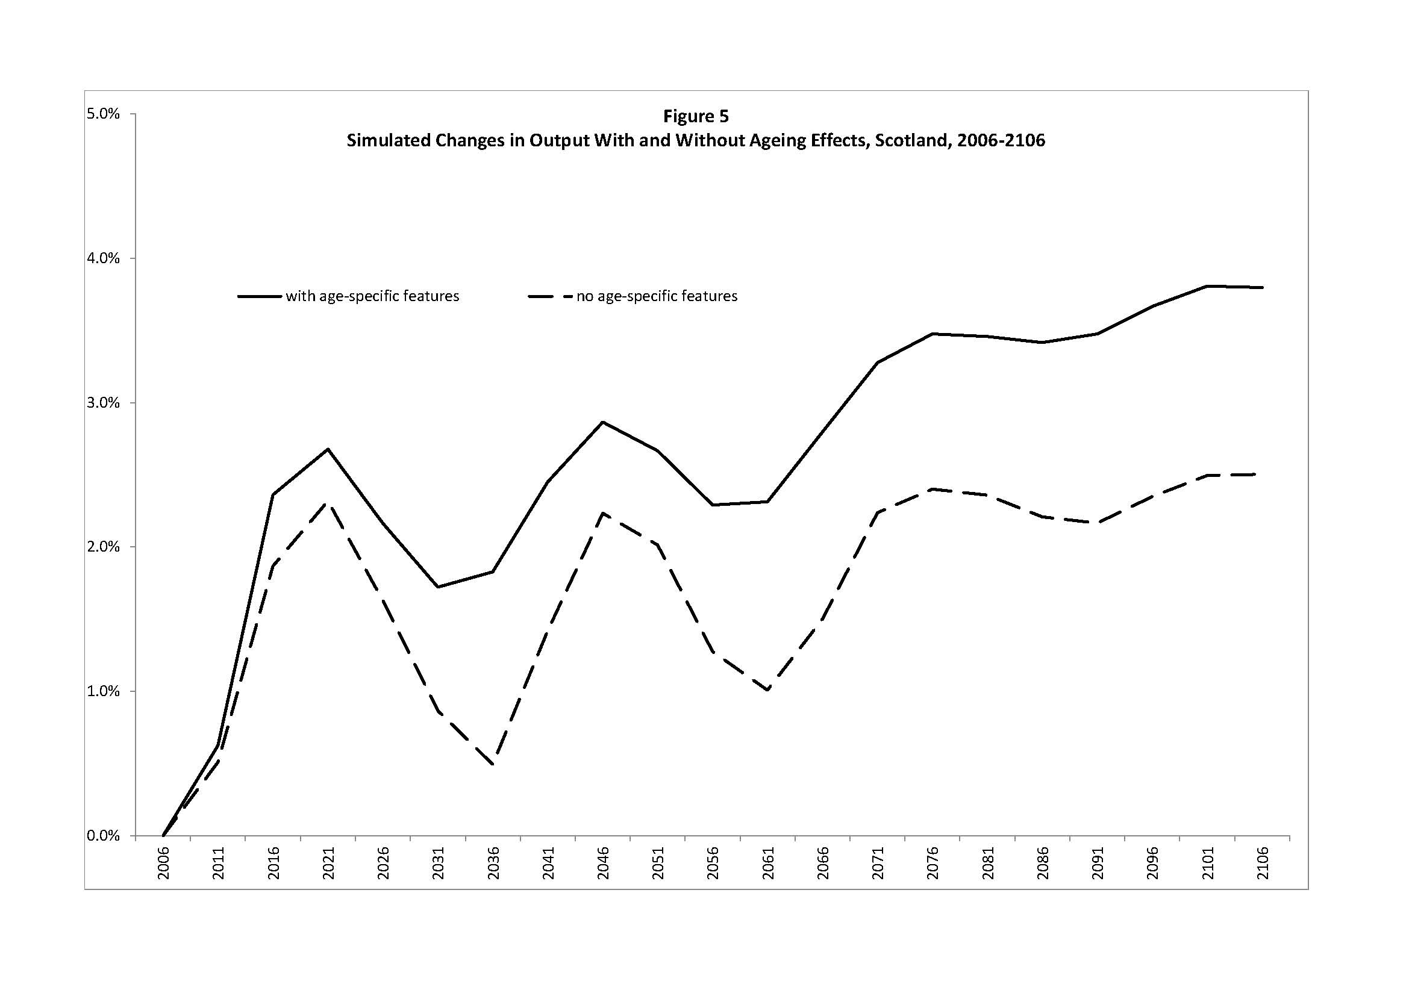

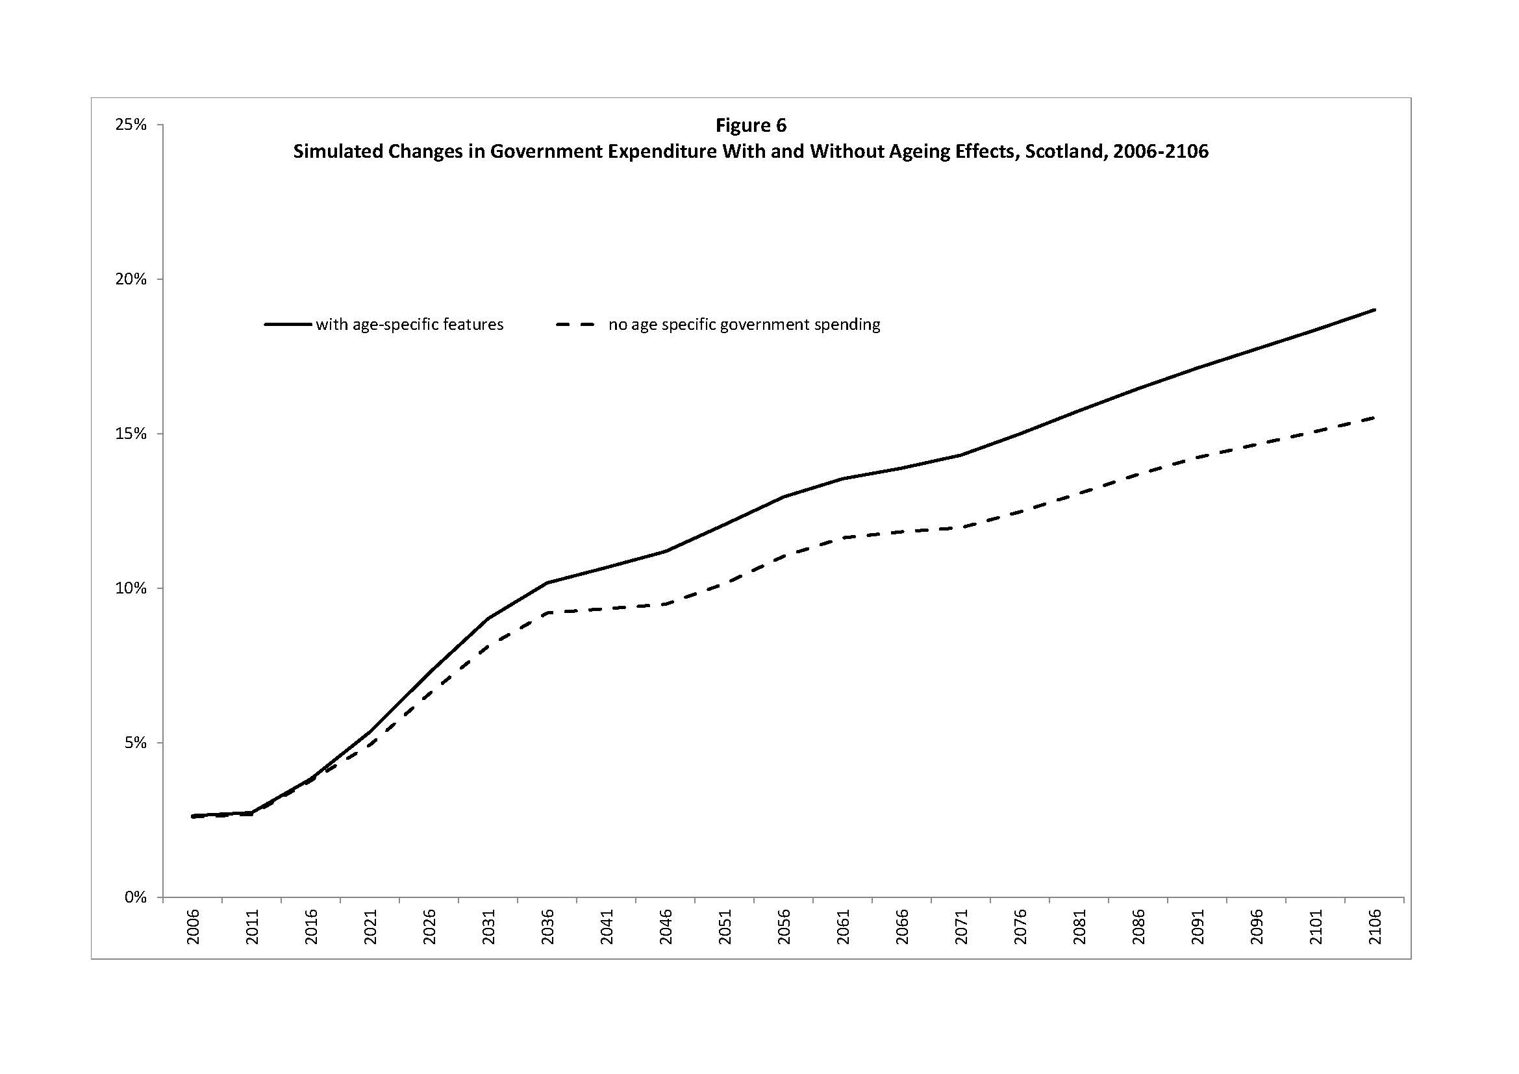

Figure 6 shows the simulated changes in government expenditure with and without age-specific effects. When age-specific effects are not taken into consideration, the change in government expenditures is smaller. As discussed above, the level of government expenditures is affected by the three age-specific features of the model. This suggests that failure to include age-specific effects leads to an under-estimation of the impact of population ageing on public expenditures and the level of public debt.

Finally in order to consider the possible welfare implication of the analysis, Figure 7 shows simulated changes in output per-person (i.e. GDP per-capita). Output per-person is calculated with and without age-specific effects. For both cases, output per-person declines, with the decline being slightly smaller when age-specific effects are taken into consideration. The simulation suggests a reduction in output per-person above 15 per cent over the next 100 years, which corresponds to a considerable welfare loss.

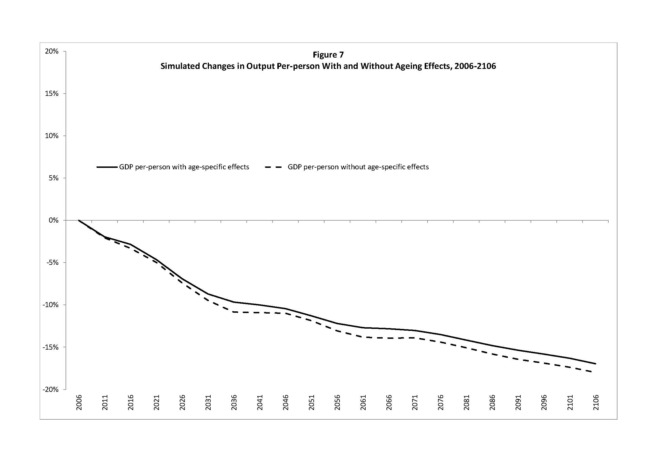

**5. Conclusions**

This paper developed an overlapping generations (OLG) computable general equilibrium (CGE) model in order to evaluate the macro-economic impacts of population ageing in Scotland. The model is particularly well suited to this task since its OLG structure explicitly allows for the incorporation of ageing effects related to age-specific labour force participation, age-specific productivity differences and age-specific government expenditures. Population ageing is also associated with lower output per-person suggesting that it is welfare reducing. This loss is less prominent when age-specific effects are modelled explicitly.

**References**

Auerbach, A. and L. Kotlikoff, (1987), *Dynamic Fiscal Policy*, Cambridge, Cambridge University Press

Bommier, A. and R.D. Lee, (2003), “Overlapping Generations Models with Realistic Demography”, *Journal of Population Economics*, vol. 16, pp. 135-160

Borsch-Supan, A., A. Ludwig and J. Winter (2006), “Aging, Pension Reform and Capital Flows: A Multi-Country Simulation Model”, *Economica*, vol. 73, pp. 625-658

Borsch-Supan, A., (2003), “Labour Market Effects of Population Ageing”, *Labour*, vol. 17 (Special Issue), pp. 5-44

Burfisher, M.E., (2011), Introduction *to Computable General Equilibrium Models*, Cambridge University Press, Cambridge

Dixon, B. and D. Jorgenson, (2012), Handbook of *Computable General Equilibrium Modelling,* North Holland, Amsterdam

Fossati, A. and W. Wiegard, (2001), *Policy Evaluation with Computable General Equilibrium Models*, Routledge, London

Fougère, M. and M. Mérette, (1999), “Population Ageing and Economic Growth in Seven OECD Countries”, *Economic Modelling*, vol. 16(3), 411-27

Fougère, M., J. Mercenier and M. Mérette, (2007), “A Sectoral and Occupational Analysis of Population Ageing in Canada Using a Dynamic CGE Overlapping Generations Model”, *Economic Modelling* vol. 24, pp. 690-711

Fouugère, M., S. Harvey, M. Mérette and F. Poitras, (2004),“Ageing Population and Immigration in Canada: an Analysis with a Regional CGE Overlapping Generations Model”, *Canadian Journal of Regional Science*, vol. 27, no. 2, pp. 209-236

Hosoe, N., K. Gasawa and H. Hashimoto, (2010), *Textbook of Computable General Equilibrium Modeling: Programming and Simulations*, Plagrave Macmillan, London

Lisenkova, K., P. McGregor, RE. Wright and others, (2010), “Scotland the Grey: A Linked Demographic-CGE Analysis of the Impact of Population Ageing and Decline”, *Regional Studies,* vol. 44, no. 10, pp. 1351-1368

Mérette, M. and P. Georgres, (2010), “Demographic Changes and Gains from Globalisation: An Analysis of Ageing, Capital Flows and International Trade”, *Global Economy Journal*, vol. 10, no. 3, art. 3

National Records of Scotland, (2011), *Projected Population of Scotland (2010-based). National Population Projections by Sex and Age, with UK and European Comparisons*, National Records of Scotland, Edinburgh

Scottish Government, (2008), *2006-07 Government Expenditure and Revenue Scotland,* Scottish Government, Edinburgh

Weil, D., (1997), “The Economics of Population Ageing”. In: M. Rosenzweig and O. Stark, (eds.), *Handbook of Population Economics*, Volume 1B, North Holland, Amsterdam

Yaari, M. E., (1965), “Uncertain Lifetime, Life Insurance, and the Theory of the Consumer”, *Review of Economic Studies*, vol. 32, pp. 137-160

Zhang, and M. Mérette, (2011), “National Transfer Accounts: The Case of Canada”, manuscript, University of Ottawa, Ottawa