Who benefits from climate investments? It depends.

Ulrike Lehr^{1,*}, Markus Flaute¹ , Malte Oehlmann², Ralph Büchele³, Patrick Andrae³
¹ Gesellschaft für Wirtschaftliche Strukturforschung mbH, Osnabrück, Germany, ²adelphi, Berlin, Germany, ³Roland Berger, Berlin, Munich, Germany
* Corresponding author. Tel: +4954140933280, Fax: +4954140933110, E-mail: lehr@gws-os.com

Abstract
Climate change mitigation, if taken seriously as agreed on COP 21 in Paris, will necessitate large sums to be spent on efficiency, renewables, and transformation of our infrastructure. Apart from the obvious benefits of less global warming, the question raised in this contribution extends to the economic benefits from this investment in an economy with large industrial production, shrinking population and increasing tightness on the labor market. The question is not so much “who pays?” but “who benefits?”
The answer depends on the climate change mitigation investment studied and on the economic sector under scrutiny. Overall effects on the economy are positive and GDP growth will be higher in the climate investment scenario. The results are obtained using a model-based approach, which entails a combination of technical bottom-up models, a macro-econometric model of the German economy and other projection tools.
Keywords: Climate Investment, Economic Modeling, Input-Output-Analysis, Germany

Background
Latest after the Paris COP 21 agreement, it became clear that the world has to turn serious in its efforts in climate change mitigation. Meanwhile, 187 nations, representing 98 percent of the world’s greenhouse gas emissions, submitted their Intended Nationally Determined Contributions (INDC). Fulfilling these commitments of limiting warming at below 2 degrees Celsius will spur a huge dollar clean energy investment opportunity, which the IEA estimated for the year 2016 as $16.5 trillion. Even today, investment in clean energy surpassed investment in fossil fuels already in 2015 and 2016. The latest data (cf. Frankfurt School-UNEP Centre/BNEF. 2017) on capacities installed and money spent on renewable energy, fossil fuel or energy efficiency show that renewable energy (RE) accounted for 55.3% of the new electricity generating capacity added worldwide in 2016 and solar power dominated new installations. Moreover, even though investment in renewables capacity fell by 23% in 2016 in dollar terms, Frankfurt School-UNEP Centre/BNEF. 2017 concludes, “it was still roughly double that in new fossil fuel power stations, and more than seven times the amount committed to new nuclear plants.”
Regarding the other pillar of climate change prevention, news for 2016 are also good: it was a particularly strong year for investment in energy smart technologies. Asset finance for smart meters and energy storage, plus equity raised for specialist companies in energy efficiency, storage and electric vehicles, totaled a record $41.6 billion last year, up 29% (Frankfurt School-UNEP Centre/BNEF. 2017).
In both areas as well as in the green transport sector, investment will have to increase in the future to meet the targets set. So-called green investment could therefore fill a gap, which has been identified for some European countries and in particular for Germany. The Economist titled in 2015 “Germany is investing too little—hurting Europe, the world and itself “. Though the empirical results are mixed (Alm, Meuers 2015) low investment activities can be detected in particular in the public sector when compared to other OECD countries. This translates into the concern that Germany will live off the depreciating stock of infrastructure in the near future.
In reaction to this discussion, the following contribution takes these two strands together and analyses the effects of a higher level of public and private investment, which aims at climate protection, on the German economy. In particular, we compare the economic development under a scenario with higher investment in GHG mitigation and green infrastructure to the economic development in a reference scenario, which does not contain this additional investment. The investment scenario covers renewable energy (PV, wind), efficiency increases in the residential and public building stock, expansion of bicycle lanes and pedestrian paths as well as railroads and the improvement of the electricity grids with a focus on storage. The economic effects are simulated with the macro-econometric model PANTA RHEI. The scenarios are developed bottom up and the measures suggested help to fulfil the GHG targets of Germany. The focus is on those measures, which are expected to have the largest GHG mitigation effect.
The remainder of the paper is structured as follows: Section 2 details the economic modelling approach before Section 3 describes the scenarios this research is based on. Section 4, then, presents the results while Section 5 summarizes and discusses the main findings.

Methodology

Net economic effects
Investment in climate friendly technologies will give positive impacts to some parts of the economy, for instance by enhancing the demand for certain goods or creating new business opportunities, and it will have negative impacts on others from increasing relative prices and leaving investment in not climate friendly technologies behind.
To quantify the net effect of these counterbalancing tendencies, we make use of an economic simulation model. This approach enables a closed framework for the analysis, in which no feedback effects and feedback loops are lost. A model-based analysis of net economic effects consists of the following steps.
Data on various possible courses of the future is collected in so-called scenarios. One scenario contains a future with no additional measure and investment and serves as a reference development against which all others compare. Bottom-up technology models, cost benefit analyses, feasibility calculations and profitability analyses as well as future market analyses (see chapter on scenario building) lead to the definition of scenarios for individual investment causes. The resulting information comprises monetary effects (e.g. energy prices) and/or energetic effects (e.g. energy savings and serves as an input to the macro-econometric simulation model described in the next section. The macroeconomic model calculates the future development of economic quantities such as GDP, employment, sector specific output or value added, taking into account feedback effects. A comparison of these quantities under different scenario assumptions with a reference scenario provides information on overall economic effects of the developments defined in the scenarios. The differences between the results are then attributed to the effect of different scenario specific measures since all other parameters in the model are kept constant in all model runs (so-called ceteris paribus method).
In this paper, a scenario with higher investment targeted at GHG mitigation and green infrastructure is compared to a reference scenario without such investment. The respective measures are the result of partial analyzes of different (lead) markets and areas of action (see section ‎3). The scenarios are translated into model variables such as total additional investment, total energy saved, energy saved by energy carrier etc.
Figure 1: Economic and environmental effects of investment targeted at GHG mitigation and green infrastructure
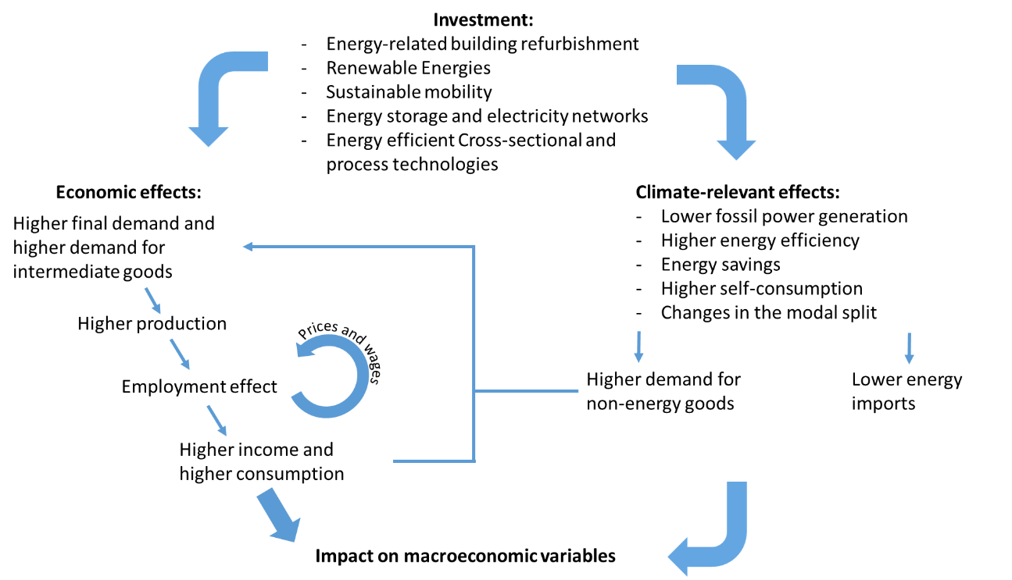
Source: GWS

Figure 1 gives an overview of the economic and environmental effects from climate friendly investment. Firstly, investments directly increase final demand and if the demanded goods are produced domestically, increases production. An increase in production also requires additional staff and employment is higher. In a rather tight labor market such as Germany’s, wages will increase. In particular, wages increase in sectors not in international competition. In sectors active on international markets, wage increases are somewhat capped by prices attainable on international markets. Profits, production and the amount of additional employment will adjust accordingly. The additional employment yields more income, which in turn is spent. This increased consumption of goods leads to further production and income effects.
In addition to more labor, more intermediate goods are necessary for production, be it from domestic or imported. The production of intermediate goods itself increases the demand for intermediate goods, and so on. These effects are taken into account in the macro-econometric model PANTA RHEI model using Leontief's approach, which links the production structure to the final demand, and thus makes it possible to determine the output of an industry as a whole.
Depending on the type of investment, environmental effects differ. Energy savings, increased self-consumption and reduced fossil fuel based power generation are possible climate-relevant effects, which in turn lead to reduced energy imports. With the funds released, additional non-energy goods can be purchased, which leads to further economic reactions. Overall, investment affects the different macroeconomic variables such as gross domestic product and employment.

The Model
The analysis is based upon simulation results obtained with the macro-econometric model PANTA RHEI. PANTA RHEI (Lutz et al., 2005; Lehr et al., 2008; Meyer et al., 2012, Lutz 2011) is an environmentally extended version of the econometric simulation and forecasting model INFORGE. A detailed description of the economic part of the model is presented in Maier et al. (2015). The economic core consistently describes the annual inter-industry flows between 63 sectors, the sector’s contributions to personal consumption, investment, construction and exports as well as prices, wages, output, imports, employment, labor compensation, profits, taxes, etc.
PANTA RHEI adds to that modules on energy and related emissions, transport and housing (see Figure 2). Links between model components are consistent. The transport module, for example, models fuel consumption in liters, which, multiplied by the price per liter, feeds into input demand from the manufacturing sector and demand for consumer goods.
In the behavioral equations, decision routines are modeled that are not explicitly based on optimization behavior of agents, but are founded on bounded rationality. The parameters in all equations in PANTA RHEI are estimated econometrically from time series data. Producer prices are the result of mark-up calculations of firms. Output decisions do not stem from an optimization process but follow observable historic developments, including observed inefficiencies. Employment is determined from the production volume and the real wage rate in each sector, which in return depends on labor productivities and prices.

Figure 2: The structure of the model PANTA RHEI
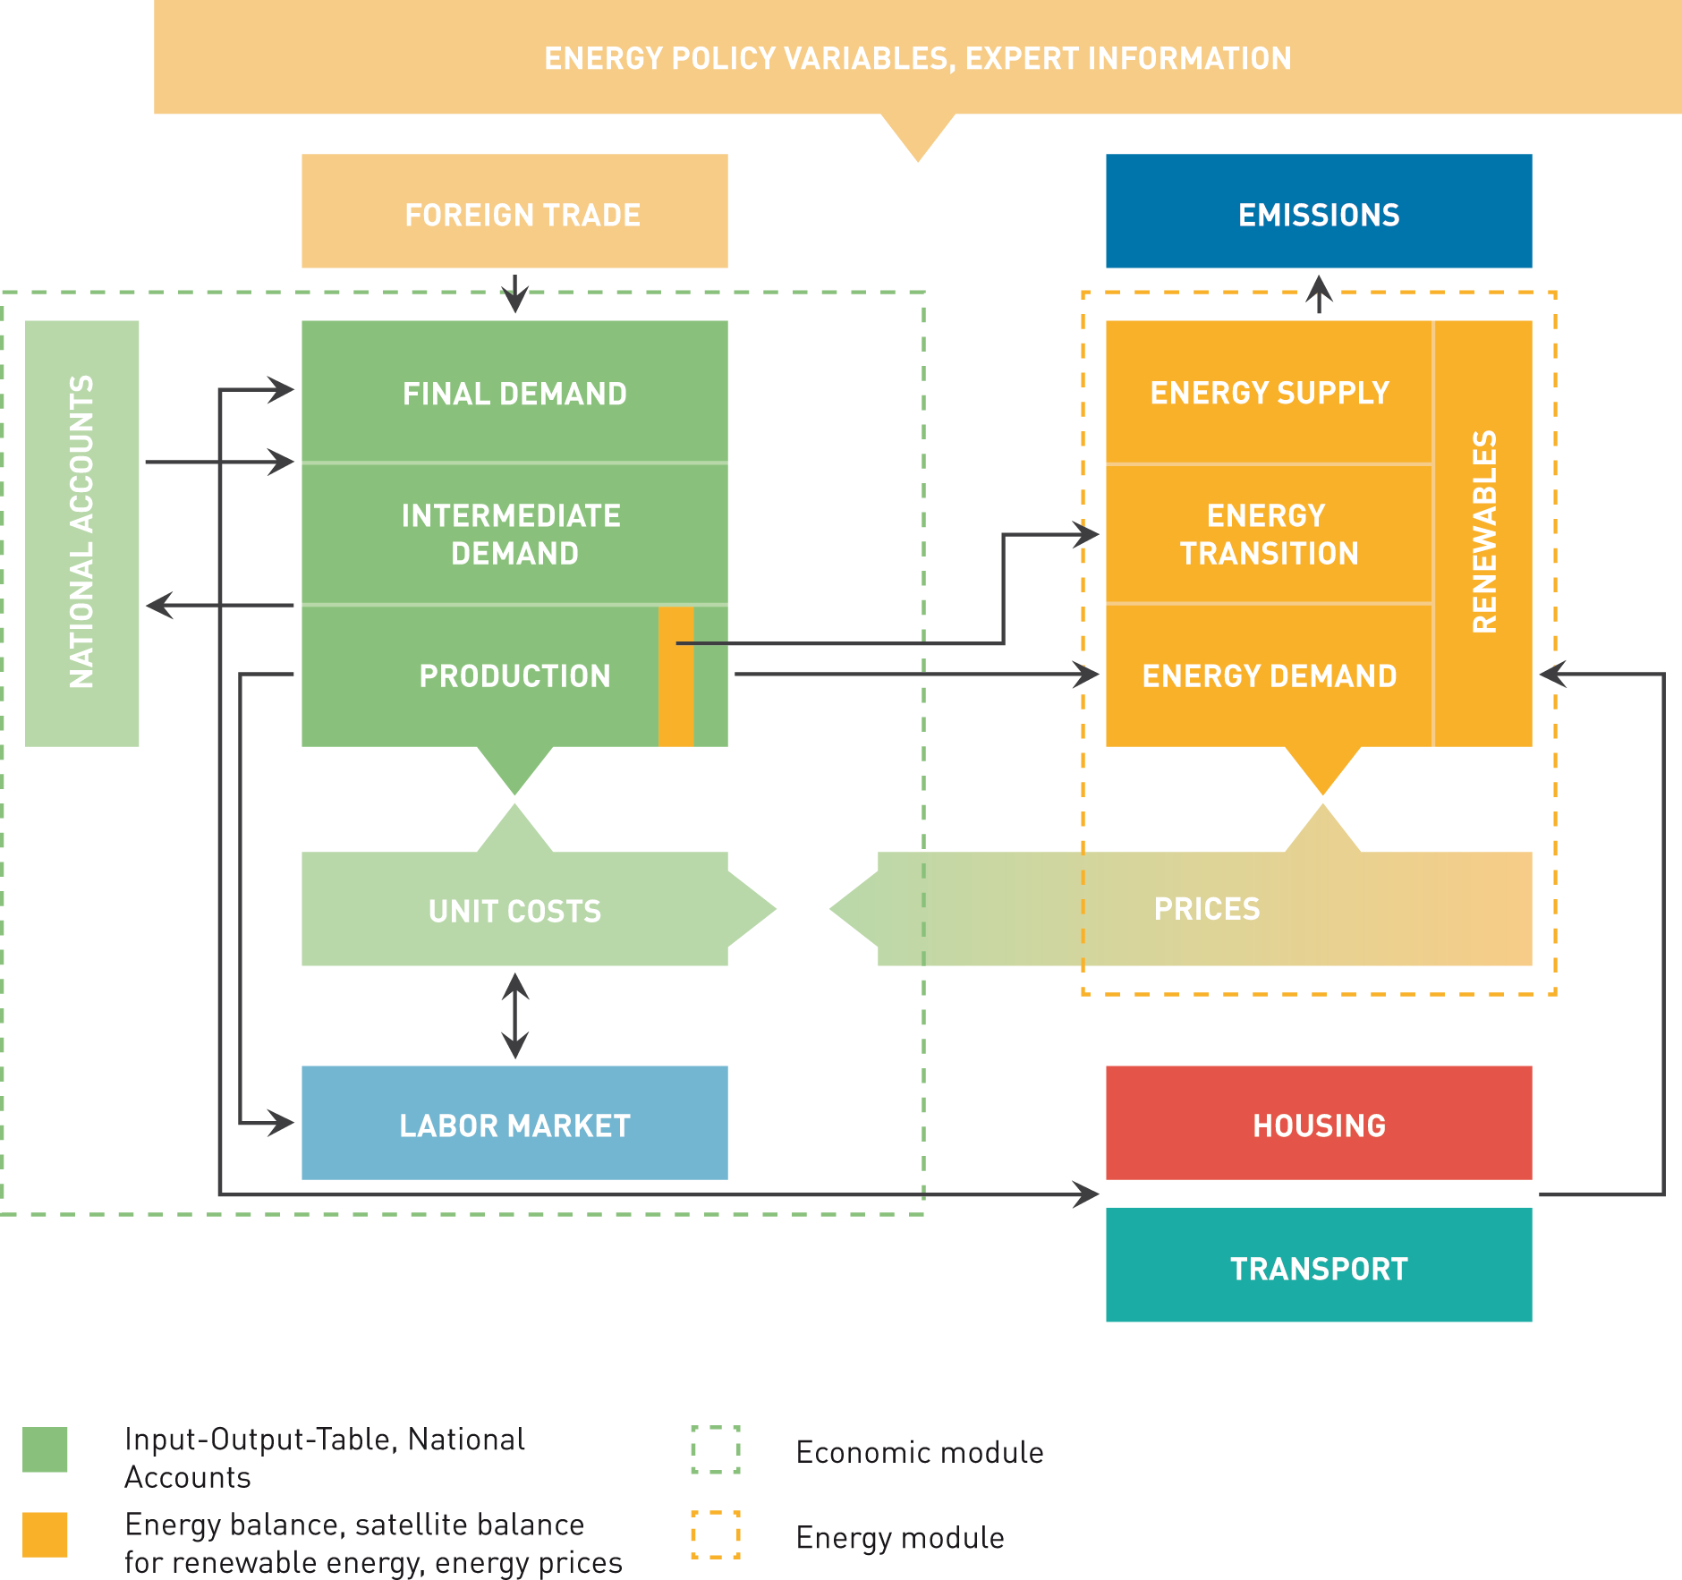
Source: GWS
PANTA RHEI has been used to answer several questions on the economic effects of environmental policy instruments. In 2010, economic effects of different energy scenarios were compared to each other, which were the basis for the German energy concept (Lindenberger et al. 2010). Recent applications include an evaluation of green ICT (Welfens, Lutz 2012), employment effects of the increase of renewable energy (Lehr et al. 2015), economic evaluation of climate protection measures in Germany (Lutz et al. 2014) and economic impacts of climate change (Lehr et al. 2016).
To examine the economic effects of green investment strategies in Germany, our analysis applies PANTA RHEI to two scenarios: a business as usual scenario and an investment scenario. Both scenarios are implemented in the macro-econometric model PANTA RHEI. The reference scenario is compared with an investment scenario that aims not only at the implementation of the objectives of the energy sector, but also aims at more ambitious targets and tries to achieve them with the focus on investment activities. The two scenarios and their sensitivities are consistent in themselves; they form closed, possibly contradictory, possible worlds. This also includes investing in the expansion of renewable energy exceeding the objectives of the German government. In areas where there is direct competition between the investment in climate protection and the investment in climate-degrading technologies, this is taken into account in the scenarios. The respective differences in economic indicators, such as employment, GDP etc. can then be attributed to the additional efforts in the sectors described above, since all other factors are held equal. Changes in volumes and prices are fully accounted for. The simulation model runs until 2030.

Scenarios

The reference case
For the development of greenhouse gas emissions and the energy system in Germany, forecasts and projections are prepared on a regular basis. The best known are the energy reference forecast of the Federal Ministry of Economics and Energy (BMWi) and the climate protection scenarios commissioned by the Federal Ministry for the Environment, Nature Conservation, Construction and Reactor Safety (BMUB). The current versions of the respective reference scenarios (ERP-Ref reference scenario) and the climate protection scenarios are similar (cf. Repenning et al 2015). Therefore, the ERP-REF scenario is used as a reference in this study. This reference scenario includes all climate protection measures already adopted by 2015, but no additional efforts. It misses the climate protection targets. For the present investigation, due to the current developments in prices, socio-political developments, and in some technological lines minor updates of the datasets of the reference scenario have been made. The installations of renewable energy up to and including 2015 are brought up-to-date. The development of the oil price in2015/2016 has also been taken into account and its future development has been adapted to the current projections of the International Energy Agency (IEA). This is important because the values import reductions depend on world market prices.
The second adjustment in the reference scenario consists in the use of the most recent population projection of the Federal Statistical Office. As the population there is slightly higher, energy demand, GDP and employment are slightly exceeded in the reference used here. For details on the reference scenario, see Schlesinger et al. (2014).

The investment scenario
Compared to other OECD countries, Germany exhibits relatively low private and particular public investment rates. Based on this and in the light of climate mitigation efforts, a scenario regarding investments is constructed. Although the investment scenario is constructed for the years 2016 to 2030, it is roughly oriented towards the aim of reducing Germanys GHG emissions by 95 percent Repenning et al. (2015) until the year 2050 as laid out in following. The scenario comprises lead markets, which contribute most to Germany’s GHG emissions. In order to reduce GHG emissions these lead markets and their corresponding fields of action are expected to attract large infrastructure investments in order to reduce emissions.
The German energy sector accounts for the highest share of GHG emissions in the country. To reduce these emissions, the development of renewable energy plays an important role. In the reference scenario it is assumed that 1.0 GW of wind power (onshore), 0.6 GW wind power (offshore) and 2.2 GW of PV are deployed annually between the years 2011 and 2030 (Schlesinger et al. 2014). In order to reduce GHG emissions by 95 percent in 2050, more ambitious targets have to be adopted. Following Repenning et al. (2015), the investment scenario therefore assumes 2.6 GW (wind power onshore), 0.8 GW (wind power offshore), 2.4 GW (PV). Based on this, additional deployment rate are derived and multiplied by the specific installation costs in order to calculate additional investments for the investment scenario. Installation costs and annual cost reduction rates are taken from Lehr et al. (2015). Table 1 summarizes the assumption for the areafield of action “renewable energy”.
Table 1: Key assumptions on renewable energy expansion in the investment scenario

 | Deployment rate reference scenario (GW) | Deployment rate investment scenario (GW) | Installation cost (EUR/kw) | Rate of annual cost reduction
Wind (onshore) | 1.0 | 2.6 | 1.360 | 0.6
Wind (offshore | 0.6 | 0.8 | 3.700 | 2
PV | 2.2 | 2.4 | 1.100 | ?
Source: Schlesinger et al. (2014); Repenning et al. (2015); Lehr et al. (2015)
Due to the intermittent character of renewable energy, the integration of electricity generated using renewable sources entails the need to adapt the electricity grid by means of storage systems. In the investment scenario, it is assumed that higher deployment rates of renewable energy are accommodated by using storage systems.
Frequency stability and reliable supply of power must be ensured also in case of a high share of renewable energy in electricity generation. The volatile electricity and heat generation from renewable energy sources requires flexibility measures over and above classical network expansion. In an investment scenario, energy storage and intelligent grids are therefore increasingly being demanded. Energy storage units represent both electrical energy storage (lithium-ion batteries) and thermal energy storage (latent heat storage).
The investments in the grid sector in the reference scenario amount to 4 billion Euros annually in Germany. The grid development includes expansion as well as replacement investments. In the reference scenario, an expansion of the storage capacities is also assumed. These energy stores are, however, not system-relevant. We expect that total capacity will amount to 5.5 GW in 2030. On the assumption of a price reduction in the area of electricity storage of 2.5% per year and a starting price of 1.800 Euro/kW in 2015, an annual investment sum of 613 million Euros in 2030 is the result.
In the investment scenario, new capacities for the use of renewable energy are 30% higher than in the reference scenario. The additional flexibility requires considerable changes in the grids and energy stores become system-relevant. It is assumed that the additionally installed storage capacity for electricity and heat by the year 2030 is about 31 GW. This results in an additional annual investment of 3.4 billion Euros in 2030. Industry, energy supply companies and grid operators make most of these investments. Private households will invest around 1 billion Euros if they receive a state subsidy.
The next important source for GHG emissions in Germany is the use of fossil fuels for heat generation in households and industry. Therefore, we included energy efficiency measures such as building refurbishment (renewal of heating systems, thermal insulation, etc.) and energy efficient cross-sectional and process technologies in the lead market „energy efficiency“ and the investment scenario.
In energy-efficient building refurbishment, the investment scenario is mainly driven by the rate of refurbishment and the energy efficiency standard. In line with Repenning et al. (2015), the scenario adopts a linear increase of the refurbishment rate from, depending on the building type, between one and 1.75 percent in 2015 to 3.7 percent in 2030. Also in line with Repenning et al. (2015) the KfW-55 standard is assumed for energy-efficient refurbishments, meaning that the maximum primary energy use has to be 55 percent compared to primary energy use for new buildings as laid out in the Energy Conservation Ordinance 2009.
In Germany, the cumulated living space is projected to increase by seven percent (residential buildings) between 2010 and 2030 and to be constant for public buildings over time (Schlesinger et al. 2014). The energy-related refurbishment costs are taken from Böhmer and Thamling (2013). It is assumed that these costs decrease by ten percent between 2010 and 2030 due to learning effects (Böhmer and Thamling). Based on these assumptions, the overall refurbishment costs are calculated and the corresponding costs of the reference scenario are subtracted to obtain the additional investments of the investment scenario.
Energy efficiency in industry can be split into: 1) traditional efficiency measures; and 2) efficiency gains through the holistic optimization of the production processes using methods of digitalization. The traditional efficiency measures, including energy-efficient lighting, efficient electronic drives, energy-efficient pumps (HVAC), etc., will only play a subordinate role in the future. For decades, these individual components or even isolated applications have been optimized further and further. The main efficiency increasing levers are found in holistic / systemic optimization. The links of insular systems as holistic systems and the overall optimization of the processes allow new dimensions of efficiencies to be achieved. Digitalization, which is linked through automation, networking, digital data and digital user interface (four levers of digitization), gains enormous importance.
Studies estimate that "Industry 4.0" can achieve energy efficiency levels of 3.5% - 30%. In our calculations, we are assuming 15%. These additional savings potentials can be related to the total energy consumption of industrial production in Germany. If the companies invest in all efficiency measures, which are expected to have a payback time of less than 4 years, a market potential of 25 billion Euros is calculated. An industrial electricity price of an average of 80 Euros / MWh and an industrial heat price of 50 Euros / MWh are assumed.
Based on a very low penetration rate of digital solutions in the industry of 1% in 2015, we expect an annual growth of 17% in the reference scenario and 31% annual growth in the investment scenario. After a penetration rate of 15%, the annual growth rate is decreasing. In 2030, the penetration rate of digital solutions will reach 10% in the reference scenario and 50% in the investment scenario. The degree of penetration of digital solutions is defined at plant level using all four levers of digitization.
With these assumptions, the investment in the reference scenario will amount to 379 million Euros annually in 2030 and 2.7 billion Euros annually in the investment scenario in 2030.
In the third lead market taken into account in this scenario, additional infrastructure investments in transport are considered: the expansion of bicycle lanes and pedestrian paths as well as the expansions of rail-roads. Additional investments compared to the reference scenario are directly taken from Doll et al. (2012). For the shift of freight transportation from roads to rail-roads, Doll et al. (2012) assume that the share of rail-based freight transportation increases from today 17 percent to 27 percent in 2030. To derive additional investments for a mobility shift from motorized vehicles to non-motorized mobility (cycling and walking), Doll et al. (2012) assume that the share of routes travelled by bicycles or walked in inner-cities increases from 37 to 47 percent in 2030.
The investment volume was calculated by assuming that investments are made when they are economically viable. For this assumption, a total market potential of the respective technology was calculated in the individual scenarios. For this purpose, the savings potential was multiplied by the variable costs (e.g. 20% on the electricity costs for industrial production processes) and then multiplied by a typical amortization time (e.g. 4 years). The total potential savings resulting from this are then the market potential. In a final step, an acceleration curve for the penetration of these classical and new technologies was identified, based on scientific publications on the relevant topics (digitization in industry, energy storage, etc.).

Results

GDP and employment – the macro effects
The modelling results show that investments in climate protection and climate protection goods have a positive effect on economic growth and the living conditions of the employees. Investment triggers various economic effects. The differences between the investment scenario and the reference scenario are positive for all relevant parameters, such as gross domestic product, private consumption, earned income and the investment rate. Overall, the rate of growth in the investment scenario is higher than in the reference scenario for the entire time. Private consumption is also developing at a higher level, primarily because of higher wages. Savings attributed to reduced energy consumption open up further possibilities for consumption. Investments as drivers of the scenario lead to a significantly higher investment rate. A total of 220,000 people are employed additionally in several economic sectors.
Table 2: Absolute and relative deviation of the components of GDP in the investment scenario compared to the reference scenario
 | Absolute deviation  (in bn. Euro) |  |  | Relative deviation  (in percent)
 | 2020 | 2025 | 2030 | 2020 | 2025 | 2030
Private final consumption Expenditure | 21,5 | 34,5 | 49,7 | 1,3 | 2,0 | 2,7
Government final consumption expenditure | -0,4 | -0,4 | -0,7 | -0,1 | -0,1 | -0,1
Investment (equipment) | 9,9 | 12,7 | 17,8 | 2,8 | 3,3 | 4,1
Investment (buildings) | 16,9 | 25,5 | 34,3 | 6,2 | 10,3 | 13,5
Exports | 4,3 | 4,8 | 2,1 | 0,3 | 0,2 | 0,1
Imports | 9,5 | 13,7 | 20,9 | 0,7 | 0,8 | 1,0
GDP | 42,5 | 62,5 | 80,6 | 1,4 | 2,0 | 2,4
Source: own calculations, GWS
In 2030, GDP in the investment scenario is 80 bn. Euro higher than in the reference scenario, which equates to 2.4 %. Looking at the components of GDP, we find the obvious increase in investment by definition, followed by increases in consumption due to more production and increased employment as well as increases in imports from higher production. The construction sector is experiencing the strongest growth compared to the reference scenario (+13.5 % in 2030), Equipment (+4. 1 % in 2030) and private final consumption expenditures (+2.7 % in 2030) are higher than in the reference scenario. Investment as a driver in the scenario leads to a much higher rate of investment compared to the reference scenario. In 2030, it is around 5 percent higher than in the reference.
Figure 3: Scenario comparison - Primary energy consumption, final energy consumption, and greenhouse gas emissions
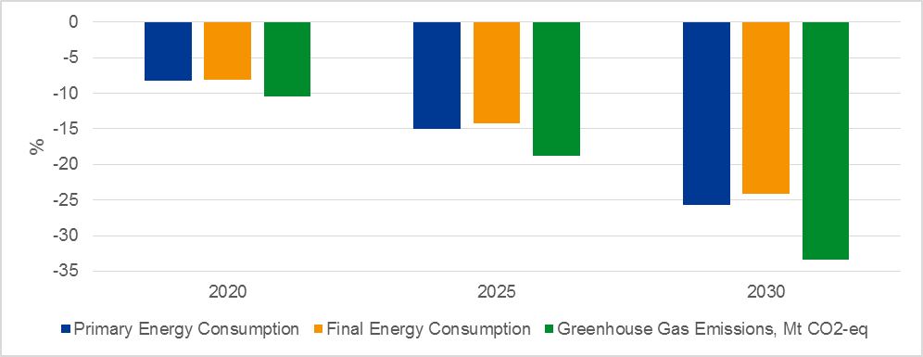
Source: own calculations, GWS
In a scenario with higher investment targeted at GHG mitigation and green infrastructure, one has to take a closer look at the impacts on environmental indicators. Relative to the reference, primary energy consumption, final energy consumption and greenhouse gas emissions are all much lower by 2030. However, the economic activity is stimulated by an increased final demand and an increased demand for intermediate goods, this activity leads to additional emissions emitted, too. It is counterbalanced by additional efficiency and emission reduction goals are achieved in the investment scenario than in the reference scenario.

Winners and losers
The investment scenario comprises impacts in different fields of the economy. In order to be able to identify and assign the effects in the respective fields, sensitivities were simulated for each field.
Figure 4: Comparison of scenarios - overall economic effects per sensitivity
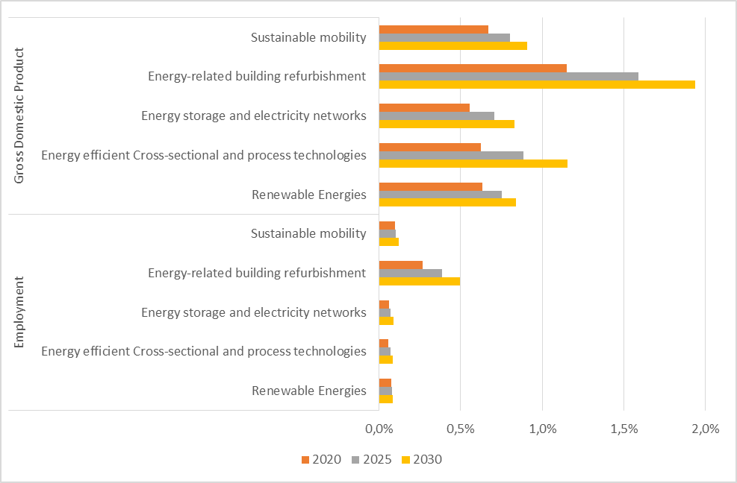
Source: own calculations, GWS
The largest impact on gross domestic product and employment is attributable to the investment in energy-related building refurbishment. In 2030, GDP is almost two percent higher than in the reference scenario. The same applies to employment, which is also half a percent higher in 2030, despite the nearly exhausted labor market potential. In all other areas, the investment impact and energy savings also lead to clearly positive effects. GDP is at least half a percent higher than in the reference scenario in all years shown in Figure 4. The distance to the reference scenario also increases over time. In addition, emission reduction is highest from energy-related building refurbishment. The additional expansion of renewable energy has a similar effect as the measures in “sustainable mobility”, in “energy storage and electricity networks” and in “energy efficient cross-sectional and process technologies”.
While the latter are investments by the private sector, the public sector could engage in refurbishment. Moreover, the energy-related refurbishment of schools, colleges, kindergartens and administrative buildings fulfills further relevant functions. The energetic refurbishment of public buildings has a representative character. In schools and hospitals, the benefits of such a refurbishment are directly felt by all those who visit this institution. In addition, the energy savings relieve the public budgets and release funds for other purposes.
Energy efficient cross-sectional and process technologies will be one of the inevitable components of a future industrial location in Germany. Targeted investments in networked technologies to exploit efficiency potentials have not yet been the focus of efforts. Therefore, the scenario considered here is relevant for the energy political discussion. It shows how investments in energy-efficient digital technology have an impact on the economy as a whole.
Figure 5: Comparison of scenarios - employment effects in the different sectors
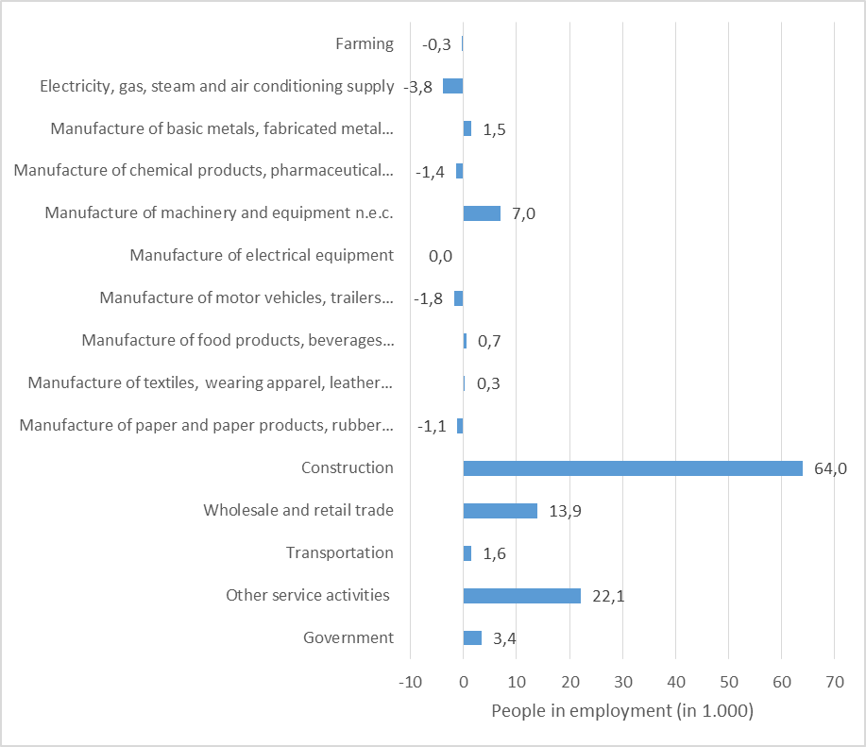
Source: own calculations, GWS
Employment in the various sectors reacts differently to the additional investment impulses. The construction sector receives the strongest impulse, followed by the services sector, which is involved in any increase in economic activity through the intermediate goods structures. In addition to direct investment in construction, the construction industry is also receiving additional increases in demand via the intermediate structures, such as the expansion of renewable energy.
The manufacturing sector receives mixed impulses. On the one hand, wages and salaries are rising as more people are employed than in the reference scenario. Moreover, the situation on the labor market is becoming tenser. On the other hand, there is a growing demand for the products of some industries, above all the demand for mechanical engineering.
On the one hand, mechanical engineering is not reacting markedly to wage increases and is experiencing strong additional demand impulses in the process of digitization, efficiency investments and the expansion of renewable energy. Indirectly, it benefits from the energy savings through energy-efficient cross-sectional and process technologies and by increasing the energy efficiency of buildings. Companies in the sectors glass, ceramics, stones and earth benefit from the additional demand for their products from the construction industry and to a lesser extent from supplies to the renewable energy companies. Metal production is also benefiting from the demand for input from the construction and renewable energy industry. On the one hand, vehicle construction reacts to rising wages. On the other hand, the sector receives no direct or indirect impulses from the scenario, as does the chemical industry. Overall, it must be borne in mind that the employment effects in the manufacturing sector are very small, among other things because the work processes there are already largely automated. This applies in particular to the chemical industry and vehicle construction.
If the results are compared with the current literature such as BMWi (2016), the effects fit well into the picture. In BMWi (2016), between 2016 and 2020, an additional investment of around 100 billion Euros₂₀₀₅ in energy efficiency will result in some 190.000 additional jobs. The results calculated with the ASTRA model in climate protection scenarios show a smaller but slightly positive employment impulse. The results of the economic model calculations represent the overall economic responses to a scenario that is increasingly investing in climate protection. These are positive. The effects are also positive in the individual fields of action, but their effect partly differs significantly.
The effects of the investment in renewable energy fit well with the results in Lehr et al. (2015) or Dehne et al. (2015). The expansion of renewable energy leads to positive economic effects respectively. It should be noted that regulatory uncertainties affect the investment in renewable energy negatively. The results presented here regarding the growth and employment impact of an additional expansion of renewable energy suggest that investors will now have a secure investment environment in which the additional demand can be effective.

Conclusion and outlook
The results of the economic model calculations show positive overall economic responses to a scenario that is increasingly investing in climate protection measures. Moreover, the effects are positive for each single measure, but their effects differ significantly.
The resulting growth effects are not particularly large, expressed as changes in GDP. The largest specific impact is found in efficiency increases, in particular in industry. This is due to two effects: firstly, many efficient technologies are produced in Germany; therefore, additional investment directly increases domestic demand and production. Secondly, most efficient technology have a rather short payback period and are actually economically efficient. The barriers lie somewhere else. The increase in energy efficiency by means of cross-sectional and process technologies leads to energy savings. The latter enhances in the positive effects in the economic cycle, since what is saved in energy expenditure can be spent again for other purposes. The energetic building renovation pays for itself in the long term, so the savings are also used for the counter-financing of the investment over a longer period. Renewable energy leads to revenues from the operators, but in the short to medium term, they increase the prices for those consumers who are burdened with them. This reduces the effect on GDP.
In terms of employment, labor intensity in the construction industry overlays all other effects. Infrastructure investment in the "Sustainable Mobility" area therefore has the largest impact on employment, followed by the energetic building renovation. Also with regard to employment, the expansion of renewable energy has relatively little effect.
The literature on economic effects of climate change mitigation often focuses on one instrument, most often a carbon price, or selected economic sectors and selected measures. This paper contributes a cross sectional view and brings together bottom-up analyses of different measures, the discussion on the benefits of industry 4.0 and digitalization and the debate on raising the investment rate in Germany.
However, the limits of the current analysis points at further research needs: As stated earlier, this study only focused on a selection of those lead markets that are expected to attract large future infrastructure investments due to their high contributions to Germanys GHG emissions. Other lead markets such as agriculture were not taken into account. Additionally, we do not make any suggestions on policy instrument to attract such large amounts of capital. This will be an important direction of future research. For instance, it can be observed that refurbishment rates cannot keep up with expectations. However, to meet climate change mitigation, commitment to energy efficiency plays a central rule.

References
Doll, C.; Hartwig, J.; Senger, F.; SchadeI, W.; Maibach, M.; Sutter, D.; Bertschmann, D.; Lambrecht, U.; Knörr, W., and Dünnebeil, F. (2012): Wirtschaftliche Aspekte nichttechnischer Maßnahmen zur Emissionsminderung im Verkehr. Schlussbericht. Dessau-Roßlau: Umweltbundesamt.
Alm, B, Meurers, M. (2015), Essential Facts on Weak Investment Levels in Germany, Wirtschaftsdienst 2015.
Frankfurt School-UNEP Centre/BNEF. 2017. Global Trends in Renewable Energy Investment 2017, http://www.fs-unep-centre.org (Frankfurt am Main)
Lutz, C., Meyer, B., Nathani, C. & Schleich, J. (2005), Endogenous technological change and emissions: The case of the German steel industry. Energy Policy 33 (9), 1143-1154.
Lehr, U., Nitsch, J., Kratzat, M., Lutz, C., Edler, D. (2008), Renewable energy and employment in Germany. Energy Policy 36, 108-117.
Meyer, B., Meyer, M., Distelkamp M. (2012), Modeling Green Growth and Resource Efficiency: New Results. Mineral Economics 25, 145-154.
Maier, T., Mönnig, A. & Zika, G. (2015), Labour demand in Germany by industrial sector, occupational field and qualification until 2025 - model calculations using the IAB/INFORGE model. Economic Systems Research 27, 19-42. DOI: 10.1080/09535314.2014.997678
Lutz, C. (2011), Energy scenarios for Germany: simulations with the model PANTA RHEI. In: Mullins, D., Viljoen, J., Leeuwner, H. (eds) Interindustry based analysis of macroeconomic forecasting. Proceedings from the 19th INFORUM World Conference, Pretoria, 203–224.
Welfens, P. J. J., Lutz, C. (2012), Green ICT dynamics: key issues and findings for Germany. Mineral Economics 24, 155–163.
Lehr, U., Lutz, C., Edler, D. (2012), Green jobs? Economic impacts of renewable energy in Germany. Energy Policy 47, 358-364.
Lutz, C., Lehr, U. & Ulrich, P. (2014), Economic Evaluation of Climate Protection Measures in Germany. International Journal of Energy Economics and Policy 4(4), 693-705.
Lehr, U., Nieters, A. & Drosdowski, T. (2016), Extreme Weather Events and the German Economy: The Potential for Climate Change Adaptation. In: Leal Filho, W., Musa, H., Cavan, G., O'Hare, P., Seixas, J. (eds): Climate Change, Adaptation, Resilience and Hazards, 125-141, Springer.
BMWi (2016), Grünbuch Energieeffizienz. Diskussionspapier des Bundesministeriums für Wirtschaft und Energie. Berlin.
Dehne, N.; Mattes, A.; Traber, T. 2015: Die Beschäftigungseffekte der Energiewende. Eine Expertise für den BWE und die Deutsche Messe. Berlin: DIW Econ GmbH.
Lehr, U.; Ulrich, P; Lutz, C.; Thobe, I.; Edler, D.; O'Sullivan, M.; Simon, S.; Naegler, T.; Pfenning, U.; Peter, F.; Sakowski, F.; Bickel, P. 2015: Beschäftigung durch erneuerbare Energien in Deutschland: Ausbau und Betrieb, heute und morgen. Studie im Auftrag des BMWi. Osnabrück, Berlin, Stuttgart: GWS, DIW, DLR, Prognos AG, ZSK.
Böhmer, M.; and Thamling, N. 2013: Ermittlung der Wachstumswirkungen der KfW-Programme zum Energieeffizienten Bauen und Sanieren. Im Auftrag der KfW Bankengruppe. Basel: Prognos AG.
Repenning, J., Emele, L., Blanck, R., Dehoust, G., Förster, H., Greiner, B., Harthan, R., Hennenberg, K., Hermann, H., Jörß, W., Ludig, S., Loreck, C., Scheffler, M., Schumacher, K., Wiegmann, K., Zell-Ziegler, C., Braungardt, S., Eichhammer, W., Elsland, R., Fleiter, T., Hartwig, J., Kockat, J., Pfluger, B., Schade, W., Schlomann, B., Sensfuß F. and Ziesing, H. (2015): Klimaschutzszenario 2050.
Schlesinger, M., Lindenberger, D. and Lutz, C. (2014): Entwicklung der Energiemärkte – Energierefe-renzprognose. Endbericht. Projekt Nr. 57/12. Studie im Auftrag des BMWi. Basel: Prognos AG; Köln: EWI; Osnabrück: GWS.
IEA (2016), World Energy Outlook, Paris November 2016.
INTERNET:
http://www.fvee.de/fileadmin/publikationen/Politische_Papiere_FVEE/14.IWES_Roadmap-Speicher/14_IWES-etal_Roadmap_Speicher_Langfassung.pdf
http://www.fvee.de/fileadmin/publikationen/Politische_Papiere_FVEE/14.IWES_Roadmap-Speicher/14_IWES-etal_Roadmap_Speicher_Langfassung.pdf
https://www.smartgrid.gov/document/smart_grid_race_worth_winning_report_economic_benefits_smart_grid
http://industrie40.vdma.org/documents/4214230/5356229/IWU%20Vortrag%20Mark%20Richter/d1060b17-9c8b-450b-8dcf-cb66ddfa95be
https://www.ensys.tu-berlin.de/fileadmin/fg8/Downloads/NeueEntwicklungen/SS2014/Schmitt__Jonas_-_Industrie_4.0.pdf
http://www.energy.siemens.com/de/de/energiewende-deutschland/energieeffizienz.htm
http://www.fraunhofer.de/content/dam/zv/de/forschungsthemen/energie/Studie_Energieeffizienz-in-der-Produktion.pdf
http://wissenschaftstag.metropolregionnuernberg.de/fileadmin/wissenschaftstag/WT15/Praesentationen/WT15_Zukunftswelten_Plessing_Energieeffizienz.pdf
https://www.ensys.tu-berlin.de/fileadmin/fg8/Downloads/NeueEntwicklungen/SS2014/Schmitt__Jonas_-_Industrie_4.0.pdf
http://www.energy.siemens.com/de/de/energiewende-deutschland/energieeffizienz.htm
http://www.fraunhofer.de/content/dam/zv/de/forschungsthemen/energie/Studie_Energieeffizienz-in-der-Produktion.pdf
http://wissenschaftstag.metropolregionnuernberg.de/fileadmin/wissenschaftstag/WT15/Praesentationen/WT15_Zukunftswelten_Plessing_Energieeffizienz.pdf
https://www.agora-energiewende.de/fr/themen/-agothem-/Produkt/produkt/231/Get+Ready+for+150+Gigawatts+of+Solar+Capacity+and+40+Gigawatts+of+Storage+in+Germany/
https://www.diw.de/documents/publikationen/73/diw_01.c.497941.de/diw_econ_bull_2015-10.pdf
http://www.dihk.de/ressourcen/downloads/faktenpapier-stromnetze-2015/
https://www.agora-energiewende.de/fr/themen/-agothem-/Produkt/produkt/231/Get+Ready+for+150+Gigawatts+of+Solar+Capacity+and+40+Gigawatts+of+Storage+in+Germany/

It remains to be seen what the US withdrawal from the Paris Agreement actually will mean for global mitigation efforts.
excluding large hydro
Variant 2 of the population projection of the Federal Statistical Office is implemented, which already contains a higher migration.

