**Unlocking Caspian gas potential: Azerbaijan’s vital role in European energy supply diversification**

***Nigar Muradkhanli, PhD Student, Khazar University, Baku, Azerbaijan***

**Outlines:**

1. Key Challenges in the European Gas Industry
2. Gas potential in the Caspian region
3. Connecting the Caspian region with Europe
4. Other possibilities of energy supply to Europe in comparison with transportation from Caspian
5. Concluding remarks

The energy sector is the most dynamically developing strategic industries of the economy. Energy security was the priority after two oil crises in the 1970s, resulting in industrialised countries diversifying energy sources and non-OPEC areas increasing production. Europe as a whole is a major importer of natural gas. As Europe’s natural gas production has declined in recent years, its dependence on imported natural gas has increased. The EU member states are the world’s largest energy importer, importing about 55% of their energy supply—approximately 84% of their oil and 64% of their natural gas. European Commission forecasts that the EU will import over 80% of its natural gas needs by 2030.

***European Gas Demand:***

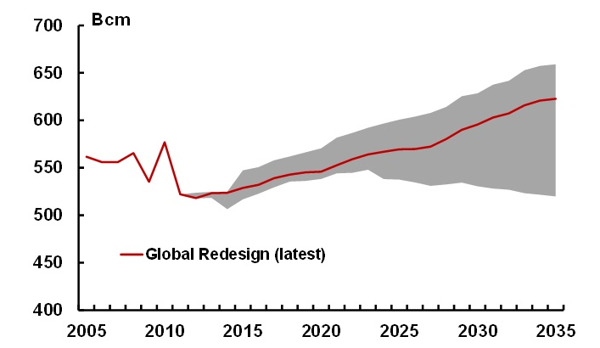

*Source: IHS CERA*

*Note: Europe = EU 27, Balkans, Norway, Switzerland and Turkey*

Gas imports in the form of liquefied natural gas (LNG) have gained market share in Europe over the past decade to comprise about 25% of total gas imports. Most of Europe’s major LNG providers including Qatar, Algeria, and Nigeria, with smaller volumes arriving from Norway,

Egypt, Libya and Trinidad and Tobago—have gradually increased supplies to Europe. However LNG supply to the flexible markets of the Northwest Europe declined by 40% in 2012.

In the early 1990s Russia’s share of the total EU gas imports stood at more than 70% but

by 2010 had fallen to 32%. This decline is mainly the result of Norway’s growth as a major gas exporter and more recently, the growth of LNG supplies.

The EU has bilateral energy dialogues with large suppliers, also has a pro-active policy to diversify sources of supply, through building LNG terminals and new pipeline infrastructure. Establishing a natural gas pipeline system to transport natural gas from the Caspian region and Central Asia to Europe is one of the focal points of European energy diversification strategies.

***The EU energy dependency***

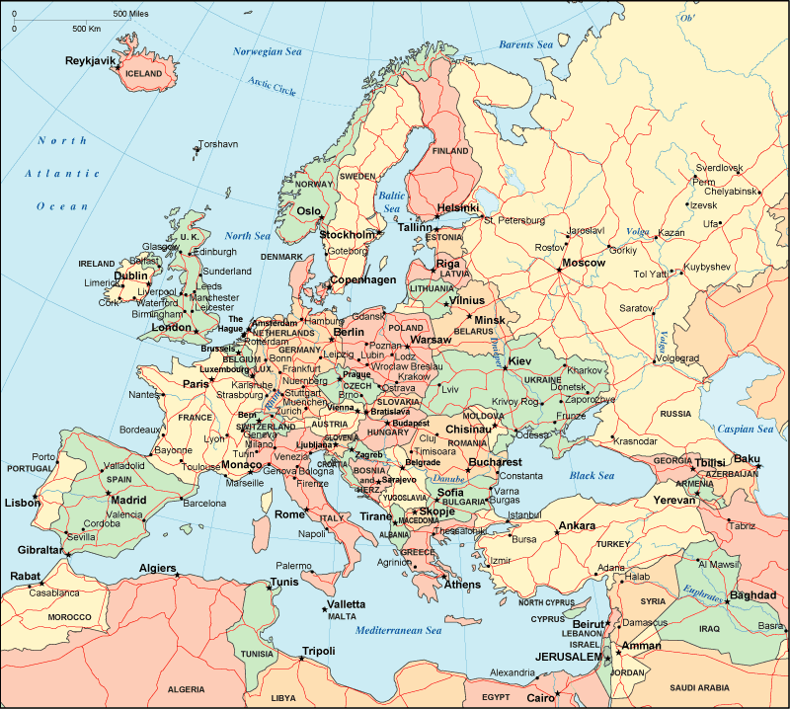

**North Africa**

**Caspian Sea**

**Middle East**

**Russia**

**Norway**

The Caspian region is one of the oldest hydrocarbon producing areas in the world, and is emerging once again as a major source of growth in global oil and gas supply. Caspian region countries with tremendous potential in supplying European market with energy resources hold an important place in diversifying transport routes. These countries have managed to attract vast investments to the development of their hydrocarbon resources and creation of a powerful infrastructure for the production and transportation of oil and gas. The Caspian region has emerged as a significant source of natural gas for world markets. The proven natural gas reserves of Azerbaijan, Kazakhstan, Turkmenistan, and Uzbekistan are estimated at over 1,000 trillion cubic feet (tcf), among the largest in the world. The International Energy Agency (IEA) estimates that the Caspian region’s proven and recoverable natural gas reserves are about 7% of the world’s reserves, but also stresses that further exploration could result in an upward revision of estimated reserves.

***Natural Gas Data, 2011***

***(units = trillion cubic feet (tcf)***

|  |  |  |
| --- | --- | --- |
| Country | Reserves | Production |
| Azerbaijan | 44.9 | 0.5 |
| Kazakhstan | 66.4 | 0.7 |
| Turkmenistan | 858.8 | 2.1 |
| Uzbekistan | 56.6 | 2.0 |
| Total | 1,026.7 | 5.3 |

*Source: BP Statistical Review of World Energy 2012*

The Caspian region has the potential to become a major strategic energy partner of the EU. Azerbaijan lies at the heart of this region and holds the key to the realisation of this concept. The discovery in 1999 of the Shah Deniz gas field of Azerbaijan in the Caspian Sea raised expectations that the Caspian region could become a lucrative region for gas exploration and development. The country is currently following a path of stable development and has established co-operation with Europe and other countries, and also with major institutions and companies, by making use of its favourable geographical position, world-class energy resources, and economic potential. Currently Azerbaijan’s oil and oil products are exported to 33 countries via different routes. As a result of the successful completion of the Azeri-Chirag-Guneshli (ACG) and Shah Deniz (SD) projects and the operation of Baku-Tbilisi-Ceyhan (BTC) oil pipeline and the South Caucasus gas pipeline (SCP), Azerbaijan occupies an important position in terms of energy security. Shah Deniz contains the vast majority of Azerbaijan’s proven gas reserves and is the country’s main source of production. The country currently exports natural gas to neighbouring countries - Russia, Iran, Georgia and Turkey, as well as to Greece in the EU. Gas from the second stage of development of SD field is estimated as the main source of supply for the planned gas transportation projects. SD gas field reserves total 1,2 trillion cubic metres (tcm), and the expected gas extraction withing the second stage is supposed to be 16 billion cubic metres (bcm). The second stage of development of SD field serves for Caspian natural gas transportation to Turkey (6 bcm) and European market (10 bcm) through opening of the Southern Gas Corridor.

The Trans Anatolian Natural Gas Pipeline (TANAP) Project envisages gas transportation from the SD 2 and other fields of Azerbaijan and other possible neighboring countries through Turkey to Europe. The 1730-kilometer TANAP is planned to begin from Georgia-Turkey border and go through the provincial borders of Ardahan, Kars, Erzurum, Bayburt, Gümüşhane, Erzincan, Sivas, Yozgat, Kırıkkale, Ankara, Eskişehir, Bilecik, Kütahya, Bursa, Balıkesir, Çanakkale, Tekirdağ, Edirne, respectively.

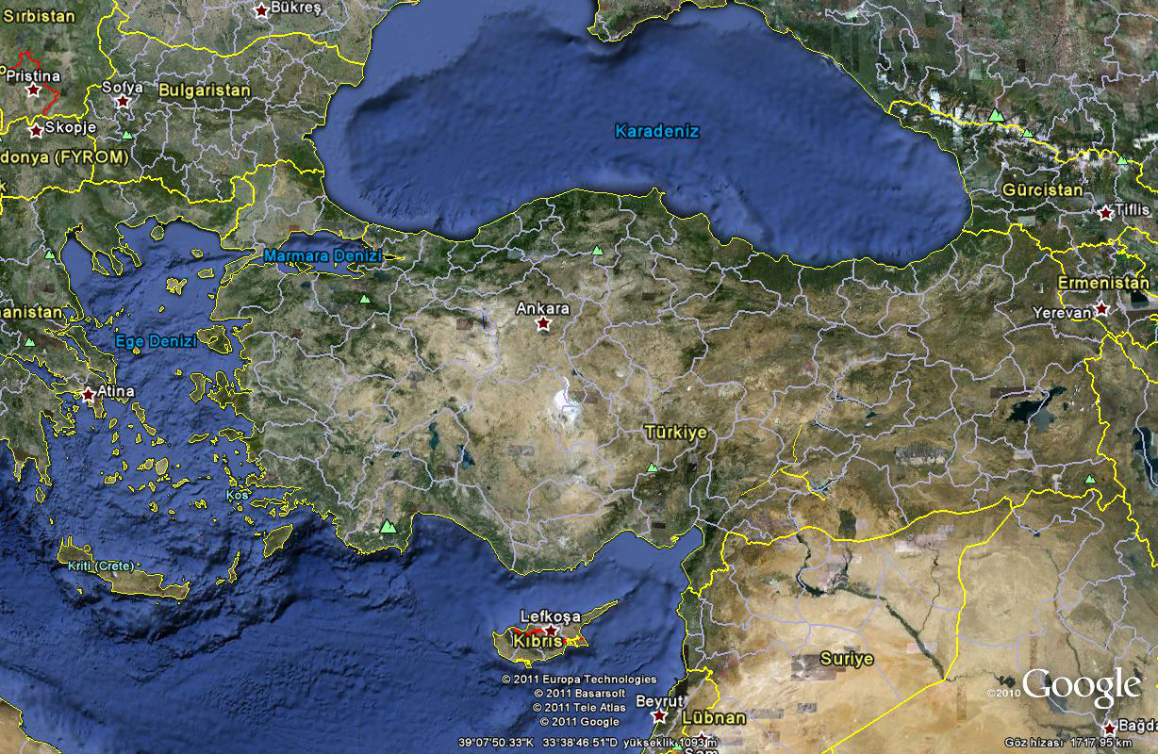

**Sivas**

**Kilis**

**Yozgat**

Kırıkkale

**İstanbul**

Eskişehir

**CS-1**

**CS-2**

**CS-3**

**CS-4**

**CS-5**

**CS-6**

**CS-7**

KP220

KP420

KP630

KP850

KP1065

KP1280

KP1500

**CS-8**

KP1695

KP1754

MS

MS

*Source: TANAP*

The Trans Adriatic Pipeline (TAP) is designed to transport natural gas from the SD 2 field in Azerbaijan, via Greece and Albania, and across the Adriatic Sea to Southern Italy, and further to Western Europe. Initial pipeline capacity will be 10 bcm per year with possibility of further expansion to 20 bcm per year. The TAP route is supposed to be approximately 870 kilometres in length (Greece 550 km; Albania 210 km; offshore Adriatic Sea 15km; and Italy 5 km).

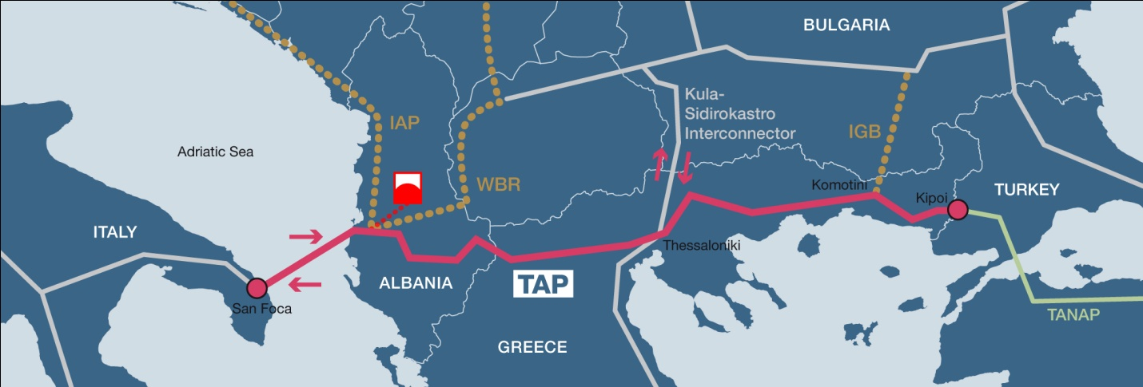

*Source: TAP*

The opening of the new gas supply corridor to Europe is an important factor contributing to the stability of the European gas market. TAP will represent an important first step in linking south-eastern European markets and Italy to Caspian energy supplies.

In 2009 the European Commission published an “EU Energy Security and Solidarity Action Plan”, which stated that: A southern gas corridor must be developed for the supply of gas from Caspian and Middle Eastern sources, which could potentially supply a significant part of the EU’s future needs. This is one of the EU’s highest energy security priorities.

In addition to SD Stage 2, Azerbaijan has other resources of natural gas that could supply Europe in the long term. In September 2011 a major offshore discovery in the Absheron block had been announced, which could have reserves of 12 tcf. In 2010 the Umid and Babek offshore fields had been discovered, with combined reserves that could add 14-21tcf, another source of

hydrocarbons is the Shafag-Asiman deepwater structure. The IEA reported in its Medium Term Gas Market Report 2013that Azerbaijan’s gas production, thanks to the developmentof fields other than Shah Deniz, could reach 39-48 bcm during 2025-30, of which27-38 bcm could be exported.

By diversifying supply, the EU wants to improve the ability to respond to supply emergencies. How can the energy sector respond to meet growing consumer demand, climate change commitments and competition for finite energy resources? As promoting energy efficiency, energy saving and the development on new and renewable forms of energy are one of the EU energy priorities, shale gas and renewables can’t stay out of the focus of Europe.

The development of indigenous energy sources like shale gas can provide Europe the opportunity to develop domestic energy resources and in some cases reduce import dependency. Many countries in Europe have significant deposits of shale gas, in 2011 the US Energy Information Administration (EIA) estimated that Europe could have 646 tcf of technically recoverable resources of the gas, largely concentrated in France, Poland and Norway. Shale gas could also inject market competition, giving countries more leverage to renegotiate existing gas import contracts and eventually contributing to a reduction in gas prices for end consumers. Shale gas is an industry with huge potential to thrive in Europe, it is essential making every effort to promote responsible development of this indigenous and low-carbon energy resource. However there are several questions to answer before asserting shale gas’ advantage for the Europe: What will it cost to extract? How soon is this to happen? It is too early to make clear predictions on how shale gas development will impact the European economy.

***Shale gas prospects in the world***

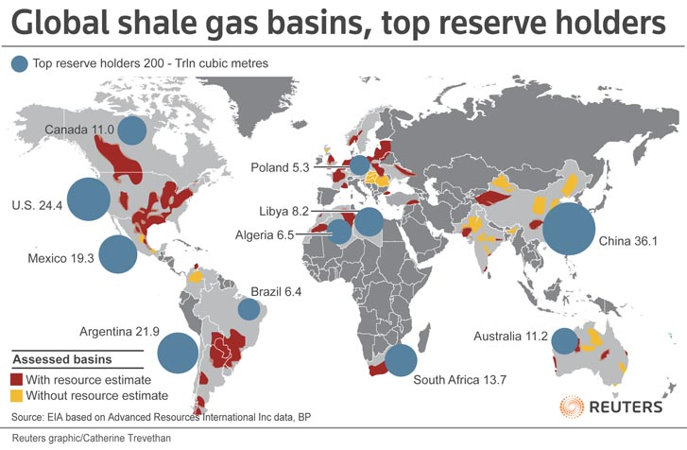

*Source:* [*www.forbes.com*](http://www.forbes.com)

The presence of the shale gas in the ground does not guarantee the unearthing of the wealth.

Shale gas developments in the United States were having a significant impact on global gas markets, creating an oversupply of LNG and downward pressure on gas prices. But can Europe

replicate the US success in shale gas development? There is a growing realization that at least in Western Europe, there are serious obstacles to the development of shale gas. Europe has some conditions (geological, industrial and other factors) that could inhibit replication of the US experience. Given the greater technical challenge of shale gas and higher development costs, exploitation of shale resources is not easily replicable in other markets.

The growing concern about the negative environmental consequences of fracking could be another factor threaten shale gas production. Given the greater energy required to produce shale gas, it might be expected that CO2 emissions would be higher than for conventional gas. Also methane is a very powerful GHG and therefore leakages associated with shale gas operations could be serious. It should be noted that the costs for shale gas production in Europe are expected to be higher than in the US, at least at the beginning.

**Concluding remarks:**

* Concerns for the energy security will dominate the hydrocarbon market dynamics in the next few decades. Europe still faces growing gas import dependency, owing to its declining output.
* European concern about the reliability of traditional energy supply has driven heightened interest in Azerbaijani and Central Asian oil and gas reserves
* Shale gas production will not make Europe self-sufficient in natural gas. Given the huge volume of gas that Europe imports, it is not likely that shale gas will eliminate Europe’s need to import gas. At best it can alleviate the continent’s import dependency. The best case scenario for shale gas development in Europe is one in which declining conventional production can be replaced and import dependence maintained at a level of around 60%.
* The less attractive the market is for LNG suppliers. Competition for LNG with Asian markets is one of the factors affecting this.
* The opening up of the Southern Gas Corridor remains a useful energy security objective. Southern Gas Corridor to be provided 10% of the European energy demand by 2019. The challenge for the next decade is to expand its capacity so it can make a greater impact on securing Europe’s gas supply needs.
* Caspian region plays a distinctive role in contributing to the security of energy supplies to Europe and global energy security

In all cases hydrocarbons will continue to be important for the foreseeable future, especially gas in its role as a transitional fuel. Natural gas would be the bridge fuel into a sustainable future of Europe. This case study illustrates the advantages of gas import from the Caspian region among other alternative solutions to diversify European energy supply.

**Sources:**

1. BP Statistical Review of World Energy 2012
2. IHS CERA
3. SOCAR official web-site [www.socar.az](http://www.socar.az)
4. “The ‘Shale Gas Revolution’: Developments and Changes”. Paul Stevens, Briefing paper. August 2012
5. Factsheet. The European Resource Centre for Shale Gas, Tight Gas & Coalbed Methane
6. IEA
7. TANAP
8. TAP
9. Wikipedia
10. [www.forbes.com](http://www.forbes.com)
11. “The EU Looks to Central Asia for Energy Security”. Richard Rousseau, January 2012
12. “Europe’s Energy Security: Options and Challenges to Natural Gas Supply Diversification”. Congressional Research Service. Michael Ratner, Paul Belkin, Jim Nichol, Steven Woehrel. March 15, 2013
13. “The great game for gas in the Caspian. Europe opens the Southern Corridor”. Industry briefing by the Economist Intelligence Unit. 2013