The impact of employment subsidies on the exit rate from unemployment to employment: the case of Belgian older workers

Maritza López Novella

Belgian Federal Planning Bureau, Brussels, Belgium

[mln@plan.be](mailto:mln@plan.be)

Preliminary draft

Abstract

*Several reforms affecting older unemployed were introduced in the Belgian unemployment insurance system in 2002. In order to identify the effect of these measures on the unemployment outflow of older workers, we follow a sample of unemployed aged 45-54 entering unemployment in 2001 during a period of 8 years. Using a regression discontinuity analysis and a duration model, we find that these measures contribute significantly to increase the job finding rate of older workers.*

1. Introduction

The labour market participation rate of older Belgian workers is one of the lowest in Europe[1]. Early retirement, passive labour market measures which exempt older workers from actually looking for a job and the wage bargaining system which makes older (white-collar) workers relatively more expensive are features that discourage employment of older workers. At the same time, population ageing is causing an increase in the proportion of older individuals in relation to the working population. Because these two factors together can generate important financial sustainability problems in the Belgian social security system, policy makers have recently tried to increase the employment rate of older workers. First, positive incentives to delay the normal retirement age have been introduced[2]. Second, passive labour market measures discouraging job search have been reformed and active labour market measures have been extended to older workers.

These measures constitute a break with the former unemployment policies introduced in Belgium since the 1980’s in a context of very high unemployment rates. Since 1996, unemployed workers aged 50 years or older are exempt from the obligation of looking for a job or even accepting one in order to receive unemployment benefits. As of July 2004, the full exemption only applies to the unemployed aged 58 and older. Similarly, temporary employment subsides have been used in Belgium for a long time aiming at increasing the employment rate of disadvantaged groups in the labour market such as young, long-term and low-qualified unemployed. It is only recently that these measures have been extended to target older workers. The ‘Activa plan’[3] (2002) allows employers to hire unemployed workers at a lower cost during a limited period through a reduction in employers’ social security contributions and an allowance paid to the worker. The amount and the length of these advantages depend on the characteristics of the unemployed. Compared to other target groups, this measure is particularly attractive for hiring older unemployed. The “re-employment subsidy” is an allowance granted to older unemployed workers who find a job and is paid during the whole employment period.

The aim of our study is to evaluate the impact of two of these measures, the “re-employment subsidy” and the reform of the “old unemployed” category on the transition rate of older workers from unemployment to employment. While other recent measures affecting younger unemployed have been evaluated for Belgium (Cockx et al., 2011), studies specifically concerned with elderly unemployed are scarce (Bollens, 2011 is an exception).

Our data comes from the Belgian National Unemployment Office and covers the population of unemployment insurance beneficiaries during the period 2001-2009. To evaluate these measures, we select an inflow sample of older unemployed. Our results show that all two measures, in particular, then “re-employment” subsidy, have a significant positive effect on the employment rate of older workers.

The remaining of the paper is structured as follows. Section 2 describes the data and the two unemployment measures evaluated. Section 3 presents the evaluation methodologies used and discusses the results. Finally, section 4 concludes.

1. Data

Our data comes from the Belgian Employment Office (RVA-ONEM) and comprises the population of unemployment insurance beneficiaries. We select an inflow sample of workers who became unemployed during the year 2001 and follow these individuals during eight years. Our database contains information on age (in years), gender, education level, place of residence, unemployment category, amount of unemployment benefits, month of entry into unemployment and family status. On the other hand, we do not observe the employment past of the unemployed nor the actual destination when exiting unemployment.

Table 1 presents descriptive statistics of the inflow sample disaggregated by age category. Important differences between young (< 50 years) and old unemployed (>=50 years) include the share of women who account for a little more than half of the unemployed younger than 50 years of age and only for 36% of those older. Education level is not recorded in our database for some unemployment categories, in particular, those categories that do not require the unemployed to search for a job such as “old unemployment” and “early retirement”. Until 2002, unemployed workers aged 50 or more were assigned to the subcategory “old unemployed” and were not required to search for a job nor accept job offers while receiving unemployment benefits. Unemployed workers on full time early retirement receive increased unemployment benefits and are not supposed to work otherwise they lose their benefits. Those on part time early retirement may only work with their current employer and are not supposed to be looking for full time employment.

Table 1 also shows that, in our sample, the share of old unemployed is relatively higher in the northern part of the country (Flanders) while the share of younger unemployed is higher in the southern part (Wallonia) and to a less extent in Brussels. While 82% of young unemployed are full time unemployed searching for a job, only half of the old unemployed (45%) belong to this category while 43% belong to categories which exempt them from searching. Finally, as in the case of education, the family status is not available for older unemployed belonging to “inactive” categories.

In the remaining of the paper, we will not be using observations belonging to unemployment categories which exempt the unemployed from searching for a job. Indeed, we are interested in transitions from unemployment to employment which cannot, per definition, take place for those categories which are not required/allowed to search for a job.

Table 1: Sample 1 - Entries into administrative unemployment by age category during 2001

|  |  |  |
| --- | --- | --- |
|  | < 50 years | >= 50 years |
| ***# persons***  ***Age (mean)***  ***Gender (% women)***  ***Schooling***   * primary * secondary lower * secondary higher * higher not university * higher university * other * unknown   ***Region***   * Flanders * Wallonia * Brussels   ***Unemployment category***   * full time unemployed   + workers   + school leavers * part time unemployed * older workers status * early retirement * training * other   ***Month of entry (year=2001)***   * January * February * March * April * May * June * July * August * September * October * November * December   ***Family status***   * head of household * partner * single * unknown | 106,743  31 years  57%  19%  23%  30%  13%  3%  3%  9%  48%  43%  9%  60%  22%  4%  /  /  2%  11%  12%  7%  8%  8%  7%  6%  14%  10%  7%  8%  7%  4%  18%  65%  16%  0% | 15,512  55 years  **36%**  24%  14%  12%  5%  1%  1%  43%  **60%**  32%  7%  **45%**  /  7%  **10%**  **33%**  0%  5%  **14%**  7%  7%  8%  7%  7%  **14%**  6%  7%  10%  7%  5%  15%  39%  13%  33% |

Tabel 2 presents our second sample which restricts observations to unemployed looking for a job and aged 45-54 during their first unemployment spell. This is the sample we will be using in the econometrics analysis. With the exception of their respective magnitude and the share of women which is slightly lower for older unemployed, Tabel 2 shows that the characteristics of unemployed entrants aged 45-49 and those aged 50-54 are quite similar.

Table 2: Inflow of elderly workers looking for work (aged between 45 and 54 years)

|  |  |  |
| --- | --- | --- |
|  | 45-49  years | 50-54  years |
| ***# persons***  ***Age (mean)***  ***Gender (% women)***  ***Schooling***   * primary * secondary lower * secondary higher * higher not university * higher university * other * unknown   ***Region***   * Flanders * Wallonia * Brussels   ***Unemployment category (first spell)***   * full time unemployed * part time unemployed * training * subsidised employment * other   ***Family status***   * head of household * partner * single   ***# spells (mean)***  ***Exit destination (first spell)***   * “regular employment” * subsidised employment * full time unemployment * part time unemployment * old unemployment * other * unknown | 9,253  47  55**%**  38**%**  23%  16%  6%  2%  2%  14%  57%  35%  8%  79%  13%  1%  1%  6%  25%  58**%**  17%  8  54**%**  5%  3%  3%  4%  6%  25% | 5,827  52  **49%**  34**%**  21%  19%  7%  2%  2%  15%  57%  35%  8%  79%  14%  0%  1%  6%  21%  61**%**  17%  **6**  **44%**  2%  2%  2%  **30%**  3%  17% |

Before commenting the transitions out of the first unemployment spell, it is important to recall that we do not observe the destination of exits in the database. Possible exits from administrative unemployment include regular and subsidised[4] employment but also disability and labour force inactivity[5]. We are not able to differentiate between these different states. In table 2, an exit from the database followed by a posterior unemployment episode during our observation period is assumed to be an employment exit. Indeed, in order to claim further unemployment benefits one has to remain active on the labour market. In the econometrics section, we will further assume that all exits from the database for unemployed younger than 60 years correspond to transitions to regular employment.

Transitions out of unemployment during the period 2002-2009 are somewhat different between the younger unemployed (45-49) and the older (50-54). Older unemployed (aged 50-54), have a smaller average number of spells (6) compared to younger (8). Exits to regular and subsidised employment are higher for younger unemployed (54%) than for older (44%). Finally, 30% of older unemployed make a transition to the category “old unemployment” where they do not have to look for a job against 4% for younger categories.

Figures 1 shows the Kaplan-Meier unemployment survival function of unemployed aged 45-54 who entered unemployment in 2001. While the two curves have similar shapes, the unemployment survival function of older unemployed (50-54) is systematically higher than that of younger unemployed (45-49). Half of younger unemployed (45-49) have left unemployment (to regular or subsidised employment) after 10 months against 17 months for older unemployed (50-54). At the end of the observation period, 40% of older unemployed are still unemployed against 22% of the younger.

Figure 1: Unemployment duration of elderly unemployed (first spell)



1. The two labour market measures studied

We are interested in evaluating the impact of two measures aiming to fight unemployment of elderly appearing in 2002. The “re-employment supplement” is an employment subsidy which targets unemployed older than 49 years who are able to find a job. It grants an allowance (182 euro per month) directly paid to the worker by the employment office and during the entire employment period. In order to qualify, unemployed workers have to prove 20 years of work experience and, until 2006, an unemployment duration of at least one year prior to hiring was also required.

The “old unemployment” category, which exempts unemployed older than 49 years of age from the obligation of looking for or accepting a job offer, was gradually reformed starting in 2002. As of July 2004, the exemption mainly applies to the unemployed older than 58 years of age.

Figure 2 illustrates the number of spells in our sample belonging to one of these two measures. The “old unemployment” category remains dominant and peaks at 58 years of age showing the effect of the reform.

Figure 2: “Re-employment” and “old unemployment” according to age: number of spells in the inflow sample (unemployed aged 45-54 years)

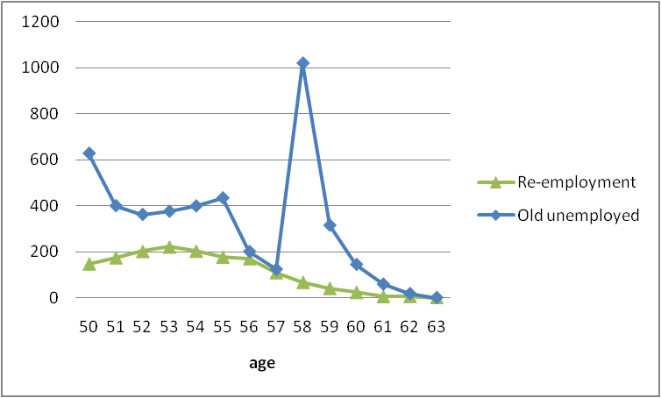

1. Econometric model

Because the “re-employment” subsidy and the reform of the “old unemployed” both affect unemployed older than 49 and both started in 2002, we examine these two measures together. Because of the age limit (50 years), we use a regression discontinuity approach to examine the impact of these measures together on unemployment duration (see, for example, Imbens and Lemieux, 2008). Figure 3 illustrates the discontinuity at 50 years.

Figure 3: Proportion of unemployed by age

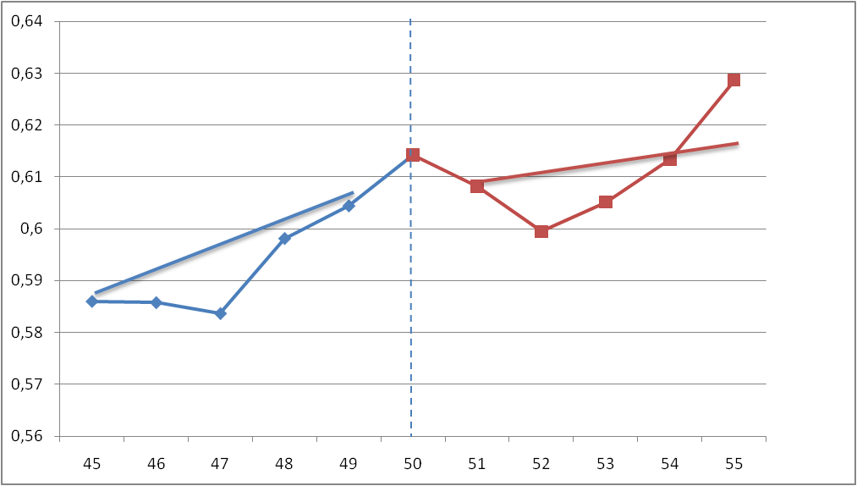

Following Lalive (2008) and Caliendo et al. (2009), we use a linear specification and a multivariate proportional hazard model to assess the impact of the two measures. Both models allow for potentially different linear trends in age on both sides of the 50 years old threshold. Table 3 reports the results for men and women separately. The dependent variable is respectively the number of months in unemployment and the number of months in employment.

Table 3: Effects of the “re-employment subsidy” and of the reform of the “old unemployed status”: linear regression model

|  |  |  |
| --- | --- | --- |
|  | Men | Women |
| 1. Unemployment duration |  |  |
| “Re-employment subsidy” | -3.75  (-2.04)* | -6.55  (-1.77)*** |
| “Old unemployed” | -1.44  (-1.03) | -0.312  (-0.74) |
| # of spells | 15,532 | 18,628 |
| 1. Employment duration |  |  |
| “Re-employment subsidy” | 1.74  (0.44)*** | 1.81  (0.41)*** |
| “Old unemployed” | 0.51  (0.60) | 0.36  (0.49) |
| # of spells | 11,439 | 24,296 |

Notes: age-cell clustered robust standard error in parenthesis. ***: coefficient significant at the 1% level; *: coefficient significant at the 10% level.

Only the “Re-employment” subsidy has a significant effect on unemployment and employment duration when using a linear regression model. However, as it is often the case with duration data, many observations in our data set are right censored and the presence of dynamic selection is not taken into account in such a model. Table 4 reports the results of a multivariate duration model.

Table 4: Effects of the “re-employment subsidy” and of the reform of the “old unemployed status”: duration model

|  |  |  |
| --- | --- | --- |
|  | Men | Women |
| 1. Unemployment duration |  |  |
| “Re-employment subsidy” | 1.73  (0.20)*** | 1.90  (0.17)*** |
| “Old unemployed” | 1.08  (0.02)*** | 0.92  (0.03)** |
| # of spells | 15,532 | 18,628 |
| 1. Employment duration |  |  |
| “Re-employment subsidy” | 0.39  (0.02)*** | 0.30  (0.02)*** |
| “Old unemployed” | 1.02  (0.03) | 1.01  (0.02) |
| # of spells | 11,439 | 24,296 |

Notes: age-cell clustered robust standard error in parenthesis. ***: coefficient significant at the 1% level; *: coefficient significant at the 10% level.

The duration model confirms the positive effect of the “Re-employment” subsidy on both the unemployment and employment duration. The hazard rate of unemployment increases with the measure while the hazard rate of employment decreases. The effect is slightly higher for women than for men. The unemployment hazard increase by 90% for women and 73% for men while the employment hazard decreases by 60% (men) to 70% (women). This time, the “old unemployed” reform seems to have an impact on the hazard rate of unemployment of men and women. However, the impact is only positive for men and negative for women.

1. Conclusions

In the Belgian context of ageing population and of particularly low employment rates of elderly workers, it seems imperative to evaluate policies which aim to promote the labour participation of elderly workers. This study presents an evaluation of two recent measures aimed to promote the employment activity of elderly workers in the Belgian labour market. Our findings show that employment subsidies help elderly men and women to exit unemployment faster and to stay employed longer. The benefits of the reform of the “old unemployment category” are less clear. While the reform seems to have an effect on the unemployment exit rate of elderly males, it does not appear to have any impact on the employment duration of elderly workers. Future work should allow to better understand this first result and expand to evaluate other measures aiming at increasing employment rates of elderly workers.

Bibliography

Bollens, J. (2011), Evaluating the mandatory activation of older unemployed, paper presented at the *Belgian Day for Labour Economists 2011 Conference*.

Cockx, B., Dejemeppe, M. and B. Van der Linden (2011), L’activation du comportement de recherché d’emploi favorise-t-ell un retour plus rapide à l’emploi ?, Regards Economiques n°85.

Caliendo, M., Tatsiramos, K. and Uhlendorff, A. (2009), Benefit Duration and Job Match Quality: A Regression-Discontinuity Approach, IZA DP n° 4670.

Imbens, G.W. and T. Lemieux (2008), Regression discontinuity : A guide to practice, Journal of Econometrics 142, 615-635.

Lalive, R. (2008), How do extended benefits affect unemployment duration? A regression discontinuity approach, Journal of Econometrics, vol. 142(2), 785-806.

1. In 2009, the employment rate of older workers (aged 55-64) in Belgium was 35%; only Malta, Poland and Hungary had a lower rate for this age category (Eurostat, 2011).
2. However, the success of some of these measures has been questioned (see, for example, M.Maes, 2010).
3. This measure will be separately evaluated in a coming paper.
4. There are many other measures in Belgium which subsidise employment, in particular, through cuts in employers’ and employees’ social security contributions. However, none of these measures are available in our unemployment data.
5. Because we are dealing with people younger than 55 years, there should normally not be any exits to retirement. Also, early retirement is included in our data.